Creative Space in Nature
A Training Course for Youth Workers to Improve their Knowledge and Skills using the ‘5 Pathways to Nature’ Framework
Based on Being in Nature, Developing Creativity, and Connecting with Each Other, using Youth Work Methodologies
Saturday, March 28th – Friday, April 3rd, 2026
(including Travel days)
Woodstown, County Waterford, Ireland
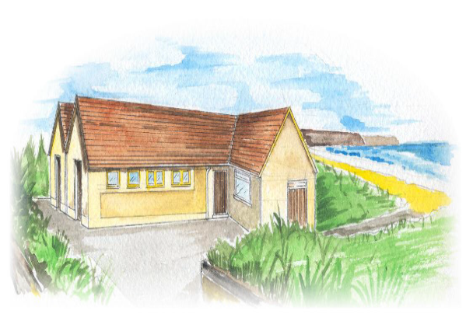
Woodstown Residential and Activity Centre
(WRAC)

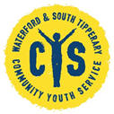
Overall Aim

The overall aim of the Training Course is to explore ways that Youth Workers can engage young people to partner with nature resulting in improved Youth Work outcomes.
The Training Course participants will do this through the development of a Learning Toolkit which they can use with their own young people in their own countries after the Course.
The idea is to immerse participants in nature, use the power of creativity, and learn from and connect with each other during the week in Ireland.

Objectives
- To learn about the ‘5 Pathways to Nature’ Framework that enables young people to connect with nature in their own way.
- To frame a learning process where youth workers feel commitment and inclusion by sharing and experience.
- To provide youth workers with tools to support a deep connection with young people they work with.
- To share tools and methods from across Europe, and to inspire the participants to implement similar learning processes after the Training Course for their own target groups.
- To reflect on their own learning process by using the Key Competences from the Youth Pass, and giving the opportunity for capacity building in the context of the Erasmus+ Program.
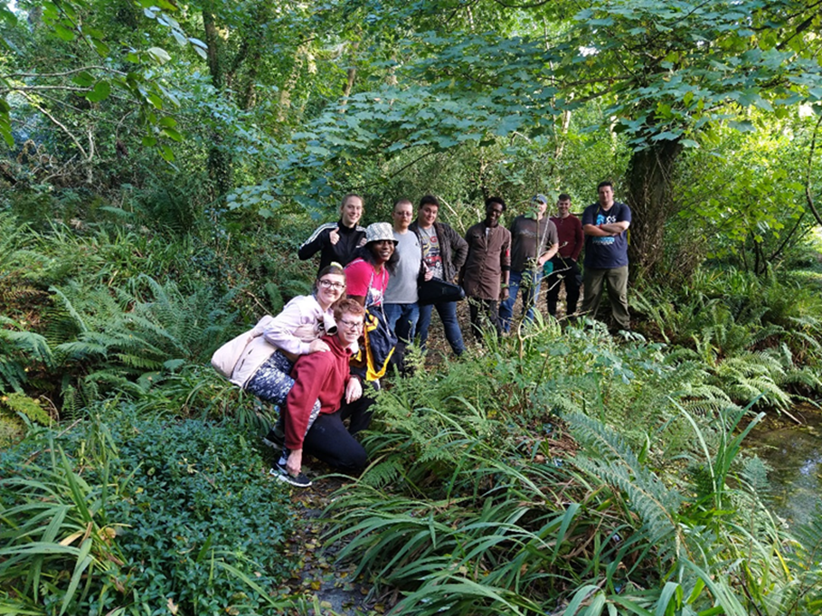

Young people on a ‘Pathway to Nature’

Background and Theme of the Project
Have you ever wondered why young people just seem happier and in better form after they’ve spent the day outside in nature?
Fresh air, glorious sunshine, reviving rain, wild wind, and sparkling snow – they all just seem to add to our positive feelings. Many youth workers want to use nature as a background for youth work, simply because it adds enormously to the outcomes that we’re looking to create with young people.

The ‘Creative Space in Nature’ Training Course was developed from a Key Action 2 Cooperation Partnership Project called Pathways to Nature.

(You can find out more about the Project here https://pathwaystonature.eu/)

The Pathways to Nature Project aimed to improve mental health and wellbeing in young people through connecting them with nature using Youth Work methodologies, and included a wide variety of academic and practitioner partners. A large network of organizations and interested people has emerged over time, and thousands of young people across Europe are benefiting from the results of the Project. This Training Course was developed from the results of that Project.
However, the premise on which Creative Space in Nature is based is deceptively simple, but seems to have gotten lost along the way in the 21st century – we all just feel better when we’re out in nature.

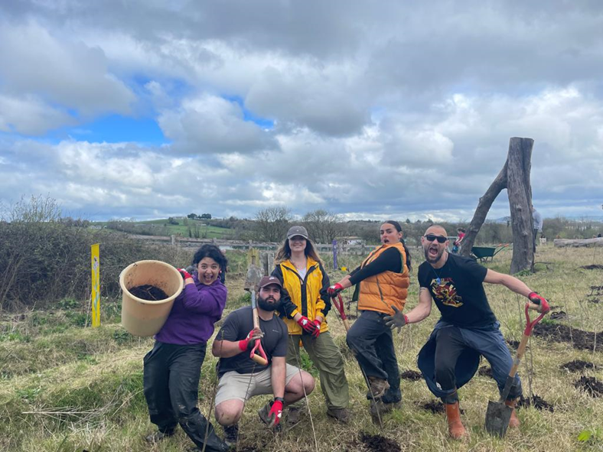

Training Course participants creating a new forest

Youth Work Approach and Methodology

Youth Work methodologies underpin all aspects of the Training Course, which will be focused on developing and creating opportunities to deliver social and personal outcomes with young people and organizations over the coming years.
Youth work is defined as:
‘A planned Programme of education designed for the purpose of aiding and enhancing the personal and social development of young people through their voluntary involvement, and which is complementary to their formal, academic or vocational education and training’.
This Course will be based on non-formal and informal education with a self-directed learning approach. Some sessions will be complemented by theoretical inputs, and all of them will be followed by group reflection or self-reflection. The Workshops will revolve around methodologies that can be used with all young people, using the ‘5 Pathways to Nature’:
- Senses
- Emotions
- Beauty
- Meaning
- Compassion

The Training Course will be characterised by highly participatory, interactive and experiential methods. We’ll be out in the natural environment of forests, coast and mountains most of the time, so it’s important that participants will be prepared for all weathers!
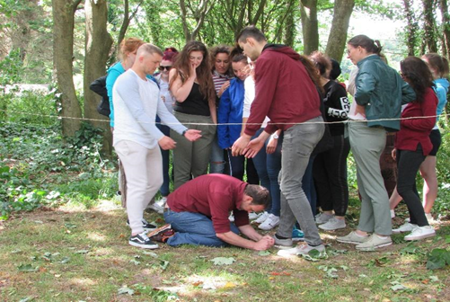
The Process of ‘trusting the process’

PREPARATORY WORK
Each participant is invited to create a short informal presentation of 10 to 15 minutes, before they arrive in Ireland, around an example from their own country of good practice youth work involving young people and nature.
Some elements to consider in this good practice example are:
- What is the activity and who is involved?
- How is nature included in the activity?
- What is the impact on the participants?
- What are the key elements that make this a good practice activity?
- Could this activity be transferable around Europe?
Presentations may be supported by audience interaction, a prop or some other creative communication, but no PowerPoint, please.

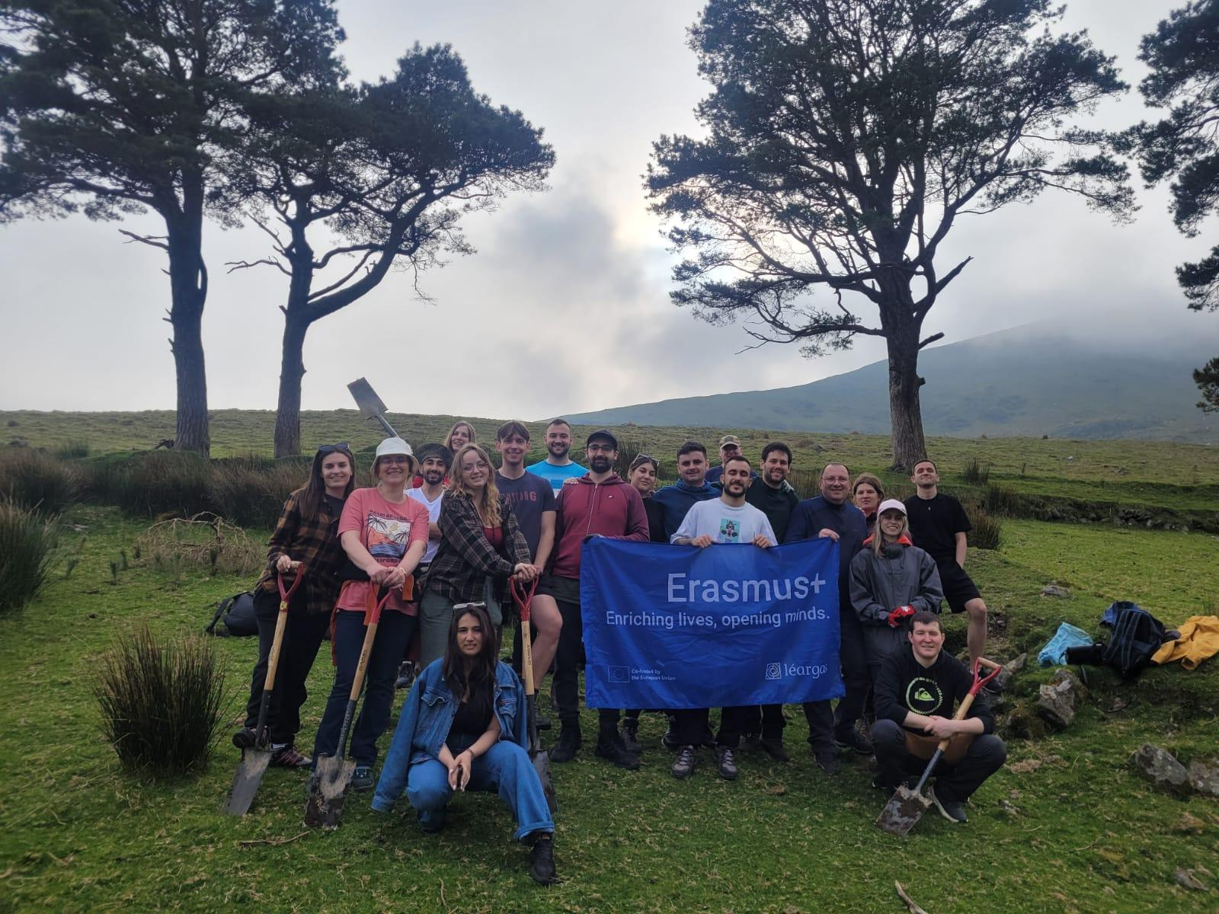
Training Course participants planting trees on the Irish mountains

Profile of the Participants

The 16 Participants on the Training Course will be youth workers, project leaders and educators involved in youth work. The participants will have a multiplier role - in other words: they will adapt what they learn in this Training Course to their own context of working with young people. In their future projects and daily work they can incorporate tools, methods and theories which they have learned during this Training Course. They can also use their personal learning and development in their daily work with their own target groups.
This Training Course will be an emotionally challenging project for trainers and trainees. That’s why we expect from trainees at all times to the best of their abilities to…
- be fully committed to the process - to reflect, share, experience and participate in all activities
- keep a clear mind, that is neither intoxicated nor distracted
- have taken care of important personal and professional matters beforehand, so that these do not intervene with the Training Course (being completely present with the group)
- be on time for all of the deadlines, sessions and appointments
- challenge themselves to step out of their comfort zones
- be willing to look into themselves and reflect on their professional and private life
- join us on an intensive, immersive and unforgettable journey
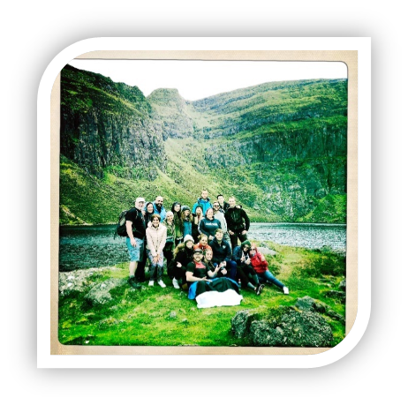
Participants immersing themselves in Irish nature

Outline of Schedule

This following schedule is intended to give participants an outline of the week’s activities, and is subject to change, depending on the needs of the group.

Timetable | Activities
Day 1 (Saturday) | Arrival of participants and a Welcome evening;  Woodstown Residential and Activity Centre is here
Day 2 (Sunday)
10 am | - Opening the Course and getting to know needs and expectations  - Introducing the ‘Pathways to Nature’ Approach  - Group management guidelines
3 pm | - ‘Getting to know each other’ activities  - Team Building (Beach and Coast)  Woodstown Beach is here
Evening | Reflections of the day. Intercultural Evening.
Day 3 (Monday)
10 am | Depart by Bus for John F. Kennedy Arboretum  Outdoor Activities Using the Senses  John F Kennedy Arboretum is here
3 pm | Outdoor Activities Understanding Emotions in Nature
Evening | Reflection of the day. Intercultural Evening.
Day 4 (Tuesday)
10 am | Depart by Bus for SETU West Campus  Waterford Greenway SETU West Campus Car Park is here  Outdoor Activity demonstrating Compassion – Giving back to Nature  Planting a new small woodland.
3 pm | Outdoor Activity Using Wood, nature’s ingenious material.
9 pm | Irish Traditional Music Night in Dunmore East  Power's Bar is here
Day 5 (Wednesday)
10 am | Depart by Bus for Lismore Castle Estate  Lismore Castle is here  Outdoor Activity Uncovering Beauty in Nature
3 pm | Outdoor Activity Finding Meaning in Nature
Evening | Reflection of the day.
Day 6 (Thursday)
10 am  3 pm | Designing a Creative Space in Nature Activity – Carriganore  Evaluation + Youthpass
Evening | Farewell Party
Day 7 (Friday) | Departure of all participants

More about the Trainers
- Tom Kent, (Forester in Waterford, Ireland)
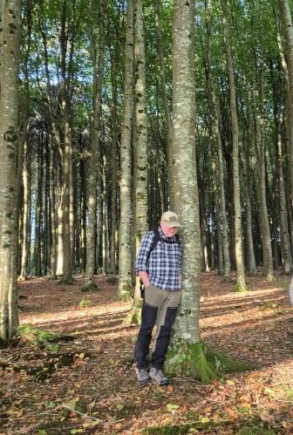
Tom is an experienced forester, working at the Department of Land Sciences in the South East Technological University based in Waterford.
He is a Voluntary Youth Worker for many years with Waterford and South Tipperary Community Youth Service, and has influenced and inspired thousands of young people over many years in the south east of Ireland, giving freely of his time and knowledge.
Tom is a man who knows more about trees than most people who ever lived, but is passionate about learning new things every day, especially from young people.

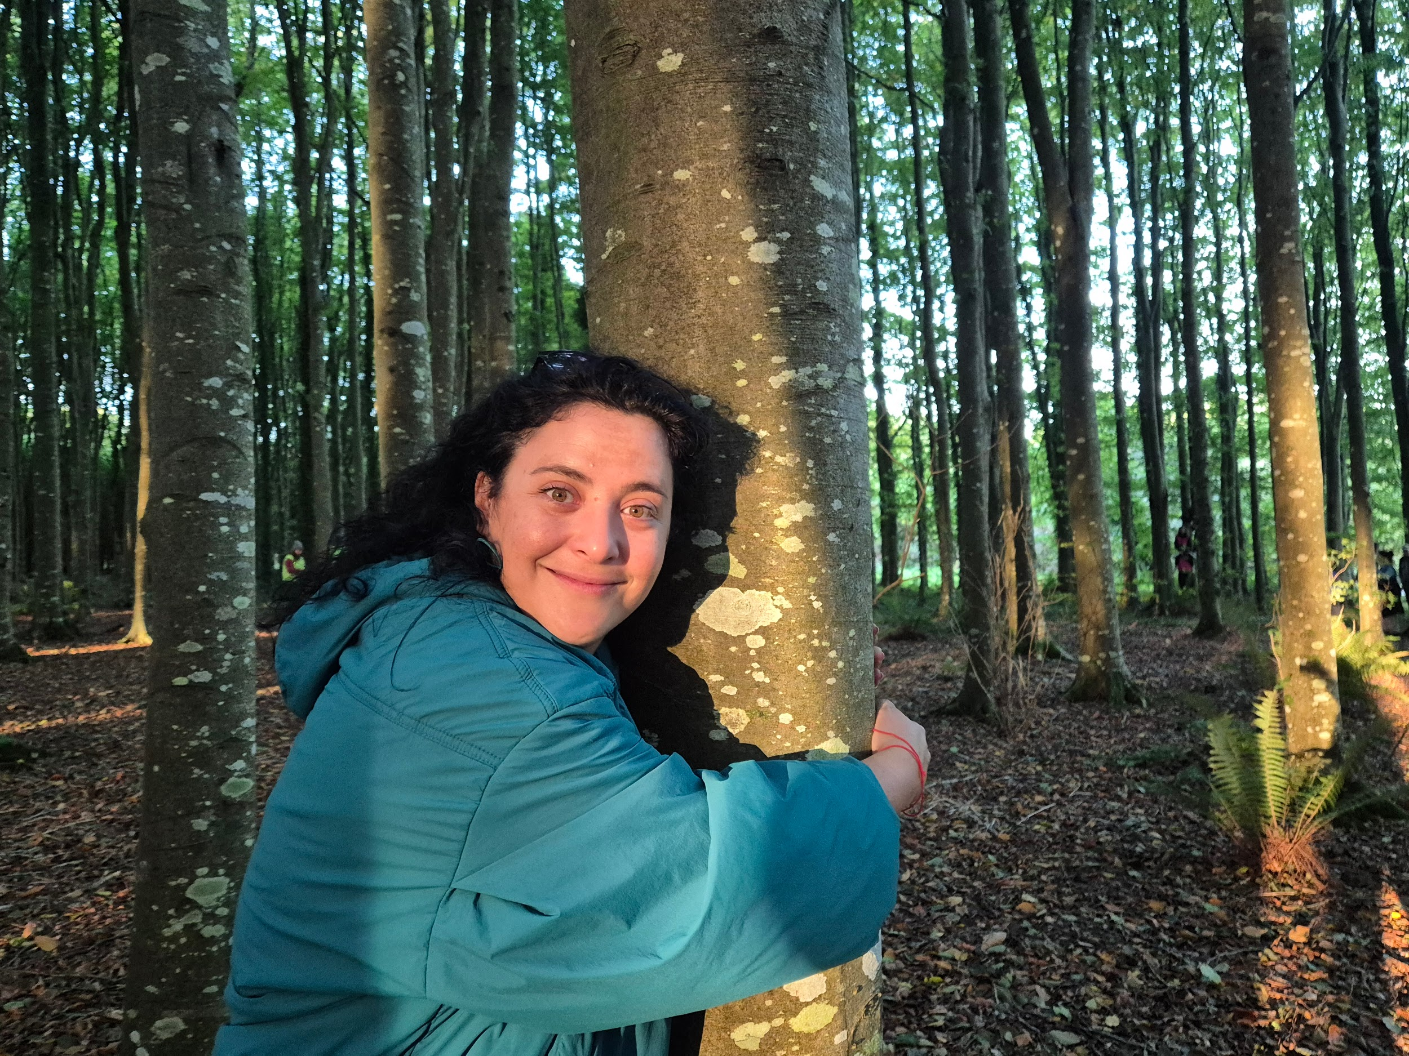
- Elena Serrano, (Actress in Murcia, Spain)

Theater actress and youth worker with over two decades of experience spearheading European projects. She specializes in cultivating safe, immersive environments by integrating creative exploration in Nature. She believes that artistic engagement with Nature fosters global awareness, critical thinking, a deeply empathetic worldview, ultimately leading to more resilient and fulfilled individuals.

The Organisers – Waterford and South Tipperary Community Youth Service is a Community-based Youth Service that operates in the south-east of Ireland, working with thousands of young people every year. Find out more at www.wstcys.ie
Declan O Driscoll is the European Youth Work Manager at WSTCYS, who will look after the organizational and financial aspects of the Training Course. (00 353 86 3889723 or declan@wstcys.ie )
Rosa Lopez is the experienced person in charge of running this Training Course, and she’ll be looking after all the day-to-day logistics and operations, ensuring that the Course runs smoothly and that you’ll be welcomed to Waterford very warmly.

Practical & Travel information

Venue
The Training Course will take place at:
Woodstown Residential and Activity Centre (WRAC), Woodstown Beach, Co. Waterford, Ireland (X91FX29)
Telephone: 00 353 86 4555346 or 00 353 51 309364
Email: woodstown@wstcys.ie

WRAC is a Project of the Waterford and South Tipperary Community Youth Service, based at the Edmund Rice Youth and Community Multiplex, Manor St., Waterford City, Ireland

The Centre is situated on the beachfront around 10km from Waterford City – it offers tranquility and privacy in a quiet rural area, and is set on 2 acres of its own grounds.
The accommodation is mainly aimed at sharing the space as one large group. Keep this in mind when you decide to join this TC. Practically this means:
- The Centre operates on a self-catering basis, and has bunk-bed type accommodation for up to 32 people.
- Please note that the sleeping space involves two shared 16-person dormitories. For this Training Course, we limit the rooms to just 8 people in each. So you still share the sleeping room with many other people! Depending on the gender mixture of the participants, you may be sharing with people of different genders.
- There is a fully equipped kitchen, a large dining room, a living room and a TV/Training room with a fireplace.
- Bed linen, duvets, pillows and towels are provided, but you will have to bring your own toiletries (soap, shampoo, toothpaste, etc.).

Meals
All food will be provided by the organisers either at the venue or in the restaurant next door. It will be self-catering for breakfast and lunch, and dinner will be provided.
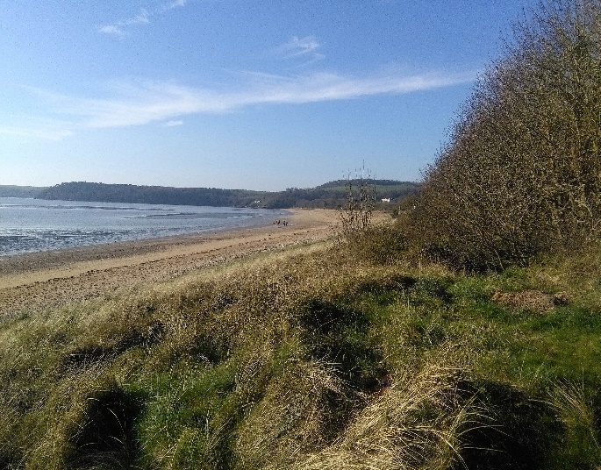
(NB. If you have any allergies, or other dietary requirements, please let us know)
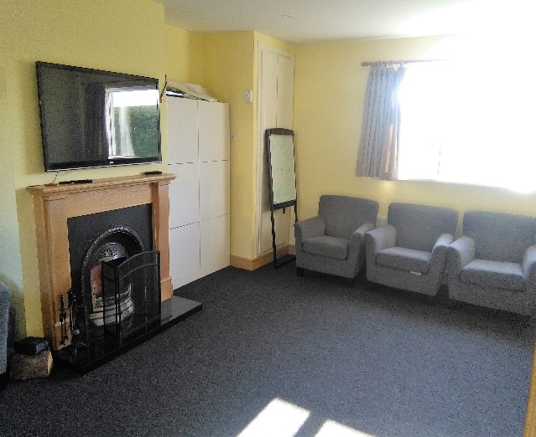
WRAC Training Room Woodstown Beach

When & How to Get There
Participants are responsible for booking their own travel – it’s up to the partner organizations to support them in the process.
Depending on where you’re travelling from, the two closest airports are Dublin and Cork, which are both around two hours travelling time from Waterford City.
You’ll need to get to Waterford City yourself.
You can take either a train or a bus from Dublin Airport (www.irishrail.ie, www.buseireann.ie, www.jjkavanagh.ie) but only a bus from Cork (www.buseireann.ie).

NB. We’ll be running 2 buses from Waterford to Woodstown on Saturday, March 28th – the first bus will leave at 6pm and the second bus will leave at 9pm – You’ll need to catch one of these buses, so participants must arrive in Waterford BEFORE 9pm.
Please DO NOT arrive in Waterford City later than 9pm, as there will be no way of transporting you from the city to the venue.

Other Practical Details:

- Participants will be accommodated in bunk beds in shared, dormitory-style rooms.

- There is a wireless internet connection available at the venue

- The weather in Ireland in March and April can be very wet, windy, cold, warm, cloudy and sunny – often all on the same day.
Please don’t travel if you expect gentle, sunny weather – you need to go to the Mediterranean, and not the North Atlantic!
You will be spending time outdoors, in forests and in muddy places, so you need to be prepared for the outdoors – you will need warm and waterproof outer clothes and footwear, hats, gloves, coats etc.
Then you will need warm clothes and slippers for inside as well.
Don't forget your umbrella, as there might be rain, but you might also need sunscreen. Half the fun of being in Ireland will be guessing the weather! You can follow the weather forecast here: http://weather-finder.com/Ireland/Waterford/

- The currency is Euro. If you need to change money: Please use the Airport Exchange Office.
- Insurance: Insurance is each participant’s responsibility. You need to have travel insurance and the European Health Card.
- Working language: The working language of this training course is English. Don’t be afraid, your English doesn’t need to be perfect, neither is ours! What is important is that your English is good enough to actively participate.
- Contact details in case of emergency If you are ever in any trouble, you can call Sanja on 00 353 86 4555346 (or Declan on 00 353 86 3889723)

Financial Considerations:
- The food and accommodation will be completely provided and paid by Erasmus+.
- Visa costs (if needed) will be reimbursed by the organizers after the Training Course, once receipts are received.
- Travel costs include plane, train or bus costs from your home country to Woodstown.
- ALL costs must be receipted.

Reimbursement of travel costs:
Travel costs (plane, train and bus) will be counted by distance calculator provided by the European Commission and reimbursed by bank transfer directly to the participant within 4 weeks of the Course finishing. The reimbursement is determined by the Erasmus+-guide 2025.
The participants have to give the receipts for the travel costs to the organizers.
The reimbursement will be made through bank transfer after the training course after Waterford & South Tipperary Community Youth Service have received the travel tickets.
Please note that WSTCYS will reimburse any bus or train costs that you incur either in your own country, or in Ireland, as well as your flight/ship costs – up to the maximum allowance in the Programme Guide. But you must provide your receipts!

Communications:
Contact us anytime if you have any questions, concerns or feedback.
Let us know of any changes that are relevant to the running of the Training Course as soon as you can, such as:
- Your (non) participation in the course
- All travel related issues, including costs and the exact itinerary
- Your contact details
- Anything else we need to know for a smooth functioning of the Training Course – all information will be treated confidentially

Remember, we’re here to help you out in any way that we can, and to ensure that you enjoy your time in Ireland. We want you, your organization, and most importantly the young people you work with, to get a significant benefit from attending the Training Course, so if there’s anything we can help you with or any question that we can answer, just ring Declan on
00 353 86 3889723 or email at declan@wstcys.ie

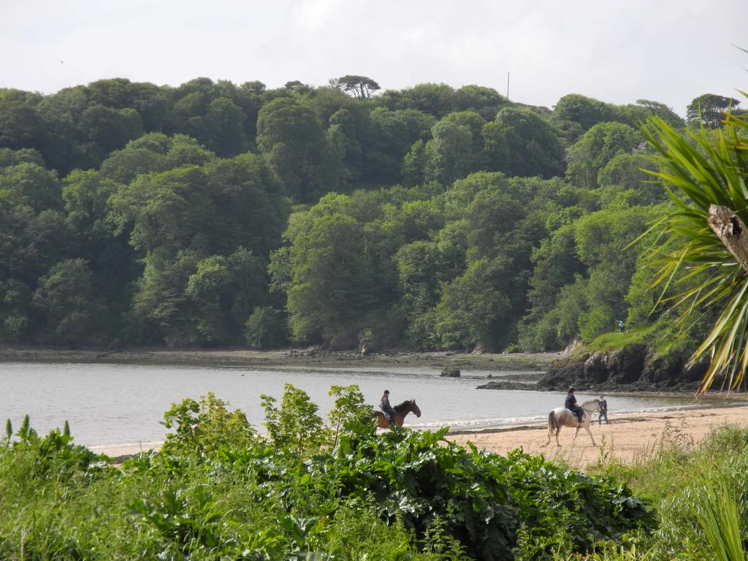
Woodstown Beach, County Waterford



