Hands on European Citizenship
08
Fall

European Citizenship & Youth in Action
A conference around the European Union’s Youth in Action Programme
and one of its main themes, aspects & objectives: European Citizenship

Netherlands Youth Institute | Dutch National Agency

[Manuscript | May 28, 2010]

Hands on european citizenship
Written by Marit Kannelmäe-Geerts and Andreas Karsten
The views expressed in this publication are the responsibility of the authors and do not necessarily reflect the opinions of the European Union, the Netherlands Youth Institute or the participants of the Hands on European Citizenship Conference.

Hands on European Citizenship Conference
12-14 May 2009, Rotterdam, The Netherlands

Organiser & Host: Dutch National Agency of the Youth in Action Programme,
Netherlands Youth Institute | www.nji.nl

Co-operation & Partners: Austrian National Agency * | www.iz.or.at
Estonian National Agency * | euroopa.noored.ee
German National Agency * | www.jugendfuereuropa.de
Youth Partnership | www.youth-partnership.net
Dutch National Youth Council | www.njr.nl
Rotterdam Youth Council | www.rjr.nl
Rotterdam European Youth Capital | www.reyc.nl

* National Agency of the European Union's Youth in Action Programme

Facilitation & Moderation: Paola Bortini | www.pameambro.org
Facilitation & Music: Max Douw | www.maxdouw.nl

Hands on European Citizenship Booklet

Publisher: Netherlands Youth Institute | www.nji.nl
Editor: Andreas Karsten | www.nonformality.org

Published by the Netherlands Youth Institute
© Netherlands Youth Institute 2010

european citizenship
An active social, political, cultural and economic role to construct a shared Europe?

Table of contents
Executive summary 8
Behind the conference 10
Context 11
Objectives 11
Participants 11
Methodology 11
Before the conference 12
Project Overview 13
Youth Exchanges 13
Youth Initiatives 14
Youth Democracy Projects 14
European Voluntary Service 15
Peer-to-Peer Projects 15
Training Courses 15
Youth Seminars 15
Project Examples 17
What can young people do about global warming? 17
Photography project „Empower yourself“ 17
Training Courses „Sailors on the Citizenship“ 18
European Cultural Puzzle 18
European Volunteers and the Diaconal Year 18
Active Living on the Edge 19
impACT!on – Youth in Action! 19
EuroPeers 19
Network Trainings on European Citizenship 20
At the conference 22
Composing European Citizenship 23
Performing European Citizenship 24
Questioning European Citizenship 25
Deconstructing European Citizenship 26
Mediocracy and Citizenship 26
Legitimacy and Citizenship 26
Rethinking European Citizenship 27
Defining European Citizenship 27
Opening Up European Youth Citizenship 27
Space for dialogue 27
Experiencing European Citizenship 28
Plan B – A simulated reality exercise? 28
impACT!on – Steps towards active European citizenship 28
European Citizenshipism! 28
What makes a European citizen? 28
Constructing European Citizenship 29
Revisiting European Citizenship 30
After the conference 32
Conceptual Framework 33
Defining European Citizenship 34
Educational Framework 35
Project Characteristics 36
Tips & Hints 38
Reading Further 39
Discussing Further 39

Executive summary
Context | Overview | Rationale

Executive Summary
Youth in Action is the European Union's Youth Programme, aiming to inspire a sense of active citizenship, solidarity and tolerance among young Europeans and to involve them in shaping the Union's future. The programme has a budget of 885 million euros for seven years (2007-2013). It promotes mobility within and beyond the EU borders, fosters non-formal learning, initiates intercultural dialogue, and encourages the inclusion of all young people, regardless of their educational, social and cultural background.

European Citizenship is a central element of the Youth in Action Programme – the promotion of young people’s European citizenship constitutes one of the five core objectives of the programme, which is further underpinned by four permanent priorities, one of which is European Citizenship.

Sharing experience on how to work with and on European Citizenship in the framework of the Youth in Action Programme was at the heart of the working conference «Hands on European Citizenship» in May 2009, a gathering of programme stakeholders wanting to explore how concepts and practices of European Citizenship can be translated into and operationalised for the Youth in Action Programme.

Documenting the discourse around European Citizenship is the ambition of this publication, a direct outcome of the working conference. It brings together previous thinking and writing with current questions and ideas. While it can be read in sequence, it is also intended to function as a reference document. Readers who are unfamiliar with the concept of European Citizenship—in general or in the context of the Youth in Action Programme—may find it useful to start with a glance at the educational framework and project characteristics.

The diversity of programme stakeholders who contributed to the conference and this publication—trainers, organisers and researchers, national agencies and youth councils, organisations and institutions, programme users and support centres—has been a strong 'hands on!'–support in developing this handbook.

We are looking forward to your feedback and hope you will enjoy the read!

Marit Kannelmäe-Geerts, Andreas Karsten &
the team of the Netherlands Youth Institute

Behind the conference
Context | Objectives | Participants | Methodology

Context
European Citizenship is at the heart of the Youth in Action Programme – the promotion of young people’s European citizenship constitutes one of the five objectives of the programme, underpinned by four permanent priorities, one of which is European Citizenship.
After two years of working on and with European Citizenship in the framework of the Youth in Action Programme—which succeeded the Youth Programme in 2007—the Dutch National Agency invited programme stakeholders to attend a working conference aiming to
share, inspire and provide insights on how to work with & on
European Citizenship within the Youth in Action Programme.

Objectives
The working conference sought to achieve three main objectives, namely
- to explore the topic of European Citizenship and to become aware of the questions and dilemmas related to the theme and its different dimensions,
- to collect and share existing practices of European Citizenship,
- to enable programme stakeholders to translate European Citizenship into and operationalise the concept for the Youth in Action Programme.

Participants
The conference was open to all programme stakeholders and had the ambition to address—within the framework of the Youth in Action Programme—a combination of experts across the domains of youth work, youth policy, youth research and youth training. It consequently brought together individuals and representatives from different training networks and academic institutions, several National Agencies and National Youth Councils, the Salto Resource Centres, as well as the European Commission, the Council of Europe and their Youth Partnership.

Methodology
The conference relied on and utilised a methodological approach rooted in non-formal education. Modes of discussion ranged from small group techniques to large panel debates; methods employed included statement exercises, role plays, and simulation games. The entire conference was embedded in and enriched by skilful and musical facilitation.

Before the conference
Project Overview | Project Examples

Project Overview
The Hands on European Citizenship Conference brought together stakeholders of the Youth in Action Programme who—in their roles as project organisers or project funders, as project trainers or project mentors, as project managers or project evaluators—work with and on European Citizenship. In this chapter, we offer a glimpse—concise descriptions complemented by several project examples—at some of the projects that were implemented and organised or supported and funded by the conference participants.

Youth Exchanges
- The Spanish Youth Group „Fuenlabrada“ has explored human rights through a youth exchange addressing equality and inclusion across Europe in a constellation that resembled the diversity of Europe and strengthened everyone’s European identity.
- The German NGO „Sonnenbergkreis“ has implemented a youth exchange entitled „Equal Opportunities in Europe? You decide!“, exploring themes including discrimination and exclusion and how equal opportunities could become a reality for all European citizens.
- The Swedish Municipality „Oxelösund“ has engaged more than fifty young people in a youth exchange asking what young Europeans could do about global warming that resulted in a widely distributed book entitled „Don’t wash your socks alone!“
- The Czech School „Základní škola Malíka“ has realised a youth exchange with Swedish and Czech school students, who discussed democracy, human rights and identity and co-developed ideas to improve life in their respective communities.
- The Romanian NGO „Millennium Art“ has created a „European Cultural Puzzle“ through their youth exchange, which gave the participating young people time and space to explore and share their own identity and its European components.
- The German NGO „IKAB“ has organised a youth exchange during which young people explored their own cultural identity, developed shared ideas for a peaceful Europe and creatively presented their common ideas to the public.
- The Finnish Municipality „Suomussalmi“ has brought young people together for a new year’s meeting, a time for reflection and discussion, for exchange and interaction about growing up in Europe and how to become active European citizens.
- The Italian NGO „Eurotrain“ has provided young people with the opportunity to reflect on and reduce the environmental impact of their daily consumption and life styles, an experience that the group shared and discussed online with many other Europeans.
- The Turkish Youth Group „Karatekin“ has explored European values and their validity in a youth exchange hosted in a small city currently not part of the European Union, aiming to challenge the perception that the borders of Europe are defined by the Union.
- The Spanish Municipality „Pilas“ has set up a framework for young people to self-organise youth exchanges, one of which explored the benefits of diversity and how intercultural dialogue can contribute to and develop European citizenship.

Youth Initiatives
- The Spanish NGO „Capacitarte“ has run a project with disabled young people that explored European Citizenship through photography and brought together art and disability with empowerment and European values.
- The German Project Team „Connecting Europe“ has realised an intercultural research trip involving more than a hundred young Europeans searching for and (re-)define Europe as part of their own and, more generally, of young people’s own identity.
- The Latvian „Skolēnu Dome“ has initiated a cultural festival called „27 stars“ in which teams of school students engaged with one of the European Union’s member states in preparation of a public street action where all countries were creatively introduced.
- The Dutch National Youth Council interviewed young people on the streets about their opinion on the European elections. Of these interviews, a short documentary was made and published on their website.
- The Portuguese Youth Group „A Nós in Europe“ has gathered young people to become actively involved in their community life, a process that has been enriched and supported by experiencing the diversity of ideas and approaches across Europe.
- The Estonian NGO „Tegusad Eesti Noored“ has hosted youth parliament sessions that brought together Russian and Estonian young people and approached youth participation as a transversal topic cutting across policy fields and cultures in Europe.
- The Spanish NGO „Sin Esquemas“ has founded a network with the ambition to introduce methodologies of non-formal learning in formal education systems in several European countries, aiming to empower young Europeans to practice their citizenship in school.

Youth Democracy Projects
- The Austrian NGO „Forum Politische Bildung Steiermark“ has implemented a series of lively debates around provocative European topics of interest to young people that were not only interactive but also interacting with an online audience.
- The Youth Department of the Finnish City Lahti has developed a project entitled „Active Living on the Edge of Europe“ aiming to find, try and discuss possibilities of participation from local to European and global level.
- The Swiss NGO „Infoklick“ has established a national network of municipalities committed to facilitate youth participation, gravitating around annual participation days dubbed „Youth with Impact“ that lead to locally rooted and embedded projects.
- The German NGO „Demokratie & Dialog“ has initiated a project about voting and nonvoting, aiming to look behind the usual arguments around nonvoting and wanting to explore why so many young European citizens do not—or cannot—use their right to vote.

European Voluntary Service
- In the framework of the Danish Diaconal Year, 24 volunteers from 13 different countries have spent nine months working in numerous Danish NGOs in different social projects, strengthening not only their own European identities.
- The Finnish Agency „Centre for International Mobility“ has developed a module for their on-arrival training courses that invites the volunteers to explore their own choices and values and links these aspects with European citizenship.

Peer-to-Peer Projects
- The German Agency „Jugend für Europa“ has set up a network of young people – the EuroPeers – who have participated in the Youth in Action Programme and who want to share their European experiences through self-organised information activities.

Training Courses
- The Austrian Agency „Interkulturelles Zentrum“ has implemented a training course with participants from Southeast Europe and the European Union to delve into European Citizenship and related themes, including identity and values, human rights and democracy.
- The Czech NGO „Liberecká občanská společnost“ has run a training course named „Sailors on the Citizenship“ exploring citizenship in local, national and European contexts with the aim of raising the quality of European Citizenship projects.
- The German Youth Education Centre „EJB Weimar“ has organised a training course „Going East … Southeast“ aiming to support participants in answering their questions around European Citizenship, thus making the concept accessible and practical.
- The Dutch, German and Latvian Agencies have supported a team of youth trainers to organise a series of courses named „impACT!on – Youth in Action!“ aiming to equip young people with knowledge, skills and understanding around active citizenship in Europe.
- The Salto Resource Centre „Training & Cooperation“ has enabled hundreds of participants to benefit from the programme’s network trainings on European Citizenship aiming to support the professional development of youth workers and youth leaders.

Youth Seminars
- The Estonian NGO „Euroopa Maja“ has run a Model European Parliament to offer young people from Estonia the opportunity to experience the potential of parliamentary work and discuss many of the issues around European Citizenship and its political dimension.
- The German NGO „LKJ Sachsen-Anhalt“ has held a series of regional youth conferences – preceding one of the European Union’s Youth Events – around transversal issues including intercultural dialogue, education and youth participation.
- The Swedish NGO „Keks“ has organised a seminar on youth participation and influence, preceded by local projects and embedded in a multi-measure project that brought together practitioners and policy-makers to explore active citizenship.
- The Slovak Regional Youth Centre „Košice“ has facilitated a seminar exploring European identity and European Citizenship in an intercultural context with the ambition to embed today’s chances and dilemmas in their historical context.
- The Norwegian Youth Culture House „X-Ray“ has brought together fifty young Europeans to discuss their visions of Europe’s future – a Europe that values difference and knows how to benefit from its richness in diversity.
- The Flemish Youth Council has hosted days of reflection and exchange about Europe named „Europinion“ during which young Belgians were invited to participate in the construction of Europe as they see it and develop ideas that were discussed with policy-makers.

Project Examples
Complementary to the brief summaries in the first section of this chapter, a selection of projects will be introduced briefly as exemplary case studies on the basis of information kindly provided by programme stakeholders.

What can young people do about global warming?
In an environmentally-themed youth exchange, the Swedish Municipality „Oxelösund“ brought together fifty-five young European citizens from thirteen countries to explore, experience and define young people’s contributions to the protection of the environment from local and regional to European and global level.
In preparation of the exchange, participants researched and worked on the theme in their own contexts to bring initial answers and informed questions as well as first experiences and encountered obstacles to the multilateral discussions, workshops, excursions and visits.
The project was embedded in the European Town Twinning Association „Douzelage,“ which provided not only financial, administrative and political support but also constituted an excellent network for the dissemination and exploitation of results.
The Oxelösund Report – subtitled „Don’t wash your socks alone!“ – outlines a wide range of individual and collective actions and the underpinning findings and beliefs with the intention to reduce the potential escalation of global warming.
http://www.douzelage.org | mats.ericsson@oxelosund.se

Photography project „Empower yourself“
In a youth initiative around photography, the Spanish NGO „Capacitarte“ provided the space and support for young disabled people to experience European Citizenship through art, aiming to promote creativity and the spirit of initiative through non-formal education.
The project combined workshops to learn about the technical aspects of photography and seminars to explore the creative dimensions of photography. For a year, the involved young people experimented to express values and ideas around European Citizenship.
Through the initiative, the organisation did not only bring Europe together with a group of young disadvantaged people, but also introduced a strong European dimension to its other activities and its social and youth work.
A selection of the many photos developed within the project were presented in an exhibition that showcased the young people’s individual and collective visions and values around Europe as an invitation for the larger community to engage with European Citizenship.
http://www.capacitarte.com | capacitarte@capacitarte.com

Training Courses „Sailors on the Citizenship“
With the aim of supporting the professional development of youth workers and youth trainers, several European associations formed a network centred around the Czech NGO „Liberecká občanská společnost – LOS“ to create a series of training courses known as „Sailors on the Citizenship.“
On their cruises, participants explore citizenship in local, national and European contexts to raise the quality of their European Citizenship projects. Over the years, special editions of the training were developed to, for example, target new member states of the European Union, neighbouring countries or the Mediterranean region.
Each course contributes to the online toolbox, where the different approaches and methods of the training series are documented and openly accessible, serving as inspiration and support for follow-up and spin-off projects.
http://www.sailorstraining.eu | sailor@sailorstraining.eu

European Cultural Puzzle
Discovering identities and its European layers was at the heart of the youth exchange „European Cultural Puzzle“ co-ordinated by the Romanian NGO „Millennium Art“ that gave 36 young people from four younger member states of the European Union the possibility to experience and enjoy cultural diversity.
Based on their self-directed hands-on research, participants developed and created a puzzle of European cultures, which they presented successfully not only at the youth exchange but also in their respective communities.
With time and support at their hands, it proved quite possible for the group to go beyond cultural stereotypes and extend the exploration of European values and active citizenship, looking behind and questioning initial assumptions.
http://milleniumart.piczo.com/europeanculturalpuzzle | floricontact@yahoo.com

European Volunteers and the Diaconal Year
In the framework of the Diaconal Year, 24 volunteers from 13 different countries spent their voluntary service in social projects across Denmark, conveying solidarity and tolerance within and beyond the projects and their group.
Besides their daily work, the entire group co-operated on projects around creativity and innovation, aiming to appreciate and draw on cultural diversity and to develop common understandings by sharing ideas, thoughts and actions.
As part of the arrival and midterm training courses, the volunteers enjoyed substantial support in a non-formal education setting, which allowed them to reflect on and respond to their experience and the shaping of their identities as European citizens.
http://www.diakoniaaret.dk | diakoniaaret@diakonissen.dk

Active Living on the Edge
Challenging the cliché of young but passive individualists in and beyond Finland was one of the strongest motivations of Lahti’s Youth Department when developing the democracy project „Active Living on the Edge (of Europe).“
Using European Citizenship as an entry-point for questioning how the nature of citizenship and the role of citizens change through a complementary European level, the project managed to create an open forum for young people to discuss their engagement in society.
The different ideas for becoming active and involving others were gathered in a youth participation guide that was widely distributed. A round table discussion on European identity complemented the guide and involved the larger community in the project’s debates.
http://www.lahti.fi | ira.custodio@lahti.fi

impACT!on – Youth in Action!
With the ambition to equip young people with knowledge, skills and understanding around active citizenship in Europe, a team of trainers developed the training course „impACT!on – Youth in Action!“ with the support of the Dutch, German and Latvian Agencies.
Departing from participants’ previous experiences, the course chose a practical approach to discover European citizenship in a multitude of ways, through which opportunities and motivation for many follow-up projects evolved.
With young people at the centre of the training, the course practiced what it preached – respecting the needs and interests of its participants, providing safe grounds to experiment with European citizenship, and constructing shared ideas for future activities.
http://www.salto-youth.net/training | adams@context-bildung.de

EuroPeers
They have participated in the Youth in Action Programme, want to share their European experience, and in doing so they encourage others to discover Europe – the EuroPeers, a network of volunteers set up by the German Agency „Jugend für Europa.“
The variety of self-organised information activities is considerable and ranges from workshops and presentations to interviews and exhibitions. The EuroPeers take all of this and more to schools, culture centres, youth clubs and the street.
The volunteers are embedded in a national pool offering training and support as well as information and feedback. 200 EuroPeers belong to the young and growing network, which has already reached more than 15.000 young people through its activities.
http://www.europeers.de | europeers@jfemail.de

A Nós in Europe
Empowerment, participation and integration underpinned the youth initiative of an informal youth group wanting to become active in its neighbourhood. Supported by the Portuguese Municipality “Cascais” and coached by “Team MAIS”, the group took on the challenge to shape European Citizenship and change things to the better.
Through intercultural encounters embedded in the project, participants experienced and learned from the diversity of Europe and discovered how they can contribute to the construction of a more just society with equal chances for everyone.
Through the project, several individuals broke through the vicious circle of social exclusion: encouraged and empowered by their experiences, many have now become active citizens and role models in their communities.
http://www.cm-cascais.pt | jo.claeys@speelplein.net

Network Trainings on European Citizenship
With the start of the youth programme’s new generation „Youth in Action“, the Salto Resource Centre „Training & Cooperation“ established a new network training on European Citizenship in support of the professional development of youth workers and youth leaders.
The courses built on the previous experiences of the Council of Europe and the Partnership on Youth and continued the efforts of enabling hundreds of participants to benefit from exploring European Citizenship in constellations resembling the diversity of Europe.
This richness enables participants not only to situate European citizenship across many political and historical contexts, but also to confront the dilemmas of the concept pro-actively and question current understandings of this concept under construction.
The trainings are run in co-operation with the network of national agencies, and have meanwhile led to the creation of a platform for practitioners addressing European Citizenship in their youth work.
http://www.european-citizenship.org | udo@salto-youth.net

AT the conference
Composing European Citizenship
Questioning European Citizenship
Performing European Citizenship
Deconstructing European Citizenship
Experiencing European Citizenship
Constructing European Citizenship
Revisiting European Citizenship

Composing European Citizenship
Theatre-maker and artist Max Douw added a refreshing musical element to the conference facilitation by starting the event off with a song about Europe.

YOU-ROPE
Melody composed by Max Douw

I sit in my chair and I think of you
my world as small as my room
I want to sing you a love song
But I don’t know you too well

They all say I should love you
They say I need you too
But where am I and what can I do
Where can I find you
Where can I find you

My house is my house is haha
my town is my town is tata
and they, they are there
And I am here
and you are you-rope

Sometimes I cross your borders
by computer and TV
I see all those beautiful people
But they cannot see me
No they cannot see me

My room is my room is rarara
my life is my life is lalala
A stone is a stone, a kiss a kiss
Alone alone
But they will change my life
They know just what to do
They all will buy me tickets
and bring me close to you
yes, they bring me close to you

me me me me me me
to you you you
I want you
You, You

Europe kiss me
Europe need me
Europe love me
Europe feed me

Me rope
I rope
You rope
We rope

Let me be me
Together with you
Together with you
Together with you

You-rope

Performing European Citizenship
Theatre-maker and artist Max Douw also provided the final musical touch to round off the conference with a song about the experience, documented here in excerpts.

European Citizenship
Melody of "Comme d'habitude" composed by Claude François &
Jacques Revaux – and popularised by Frank Sinatra’s “My way.”

And now, the end is near
We will all be travelling back
To Denmark, Turkey, Spain and Norway

But we are not ready yet
We have to make an evaluation
About, about Hands On!
European Citizenship

European Citizenship is about political
Political Europe and this means
An awareness about European issues
Not promoting but informing & reflecting

European Citizenship should be attractive
Inspiring – implicit, explicit
And youth in action is going to be
The doorway

European Citizenship you can’t explain it
Nor can you touch it, talk it or eat it
It gives you frustration

But it makes you happy
When you do it you and when you feel it
And through it all it leads to love
But you have to do it your way

European Citizenship
It has no definition
Maybe we should stop this long discussion

We have to listen to the youngsters
Competences are the answers

We have to act, and what awakes
Is a sense, a sense of belonging

And a word impossible to sing
European Citizenship

…the names of all participants…

You all did it, did it
Your-rope-way!

Questioning European Citizenship
The invitation to note down questions around European Citizenship had not been fully spoken when people started to write already – exemplifying the timely need for discussion and exchange between programme stakeholders. After some moments of consideration and concentration the air was filled with paper planes, on which the questions had been written. As the airplanes arrived at their intended or any other destination to be moved on again soon thereafter, aerodynamics helped participants to get a first impression of the questions present at the start of the conference, which are summarised and structured below.

Questions regarding concepts and frameworks

What are similarities, differences and overlaps between local, European and global citizenship? What are similarities, differences and overlaps between active, democratic and European citizenship? How does citizenship link and relate to identity and nationality? How can the concept become more tangible, relevant and meaningful for European citizens?

Questions regarding education and youth work

How can European Citizenship be addressed transversally in training activities within the Youth in Action Programme? How can the political aspects of European Citizenship be successfully addressed in youth work? What is a good starting point for working on and with European Citizenship? How can young people from neighbouring countries be involved best? How can we help young people to understand the meaning of the concept better? How does the concept work for young people who have never been outside of their own country?

Questions regarding the programme and projects

What are good practices around working with European Citizenship? How can good approaches to addressing European Citizenship be discovered in applications? How can European Citizenship be integrated in the network training programme? How is European Citizenship different from the European dimension of projects? How can we valorise that intercultural projects contribute to the development of European Citizenship?

Deconstructing European Citizenship
Terry Barber from the University of Dundee offered a brief historical contextualisation of European citizenship and pointed at a couple of dilemmas and questions, with which the conceptual frameworks around citizenship find themselves confronted with today.

Mediocracy and Citizenship
Fabian Tassano, a British economist and author, observes in his book „Mediocracy: Inversions and Deceptions in an Egalitarian Culture“ (2007, Oxford Forum):
There is a new model of society. Let us call it mediocracy, as in: the rule of the mediocre, the triumph of style over substance.
He goes on to explain that „mediocracy is a condition in which culture is subordinated to pseudo-egalitarian ideology. Symptoms include: dumbing, jargonism, infantilisation, vacuity, phoney democratisation and authoritarianism. A key weapon of the mediocratic agenda is the Orwellian redefinition of words and ideas. In a mediocracy, the views of the elite dictate every area of life ... Culture is redefined to be whatever receives approval from those licensed by the state apparatus. It is required to promote the ideology, i.e. be reductionist about the individual and support intervention.“
Is European Citizenship an element of mediocracy?

Legitimacy and Citizenship
In his introduction to „Revisiting Political Participation“ (2005, Youth Partnership), Jörg Forbrig summarises
legitimacy as the social foundation of democracy
and highlights the following elements as central to the debate:
„…Legitimacy relates to the process and outcomes of democratic politics. It is the social judgement of the capability of democratic institutions to tackle substantial questions such as economic development and material welfare… and demonstrable performance on such issues directly relates to support in society… A second aspect of legitimacy is the institutional level it addresses. Most generally, democracy as such can be appreciated as an ideal, suitable or preferable form of government distinct from others… A third layer of legitimacy relates to the kind of political actors who consider democracy valuable and act accordingly…“
Where lies the legitimacy of European Citizenship?

Rethinking European Citizenship
While agreement is widespread that the traditional citizenship definitions of Marshall could do with being reworked and extended, there is little agreement on how to go about that. Is Citizenship dead (Wexler, 1990)? Or is it everything citizens do to change their circumstances (Janoski and Gran, 2002)?
Which questions should be asked?

Defining European Citizenship
When considering the still outstanding definition of European Citizenship – to the day a concept under construction – a couple of questions come to mind right away:
- Is European Citizenship an elitist idea?
- Is there a distinct European culture?
- Is a common identity achievable?
- Should we be satisfied by common ideas and values?
- If we are European citizens – who are the others?
- Who are the immigrants, refugees and non-Europeans?
- How will integration, inclusion and participation work?
- Which political, social, cultural, economic barriers do citizens encounter?
- How will dissident citizens be treated?
- Are we describing a reality – or constructing one?

Opening Up European Youth Citizenship
Howard Williamson observed in 2005 that “…citizenship does not materialise at a particular chronological point through a simple rite of passage. Citizenship is the product of a process – one based on a mutual relationship between the individual and community. It is contingent on a fundamental sense of belonging to a community… the reasons some young people fail to engage with their communities is that they feel these communities have rejected them.”
Is European Citizenship neglecting some young people?

Space for dialogue
As a final thought, Terry Barber quoted Paolo Freire and his thinking on dialogue.
Does European Citizenship offer sufficient space for dialogue?

Experiencing European Citizenship
Four workshops provided the opportunity to engage with European Citizenship through a practical and shared experience, introducing common references for later discussions.

Plan B – A simulated reality exercise?
The aim of the exercise Plan B as run at the conference was to expose and explore individual behaviour and the consequences of personal actions as well as interactions in a group and underlying attitudes. The exercise has evolved over more than five years to become a powerful tool for working on active citizenship. It is well described in Coyote 10; the article is available online at www.youth-partnership.net.
Facilitated by Jo Claeys | jo.claeys@speelplein.net

impACT!on – Steps towards active European citizenship
The aim of the impACT!on workshop was to raise the awareness of participants about the links between identity, citizenship and Europe and to deepen the understanding of connections between personal experiences and active citizenship.
The workshop started with activities around identity and multiple senses of belonging, allowing each individual to experience individual and collective levels of citizenship and interior and exterior forms of expression. It concluded with exercises around personal experiences, their impact and individual examples of active citizenship.
Facilitated by Dirk Adams | adams@context-bildung.de

European Citizenshipism!
The aim of the Citizenshipism workshop was to provoke reflections about European values by means of a simulation, during which each individual was invited to define five core values that an ideal citizen should believe in. Upon identifying different and mutual values, the workshop continued discussing whether and how these values are European – or not.
Facilitated by Behrooz Motamed-Afshari | behrooz.afshari@gmail.com

What makes a European citizen?
The aim of the fourth workshop was to enable participants to explore and devise a set of inclusive criteria for European citizenship. Through role-play, participants experienced a European Citizenship assessment panel implementing selection criteria either pre-determined or collectively agreed. Starting from that experience, an initial set of inclusive criteria was developed and collectively reviewed.
Facilitated by Gerald Dowden | gedgedow@hotmail.com

Constructing European Citizenship
In an attempt to bring the different elements of the programme together – from melodic introductions to thoughtful questions, from provoking scepticism to personal challenges, from inspiring visits to eye-opening discussions – participants were invited to identify core elements of exemplary projects on European citizenship. Such projects should:

- address European Citizenship openly, directly
- integrate European issues in all project phases
- adapt approaches and methods appropriately

- encourage and facilitate increased awareness
- provide space to explore what Europe means
- provide space to experience what Europe is
- build up ownership of European themes, issues

- work openly with multiple senses of belonging
- address potential conflicts between such senses

- not promote, but critically reflect and inform
- not overconceptualise, but allow for action

- explore and address values, roots and ideas
- relate European aspects to local impact, action

- be based on as much diversity as possible
- recreate the diversity of Europe in a nutshell

- relate societal concepts to individual actions
- explore our shared perspectives of the future

- be coherent in terms of concepts and methods
- respect that the process may be emotional

Revisiting European Citizenship
Before the end of the conference, participants were invited to return to their initial questions and formulate what they are taking home from their journey in search for some answers to their own questions. What follows is the overview of collective insights, some phrased as questions, others as statements – and, due to the restrictions of the returning airplane approach, often briskly formulated.

It is possible to work on the concept in a transversal way; not each and every project needs to address European Citizenship directly at all times.

It might be worthwhile to focus on the competences needed to be a European citizen – which are the key competences involved?

Further work is needed on how to address European Citizenship with young people.

The overlap between the European dimension of intercultural projects and European Citizenship needs further clarification. European Citizenship is not the same as the European dimension – but how, and how much, are they different?

European Citizenship should be reduced to and concentrated on its political aspects. Shouldn't it?

The concept remains too irrelevant for many young people. Is this a problem?

While we can currently not define European Citizenship (yet), we can talk about it. New ideas, new questions, no conclusion (yet).

Good departure points for finding a common approach to addressing European Citizenship!

European Citizenship is not only about the European Union and its politics and institutions!

European Citizenship can be approached in different ways and on different levels. Maybe it has to be abstract, some kind of idealistic aim to which projects lead young people step-by-step?

The concept of European Citizenship needs to develop further to become useful in youth work.

We must stop trying to label everything and anything as European Citizenship!

We should reconstruct holistic training courses on the topic; the current training offers are too intellectual.

European Citizenship is about appreciating the vast differences and the cultural variety of all cultures across Europe. Youth work is about empowering young people to discover and enjoy these differences.

AfTer the conference
Conceptual Framework
Defining European Citizenship
Educational Framework
Project Characteristics
Tips & Hints
Reading Further
Discussing Further

Conceptual Framework
T-Kit 7 „European Citizenship | Under Construction“ – www.youth-partnership.net
The tensions between different understandings of European Citizenship—and, more generally, citizenship—touched upon by Terry Barber remain, while not recent, unresolved. Addressing the resulting ambiguity in educational settings continues to be a challenge.
The diversity of ideas about the notions of Europe and citizenship—and the complexity of combining these two notions within European Citizenship—constitutes a potentially troublesome dilemma with implications for (non-formal) education.
The concept of citizenship has shifted towards a broader-based notion. While legal and social rights and entitlements still provide essential elements, negotiated and culturally-influenced understandings of citizenship are becoming more prominent.
The concept of Europe remains in constant flux and is subject to far-reaching transformations, as much triggered by substantial enlargement processes as by frequent attempts to challenge the right to difference by minority groups.
Not surprisingly, these quandaries extend well beyond the conceptual domain. Discourses around identity, mobility and inclusion are not merely theoretical or philosophical; they do have a tangible relevance for youth work.
Individuals and societies engage differently with the four dimensions—social, economic, cultural, political—of citizenship, implying the need to be informed and inform about current socio-political developments and dynamics within and beyond Europe.
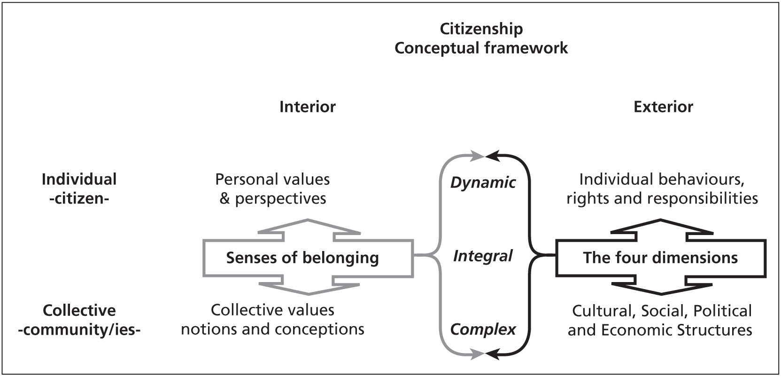
The on-going development across all four dimensions of citizenship and the changing and multiple senses of belonging of Europeans are an expression of the dynamism, integrity, and complexity marking the current understanding of European Citizenship.
Thinking about citizenship today involves exploring the bridges and interactions between different and traditionally isolated approaches. The connections and mutual influences of the different approaches offer the richest keys to understand the complex and permanently changing concept of European citizenship.

Defining European Citizenship
Catch-22 | en.wikipedia.org/wiki/catch-22
European Citizenship attempts to capture a concept for which there is, as of yet, no better substitute. Just like citizenship itself, and almost like a Catch-22, European Citizenship defies being defined.

At the Hands On Conference, one group brought forward a definition, which—in being almost immediately criticised and discarded—shared the fate of so many others before it:
European Citizenship is a feeling of unity and belonging to the European Union in terms of knowledge, common values and rights to ensure peaceful coexistence through active participation.

Instantly, questions oscillated through the room: Why only the European Union? What about the other European countries? Are they not allowed to feel European? What about skills and competences? Where are the duties to complement the rights? Where is our multiculturality?

For now, it seems, we are probably confined to attempts of describing European Citizenship much rather than defining it. One such description has been put forward together with the Wheel of European Citizenship introduced below:
European Citizenship is a notion based on a shared belief in common principles and values subsumed under the notions of human rights, democracy and peace and, in a nutshell, is:

disassociated from belonging to a particular territory and connected with voluntarily chosen belongings to value-based communities of practice; a complementary rather than an exclusive identity; an ongoing process of re-negotiating power structures and relations (rights and responsibilities, theories and practices) among and between citizens themselves as well as citizens and institutions; an active role of citizens in their different communities across social, cultural, economic and political domains; locally rooted practice and collective work in progress.

The conference has shown how much all programme stakeholders struggle with the dynamic complexity of the notion and how strongly a clear definition is desired.
But there were other voices, too, asking whether a clear definition was—as desired as it may be—desirable and whether it would be possible at all to define such a slippery notion.

Educational Framework
Trainings on European Citizenship | www.salto-youth.net/europeancitizenship
The European Union and the Council of Europe support and organise a great variety of different educational activities on European Citizenship through instruments like the «Youth in Action Programme» or the «European Youth Foundation».
Projects range from introductory workshops to longer training courses; some of these activities are run by the institutions or their partnership directly, but the majority is implemented by partners and in particular non-governmental organisations. All of these activities are developed and put into practice with the vision for participants

«to develop a sense of time, space and place in contemporary Europe, the skills and motivation required to be active agents for democratic change while participating in the building of Europe and to provide the knowledge to make informed and future-minded choices within this context.»

Among the entire variety of courses, workshops, training days and courses all over Europe, the Salto Centre Training & Cooperation organises a series of trainings with a particular role as the central training course on «European Citizenship» by the network of national agencies of the «Youth in Action» programme. The network training puts into practice «Priority 1) – European Citizenship» of the Youth in Action Programme by aiming to

«support the professional development of youth workers and youth leaders by extending their critical understanding of European Citizenship, by exploring and experiencing the potential of the notion of European Citizenship, and by enabling them to recognise and integrate European Citizenship in their youth work.»

The network trainings are complemented by a wide range of further activities around European Citizenship, all of which contribute to answering the overarching question:

How can European Citizenship be approached in youth work? How can the Youth in Action Programme support youth work on European Citizenship?

European Training Calendar | www.salto-youth.net/find-a-training

Project Characteristics
The Wheel of European Citizenship – www.european-citizenship.org/2008/04/project-characteristics
European Citizenship is a term cherished by many and is being used in a wide range of contexts – to an extent that it probably qualifies as one of the discursive impossibilities of our times. And yet, much is done with, for and about European Citizenship.
Youth work is only one part of the larger picture—arguably an important one—and so is community work in non-formal education contexts. At European level, they come together in a number of settings – some of which institutionalised, others provided by civil society.
The Youth in Action Programme certainly is a key scheme in support of non-formal youth work on European Citizenship. Under its Priority 1 «European Citizenship» it brings together four—complementary—spheres in a specific constellation, namely youth work, non-formal education, intercultural learning, and European citizenship.
Embedded in the development of a curriculum for the network trainings introduced above, a set of basic characteristics of non-formal youth work projects on European Citizenship was developed for projects combining all four areas in their approach.
Based on, informed by and aiming for human rights, democracy and peace, non-formal youth work projects on European Citizenship should therefore combine:

European Intercultural Nonformal Youth
Citizenship with Learning Education Work

and in doing so, should:

1. be based on an open and dynamic understanding of European Citizenship and hence:
encourage and work with European communities of practice (be collective),
take up and take in diverse forms of active, democratic citizenship (be inclusive),
address values and beliefs as well as attitudes, knowledge and skills (be holistic),
include several dimensions of identity, belonging, and practice (be multi-dimensional)
locate interactions with larger frameworks of power (be power-conscious).

2. respect the principles of non-formal education and learning and therefore:
make results available, have a planned follow-up, valorise outcome (be accessible),
be based on participants' needs and co-constructed with them (be learner-centred),
be assessed in a collective process without judgement on individuals (be evaluated),
be based on the intrinsic motivation and self-responsibility of learners (be voluntary),
be based on collective and individual experiences of people (be experiential).

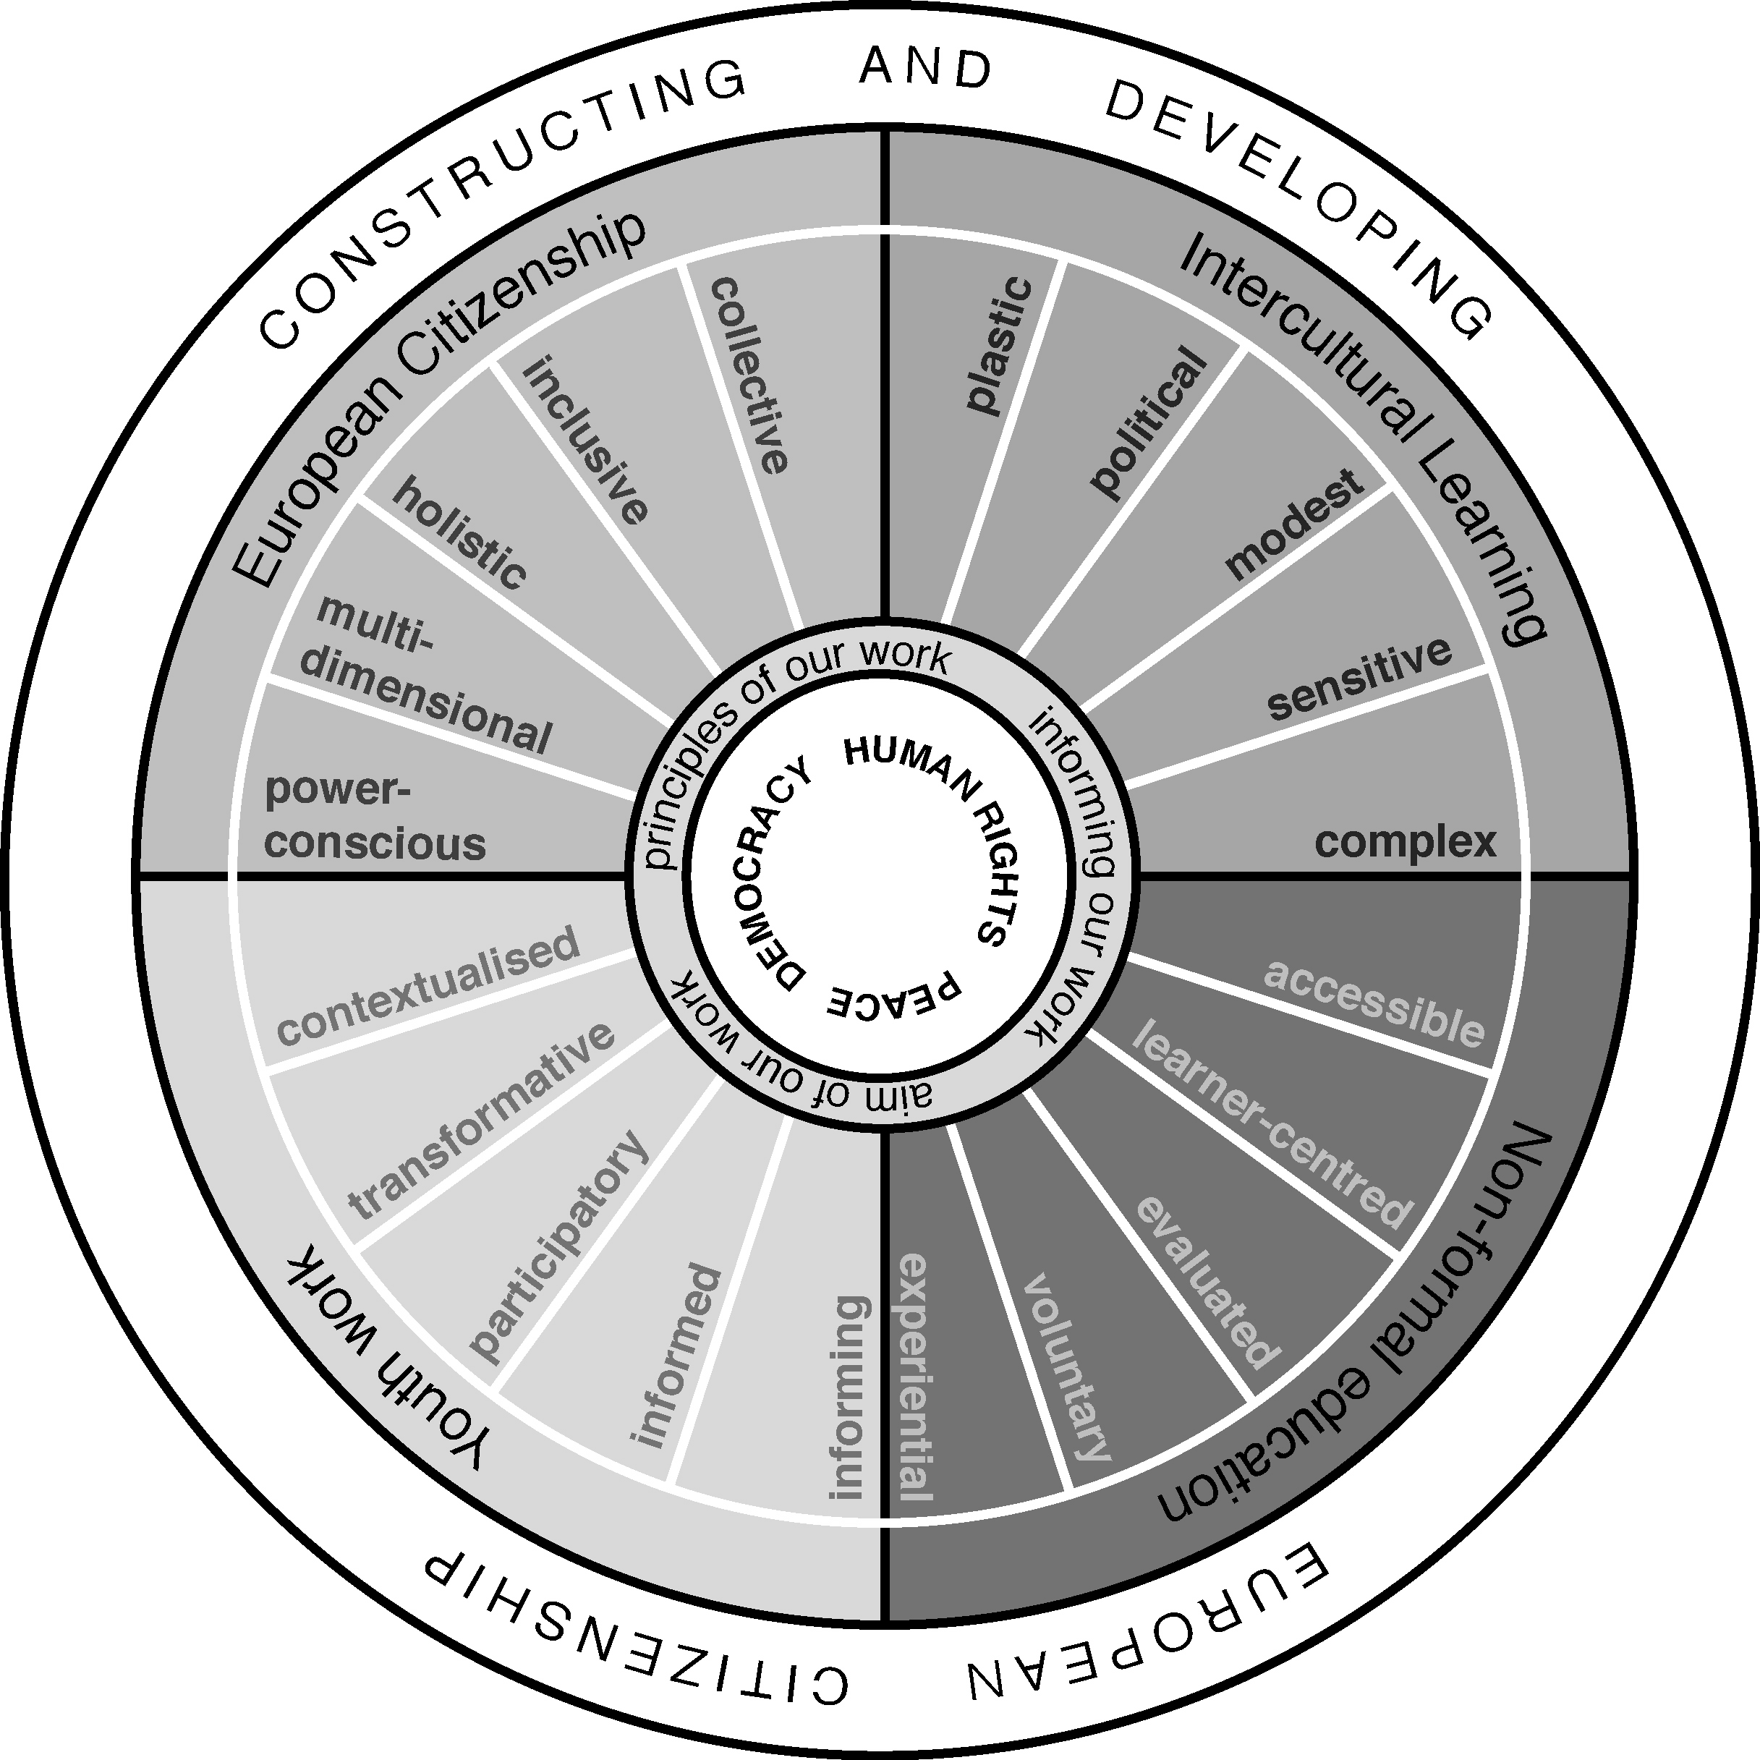
3. reflect experiences of youth and community work and consequently:
be rooted in local, authentic situations, communities and needs (be contextualised),
progressively involve and empower young people (be participatory),
improve real-life situations of people, leading to action and change (be transformative),
relate to current discourses & research on issues related to the project (be informed),
provide information, feedback & proposals to policy, practice, research (be informing).

4. respond to current demands towards intercultural learning and as a result:
explore cultural realities and conceptual understandings of culture (be plastic),
recognise contesting discourses on culture and their political relevance (be political),
be aware of the limits and dependencies of culture as a concept (be modest),
be aware of the contexts and purposes of intercultural dialogues (be sensitive),
explore identity and connectivity beyond culture, individuals and Europe (be complex).

Tips & Hints
In preparation of the conference, programme stakeholders were invited to share their experiences around European Citizenship – an invitation that was gladly accepted by many and has led to this summarised and consolidated list of tips and hints:

- “Instead of imposing one understanding of European Citizenship, one should only provide the necessary environment and opportunities for young people to let them share and express their point of views on the concept. Start from their experience!”
- “A greater variety—with partners from countries which appear to be on opposite extremes in terms of political, social and educational views—would be enriching.”
- “Constructing European Citizenship is a process, and therefore projects shouldn’t just be a punctual experience without follow-up or consequences.”
- “Without a political dimension European Citizenship is not complete – but only addressing the political dimension is not good enough either.”
- “The political dimension of European Citizenship often has a face through European politics, but giving a tangible dimension to the other aspects is equally important.”
- “Resist the temptation to define goals that are too ambitious – an embracing concept like European Citizenship has that risk attached.”
- “European Citizenship is not only a concept, it is already a reality, though a very different one. Let participants experience and appreciate that reality, that diversity.”
- “The power of the conceptual framework underpinning European Citizenship can only unfold when a narrowing definition is not imposed.”
- “It is even more crucial than usual to walk the talk – activities about European Citizenship must be learner-centred and participatory as much as possible.”
- “European Citizenship has the power to show disadvantaged young people how much they can contribute through their participation, and how much that is appreciated.”
- “It is essential to ensure that no person or group feels less important than the other – because of the unequal distribution of rights in Europe this can happen easily.”

Reading Further
There are a couple of publications to turn to in search for more information, including:

Council of Europe (2009): European citizenship - In the process of construction
Challenges for citizenship, citizenship education and democratic practice in Europe
http://youth-partnership.coe.int/youth-partnership/research/Seminars/Citizenship_2006.html

Handbook (2008): What could European Citizenship in youth work look like?
http://youth-partnership.coe.int/youth-partnership/training/EC_followup_seminar.html

Training Kit 7 (2003): Under Construction: Citizenship, Youth and Europe
http://youth-partnership.coe.int/youth-partnership/publications/T-kits/7/Tkit_7_EN

Discussing Further
Two online platforms have recently been established to facilitate e-conversations:

www.european-citizenship.org
This website on «European Citizenship» is a joint initiative of the Partnership on Youth, Salto, Connect Youth and Frankly Speaking. Through this portal, the institutions and their partners would like to offer a central point of information, exchange, feedback, and reflection to former and future participants of trainings on European Citizenship as well as social workers, NGO activists, researchers, policy makers and citizens.
http://www.european-citizenship.org

community.european-citizenship.org
This is the social networking community of former and future participants and trainers of European Citizenship training courses, which is wide open and warmly invites other programme stakeholders to join the reflection and exchange if they wish to do so.
http://community.european-citizenship.org

