"Using Media as a tool for Gender equality promotion"
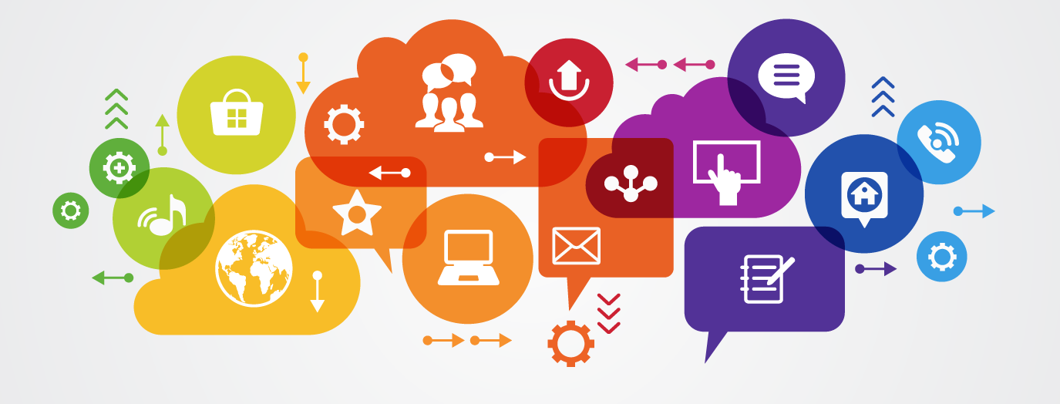

Call for a junior trainer

“Using Media as a tool for Gender equality promotion”
14-21 October 2017 Vienna, Austria

Please fullfill in English.
Full Name |  | Sex | Male Female
Working Address |  | Nationality
Home Address |  | Telephone
Date of Birth |  | E-mail

Are you a Free-Lance Trainer? (If NO, please give some details about your current job(s) apart from delivering trainings):
YES NO

Please list your experiences you consider relevant to the topic of the training:
List international training events/connected with the topic of the training, where you have been part of the team designing and implementing the event (indicate: organizer, title of event, your role):
Describe your experience and practice within YOUTH sector (running trainings for youth workers, for NGO working with young people):
Mention your most relevant (in terms of learning) educational experiences (training courses, youth activities etc.) related to the topic of the training:
Rate your level of English (Fluent-Good-Average-Poor):
How would you work out the theme of the training? What would you suggest in a programme content of this TC (considering the training to be as much practical as possible)? Describe in few sentences:
Describe your motivation to be part of the team of the training:
YES NO
Please indicate if you are available on the potential date of the training:
14-21 October 2017
YES NO
Specify any special needs (food, mobility, medical condition, etc):
Please give here the contact for recommendation:
1:
2:

From which source have you received this call:

Please send this to the project coordinator Erik Ghazaryan (erikghazaryan@apy.am) till September 15 , 2017 23:59 CET

We wish you success with the selection process!!!

