Bridges for Recognition
Report of Workshops on Hot Issues:

Workshop on Recognition and Responsibilities of Non-Formal Youth Trainers

A. Introduction

The group was composed of trainers, researchers, international institution representatives, national agencies representatives, the European Youth Forum and national governmental representatives. Over two sessions we continued the work on an idea which was born in the trainers' stakeholder workshop: to design an open, transparent and inclusive process to create a functional analysis / occupational profile of non-formal youth trainers. This would be something of a first at European level and a chance also for the youth field to demonstrate its pioneering role to other fields.

Bearing in mind the discussions around - and struggle for - further recognition of non-formal education, the group considered that it was important for trainers in youth work to facilitate proactively an increase in the transparency, credibility and accountability of their work.

B. Terminology

The term ‘non-formal youth trainer’ in this document refers to trainers involved in the non-formal training of youth workers and youth leaders with an international dimension. This can happen on local, regional, national or international level and in voluntary or paid capacity, as a free-lancer or employed trainer, full-time or part-time.

C. Aims of the process and product

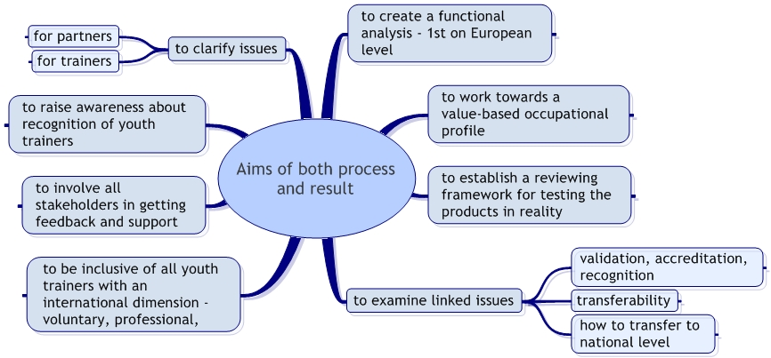

D. The process

- Creation of a steering group

This steering group will (if accepted, under the umbrella of the training partnership between the European Commission and the Council of Europe) take responsibility for the implementation of the following steps, the communication with partners and other stake-holders, the feedback to the funders – in short, the intellectual and organisational implementation of the project. For the sake of efficacy, we would suggest that it should be limited to around ten members, chosen to represent the stakeholder field, with an emphasis on those with a training background.

Time frame: April-May 2005

- An overview of contemporary developments

The aim of this step is to compile a contemporary historiography, outlining the mile stones of the development of the non-formal education sector and describing the emergence of the occupation of non-formal youth trainers. Fifteen years ago, there were few if any trainers in the European youth field; nowadays there are hundreds – this short paper will seek to explain and illustrate what has happened. It will also contain an ethnography of some key actors engaged in the process.

Time frame: May-June 2005
Instruments: Limited short-term study

- Needs analysis meeting

The needs analysis meeting will attempt to identify and document the needs of different stakeholders and interest-groups in relation to the training of youth workers and youth leaders with an international dimension. While focusing on trainers, the seminar will include a 360° feedback, involving experts from different stakeholders and focus groups (such as National Agencies, Employers, Youth Organisations etc.) in an interactive process. Its preparation, implementation and follow-up will be complemented by virtual modes of exchange, input and feedback.

Time frame: January 2006 [1st anniversary of Bridges for Recognition]
Instruments: Seminar
4 working days, 30 participants
1 preparatory and 1 evaluation meeting
5 team members
1 general rapporteur

- Creation of a functional analysis / occupational profile

Facilitated by the steering group and backed by external expertise (e.g. on designing occupational profiles; or on non-formal youth worker and youth leader training with an international dimension), the process will lead to the drafting of a functional analysis of non-formal youth trainers. The functional analysis will have to be tested against reality and reviewed accordingly.

Time frame: February 2006 – August 2006 (design pioneer version)
September 2006 – January 2007 (test this version)

January 2007 [2nd anniversary of Bridges for Recognition] –
review the functional analysis / occupational profile,
and publish it more broadly

January 2008 [3rd anniversary of Bridges for Recognition] –
evaluate the functional analysis / occupational profile,
and publish the final version; design next steps

Instruments: to be suggested by steering group

Report by Mark Taylor and Andreas Karsten

