THE COUNCIL OF EUROPE
EUROPEAN PORTFOLIO
FOR YOUTH LEADERS AND YOUTH WORKERS

AN INTRODUCTION

THE BRIDGES FOR RECOGNITION CONFERENCE
LEUVEN, 21.01.05

Introduction

At the recent meeting of the group of specialists (10-11.1.05) we reached agreement on:

The basic concept of the Portfolio, including:

- the proposed method of self-assessment enriched through external feedback
- most of the content and wording of the functional analysis
- most of the content of the competences tables and the proposed levels of assessment
- the suggested ways to demonstrate evidence of experience
- the possible contents of a glossary

Follow-up after the meeting, including:

- informing and consulting others about the Portfolio (this conference is the first to hear the details of our work)
- how and where to test the Portfolio
- a draft timetable for completing the first “official version” of the Portfolio

One very important dimension is now starting to be tackled:
- what kind of mechanism should be established to validate portfolios adapted by other organisations

Please note that the full text of the draft Test Version of the Portfolio will be available soon on the you@etv virtual platform:
http://communities.trainingvillage.gr/youth
your feedback will be most welcome!

Mark Taylor, 20.01.05
1 Why and what is this Portfolio?

Looking at developments across Europe, we witnessed a need from youth workers and youth leaders in non-formal education settings to have an instrument which would help them in assessing their competences and describing them to others.

Looking more specifically at the aims of the Portfolio, we saw:

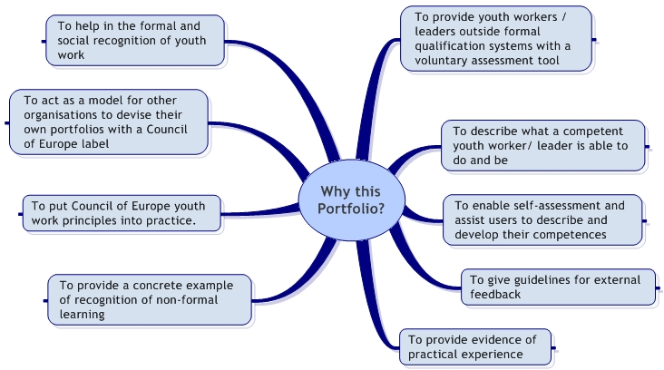

The contents of the Portfolio can be summarised as follows:

- 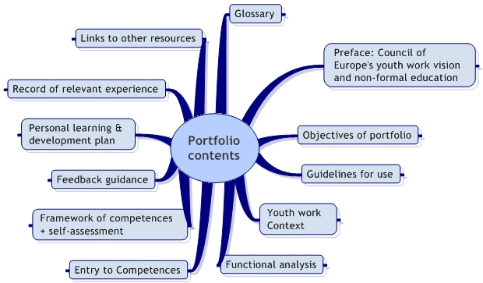

3 Functional analysis – what is a youth leader / youth worker?

When you think of yourself as a youth worker or youth leader, what is it that you do? What functions do you fulfil? In order to describe the competences necessary to be a youth worker/leader, one of the most important elements we found when putting together this Portfolio was to build upon a functional analysis of the youth worker/leader. Another way to look at it would be to say that we are trying to describe the DNA of a youth worker/leader, whose work is based on the values of human rights and democracy. Each function should be carried out within international contexts.

3.1 Function: To empower young people
The youth worker/leader is able to
1 empower young people through developing collective action and learning;
2 involve young people in planning, delivery and evaluation of activities;
3 enable young people to work towards their goals;
4 develop the confidence, knowledge, skills and understanding of young people;
5 get in touch with young people on an emotional level;
6 and widen their awareness of the concepts of power and change.

3.2 Function: To develop relevant learning opportunities
The youth worker/leader is able to
1 target individuals and groups;
2 provide young people with appropriate guidance and feedback;
3 take advantage of spontaneous learning and development opportunities in everyday situations;
4 identify any special learning needs;
5 and use a range of educational methods and techniques.

3.3 Function: To accompany young people in their intercultural learning process
The youth worker/leader is able to
1 facilitate young people’s recognition of their cultural background, values and behaviour;
2 promote active tolerance and interaction with people from other cultures at home and abroad;
3 work with conflict towards peaceful solutions;
4 assist young people to define their place in a changing world.

3.4 Function: To use evaluative practice to assess and implement appropriate changes
The youth worker/leader is able to
1 plan and apply a range of participative methods of evaluation;
2 use information technology;
3 demonstrate skills in report writing and presentation for a variety of audiences;
4 and research and use findings to influence practice.

3.5 Function: To contribute to organisational and youth policy development
The youth worker/leader is able to
1 find resources and manage them;
2 manage others and work effectively in teams;
3 work for change and development within organisations
4 cooperate with others to influence youth policy

Function: To accompany young people in their intercultural learning process

++++++++++++++ Competence ++++++++++++++ | ++++++++++++ Aid to reflection ++++++++++++ | ○ | ◉ | ▪ |  | 
1 I have explored and know my own cultural background and values | Knowing your own roots and examining your own values helps in  getting to know others and makes you aware of your own prejudice  and stereotypes
2 I can cope with ambiguous situations | When things don’t turn out the way you think they should, or your  Ideas are not immediately accepted - what do you do?
3 I reflect about my own intercultural learning process | What happens when you are in contact with people from other  cultures? What do you learn from the experience?
4 I can help young people to experience intercultural learning | There is a lot of academic research about intercultural issues, but how  do you translate them into young people’s realities?
5 I can speak a foreign language | Being able to communicate in another language gives you a different  perspective to your own
6 I can organise activities involving young people from different cultures | What aspects do you need to consider which are different from working  with a mono-cultural group? What is the difference between “intercultural”  and “international”?
7 I can take appropriate action in conflict situations | Can you analyse conflicts? Can you think of alternative actions to propose?
8 I can name the European dimensions in my work | European societies are increasingly linked – where does your work fit in?  Remember: Europe is not a planet!
9 I know about the situation of young people in other countries | What trends are there in the lives of young people across the world?  How do the life chances of your young people compare with others?

KEY | ○  Applies to me | ◉  More or less applies to me | ▪  Does not really apply to me |   Does not apply to me |   This competence has no relevance  in my situation

