How to use CIGNA in EVS project?
If you have some troubles with your health here is the guide based on my experience how to find a doctor, to pay for you meeting with the doctor and for the medicines, how to make a request for the claim for reimbursement and how to find some useful information on the webpage of Cigna.
You have to know that EVS is working with Cigna of Belgium, not of Spain. It’s not a big problem, but it may confuse you if you will come to a clinic for the first time.
Okay! Firstly we have to enter to the account here using your personal reference number and password: https://www.cignahealthbenefits.com/en/plan-members
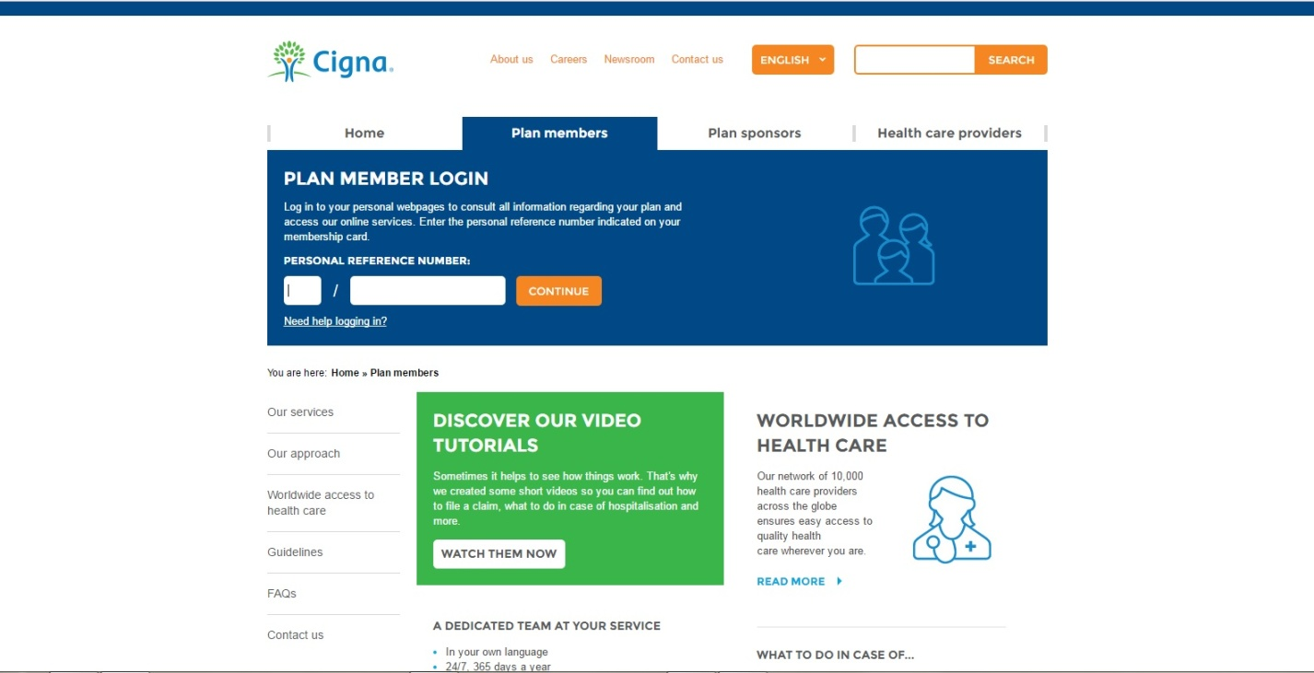
Perfect! Like this looks the home page where you can find almost all useful information:
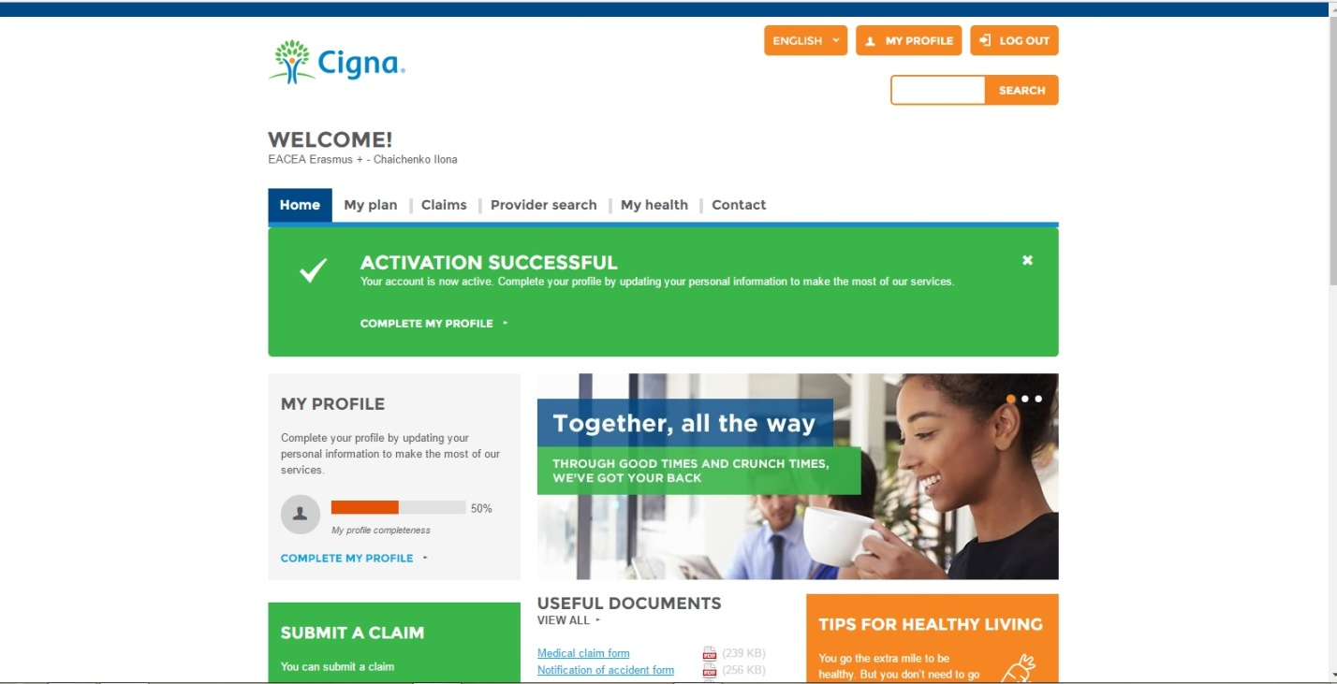

Now go to “My plan” to download your Membership card and other useful documents.
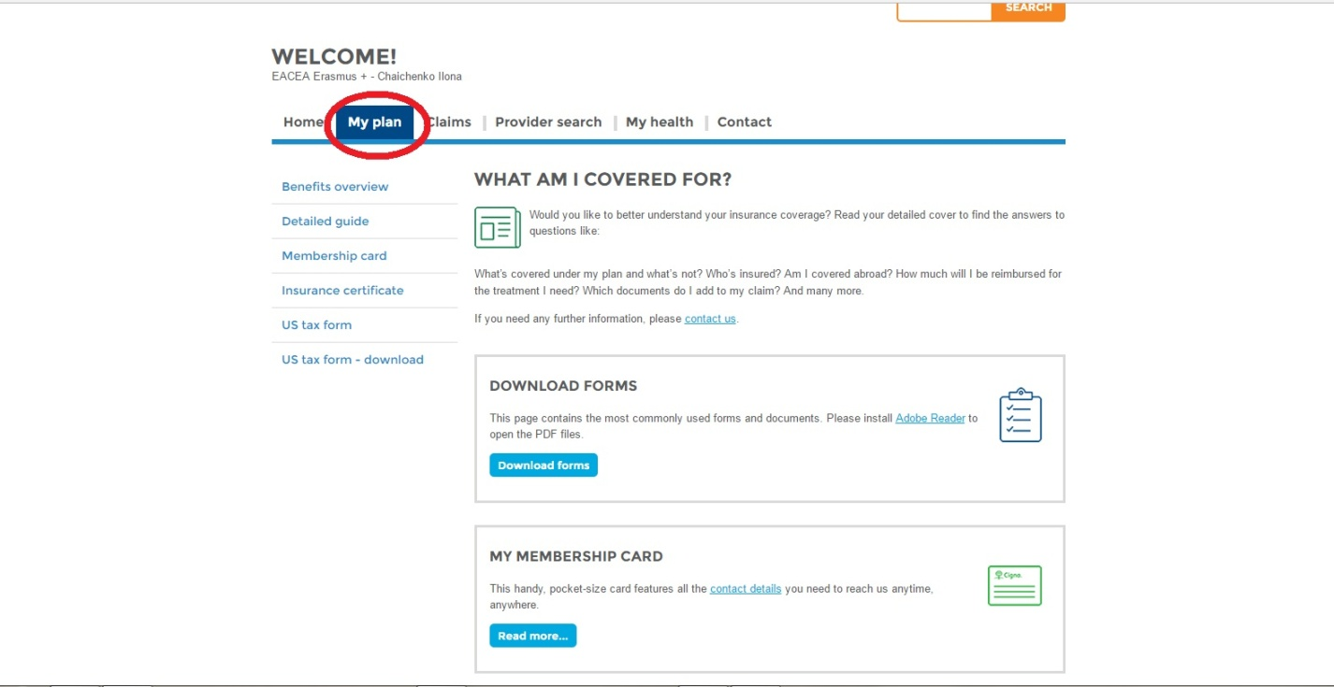
Read it properly. Membership card is an important document. It’s not really powerful document, it does not let you go for free in any clinic but it’s your ID in CIGNA in all clinics. It is better to print it and to laminate (as I did). Like this you can always have it in your wallet and show it when it is necessary.
So, what to do if you have some problems with your health during your EVS?
First, go to this webpage, enter your account and go to “Provider search”. Fill in all mandatory fields and now you can see which clinics are close to your region or city (in my case there is just one – in Seville). So we found the clinic where you have to go.
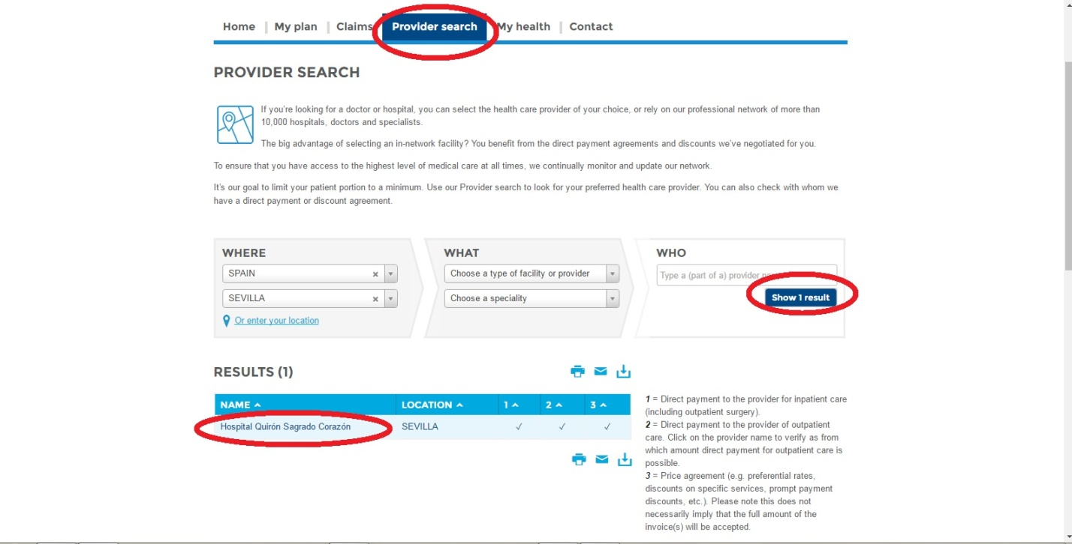

Click on the clinic for more information and here we can see all about it: 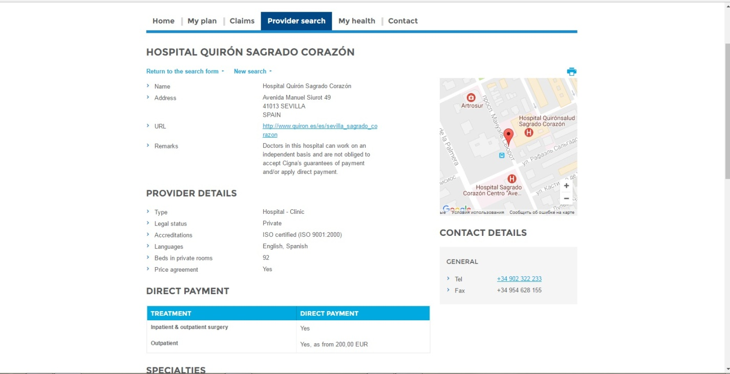
Now you have to call this clinic to make an appointment with the doctor. It is better to make this appointment for the next week, not earlier.
So why do you have to make this appointment beforehand? You have two options to pay for your appointment:

- you’re paying by yourself and then you send a claim for reimbursement to Cigna, and you’ll have your money approximately in one or two weeks. (In this case you don’t need to make an appointment beforehand)
- or if you don’t have so much money you send a request to Cigna for the guaranty of direct payment.

What is the guaranty of direct payment? It is a document from Cigna which allows you to come on the specific day and to have a treatment like as you would pay for it. The difference between self-paying and guaranty of payment is that you don’t pay when you have a guaranty. Cigna directly pays for your treatment to the clinic.

How to make this guaranty? Also, enter to the Cigna webpage with your account; find “Contact” and “Request a Guaranty of Payment”:
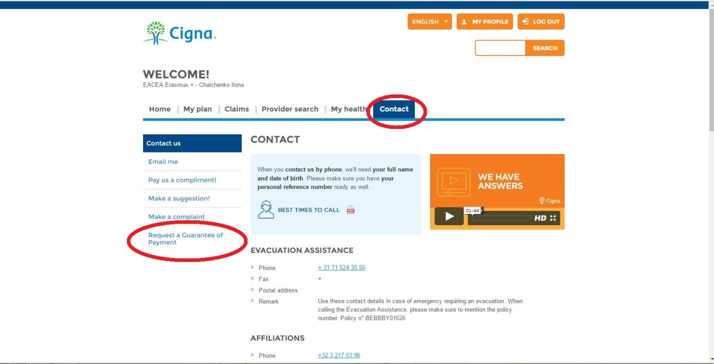

So you clicked to “Request a Guaranty of Payment” and you see this:
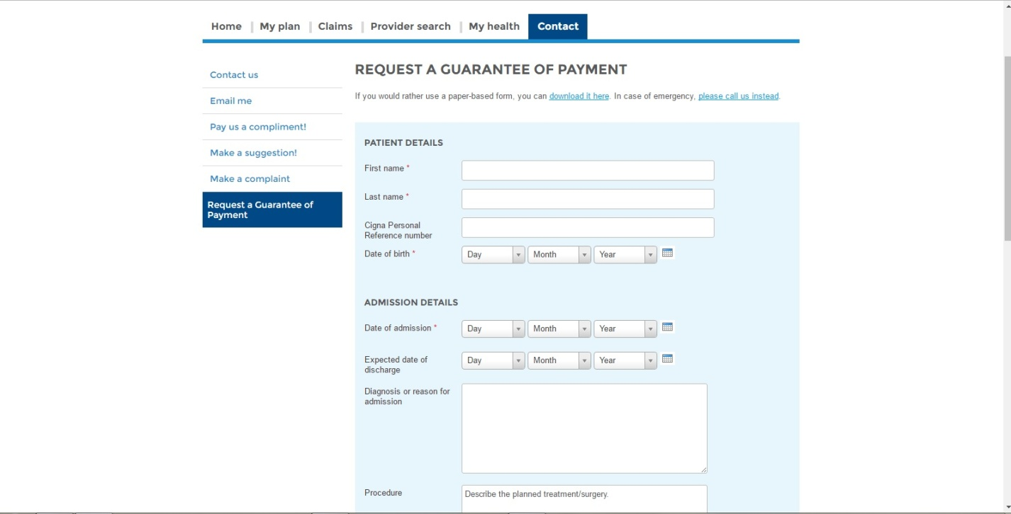
You fill in all these fields, and now – the most important. You can receive guaranty of payment JUST if the cost of the treatment is more than 200 euros. Otherwise you have to pay it yourself and then Cigna refund your expenses. So make sure how much will cost your meeting with the doctor (mine was more 200 euros).
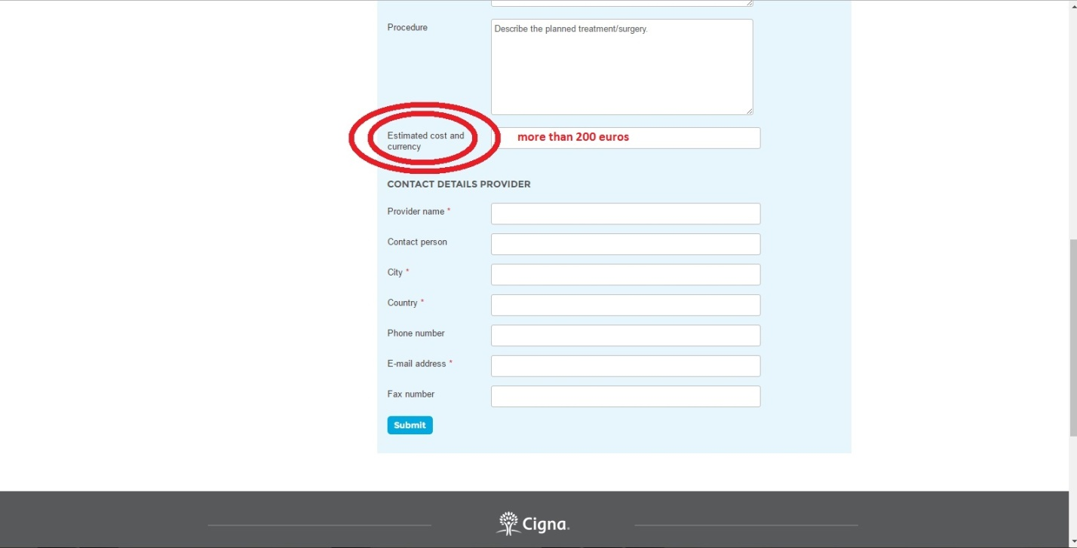
If you will put in field with the cost “I don’t know how much the treatment will cost” or a cost which is less than 200 euros – you’ll receive a mail with a reject of guaranty.
If everything is good and correct, you’ll receive your guaranty in 3-5 days (that’s why I told you to make an appointment with a doctor not earlier that one week before) and you will have a meeting with your doctor.
But it is not the end. When you are done with the doctor – you have a medical prescription. So in this case there is just one option – you have to buy it, there is no guaranties for buying medicine. If the price is too high you can ask for your organization to cover it, and then they’ll receive the reimbursement. So imagine that we have already bought all medicine. What to do? And again we go to the Cigna webpage and now we are looking for “Claims” and then “Claim online” (if you want you can submit your claim by post):
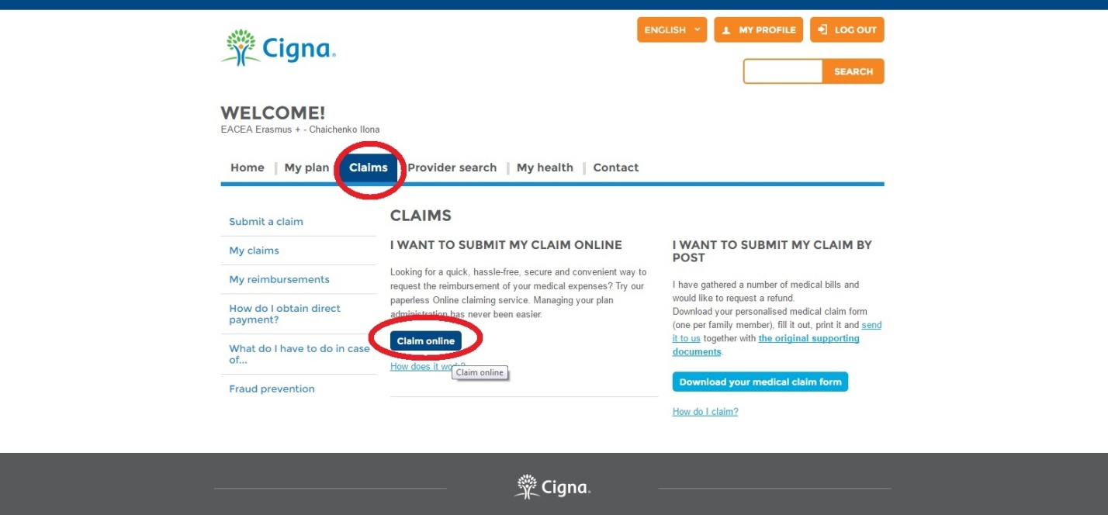
Fill in all mandatory fields and the payment method. If you still don’t have your card information in your profile – fill it out:
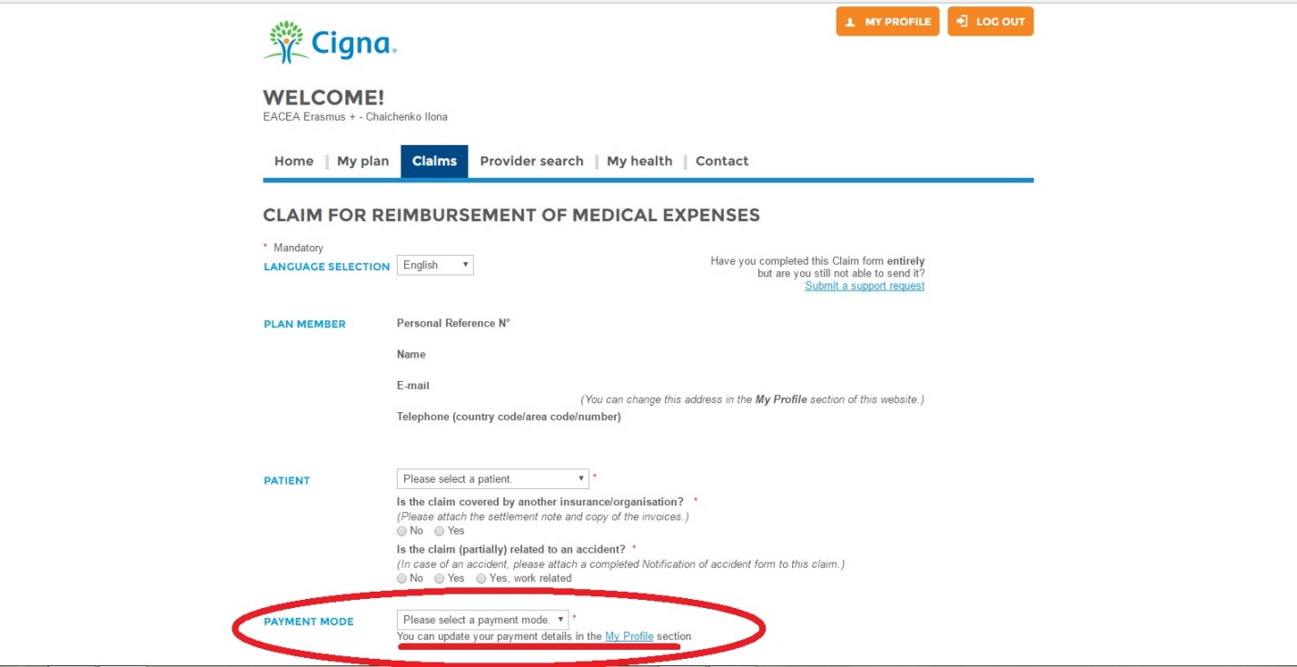
And one more important moment – make sure that your card is able to receive euros. Because I had to open new Internet-card in my bank to receive my reimbursement.
And finish your claim – put the prices of all medicines, upload scans of the bills, scans of diagnosis, medical prescription and everything which you consider as relevant information:
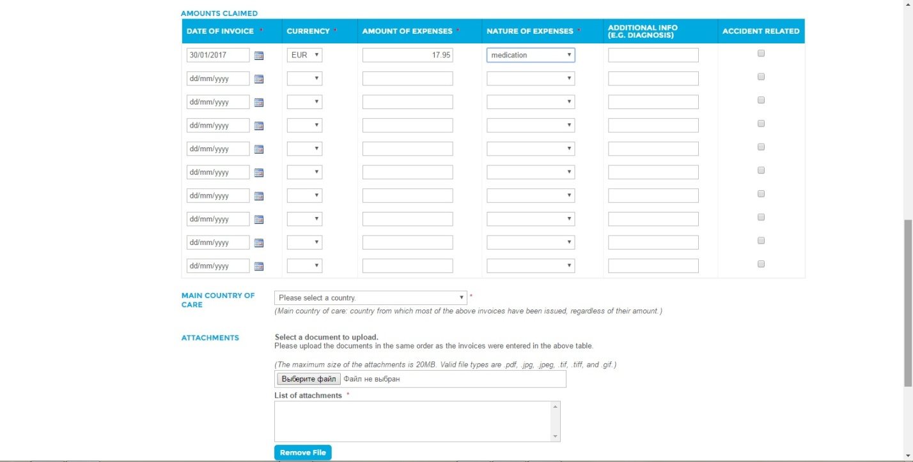

And now you have to wait until your claim is processed.
Good luck!

