Inclusion Staff Training

Blankenberge, Belgium

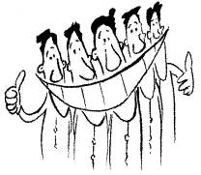

June 18-22, 2007

Final Report

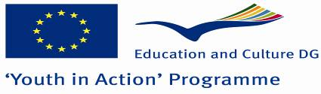

TABLE OF CONTENTS

INTRODUCTION 3

CONTEXT OF THE TRAINING 4

AIMS & OBJECTIVES 5

PROGRAMME 6

Towards a European Understanding of Inclusion 6

The Inclusion Strategy of the European Commission 9

Inclusion Snapshots – The Current State of Inclusion in National Agencies 10

Using a Strategic Approach to Maximise Inclusion 11
Analysis Phase 11
Planning phase 12
Implementation phase 13
Evaluation phase 13

Networking and partnerships between National Agencies 14

CONCLUSION 15

EVALUATION 15

ANNEXES 19
Annex 1 : Inclusion Snapshots – The Current State of Inclusion in National Agencies 19
Annex 2 : Carrying Out an Effective Needs Analysis 37
Annex 3 : Potential Stakeholders 40
Annex 4 : Tasks of an Inclusion Officer 42
Annex 5 : Forms, Indicators and Methods for Evaluating Inclusion 45
Annex 6 : Final Programme 49
Annex 7 : List of participants 50

INTRODUCTION

The Inclusion Staff Training, organised by the SALTO Inclusion Resource Centre from June 18-22 2007 in Blankenberge, Belgium, was the first event in the new Youth in Action programme to bring together National Agency staff from across Europe in order to define a common European-level approach to inclusion issues.

Although inclusion was a priority theme throughout the duration of the YOUTH programme and despite the fact that many successful inclusion projects across Europe were run during that time, there are still many unresolved issues surrounding inclusion topics. The launch of the new Youth in Action programme provided a perfect opportunity to try to address some of these.

This report provides a summary of the discussions and outcomes of the Inclusion Staff Training event. The training devoted considerable time to topics related to the development of long-term inclusion strategies. An overview of these sessions is provided here but the strategy-related sessions will be presented in more depth in a new booklet on “Developing an Inclusion Strategy”, the next in SALTO Inclusion’s “Inclusion for All” series (scheduled to be published in autumn 2007).

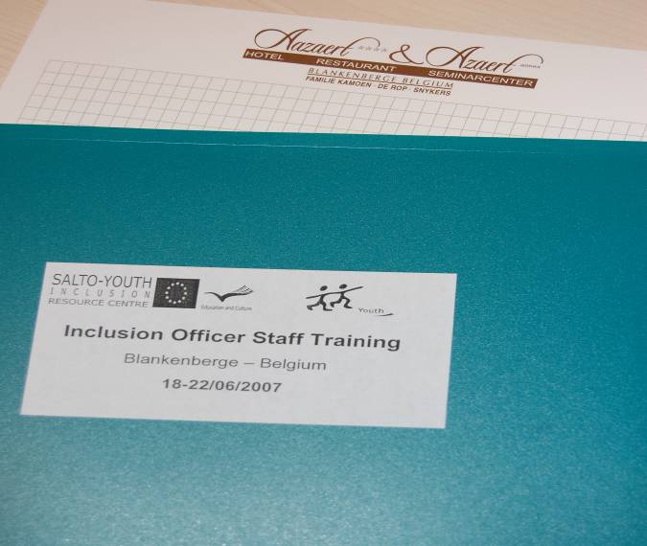

CONTEXT OF THE TRAINING

The Inclusion Staff Training event was the result of a long evolution which began when Inclusion was named as a priority within the YOUTH programme (2000-2006). From the beginning there were many questions surrounding the inclusion topic: what exactly is the meaning of “inclusion”? Why was inclusion chosen as a priority? How does such a theme fit within a European mobility programme?

The word “inclusion” itself is not easy to understand. Because of this, there were many interpretations among National Agencies and project promoters across Europe. Many inclusion-themed events were organised throughout the YOUTH programme to help NAs and their organisations to gain a better understanding of what inclusion could be. This was a help, but despite a wide range of meetings, training courses and seminars there was still little or no common European-level understanding of inclusion (what it should be and what it should not).

As the YOUTH Programme went on, National Agencies were given the task of appointing an “inclusion officer” to take on the responsibility of inclusion-related tasks. While this served to solve some problems it also created new ones. Some NAs named an inclusion officer very quickly while at the conclusion of the YOUTH programme others still had none. The difficulties were further compounded by the fact that there was no clear “job description” available for inclusion officers. As a result, many were left to fill in the blanks themselves and define their own tasks as best they could.

In November 2005 the French National Agency INJEP hosted the “Partnership 4 Inclusion seminar. This event was the first to try to make an inventory of what had been happening in terms of YOUTH programme inclusion activities across Europe. During the seminar it became clear that while much was expected of inclusion officers, few were able to meet those expectations, largely due to the lack of clarity surrounding their tasks. One of the outcomes of Partnership 4 Inclusion was the recommendation that a training event be developed specifically for inclusion officers which would respond to some of the questions which had gone unanswered for several years.
Due to other priorities, the idea for an inclusion officer training was put on hold until discussions during the SALTO Inclusion Forum (autumn 2006) raised the need once again. If NAs were to take their inclusion work forward in the new programme, and if inclusion officers were to have more than just a symbolic value, it was vital to take time to properly define this function and to strive for as much common understanding and cohesion on European level as possible.

In 2007 the new Youth in Action programme was launched with inclusion as a reinforced top priority, supported by a new ambitious Inclusion Strategy. Much has been learned about inclusion thanks to the experience gained through the YOUTH programme but some of this knowledge may be lost due to staff turnover within the NAs (veteran staff has left and many newcomers have joined). It is also clear that the Youth in Action programme will place new obligations on all NA staff and particularly on inclusion officers. All of this poses new challenges but also provides an opportunity to “go back to the beginning” and revisit inclusion from a new perspective.

AIMS & OBJECTIVES

The Inclusion Staff Training was open not just to designated inclusion officers but to project officers and/or other staff members in the National Agencies who are or will be responsible for inclusion topics. The training aimed to:
- define more clearly the tasks and functions of inclusion officers
- explore and comprehend the priority of inclusion in the new Youth in Action programme, and the new Inclusion Strategy
- establish common approaches to inclusion topics (in all Actions) on European level
- practice and stimulate strategic thinking, particularly in relation to inclusion
- gather input from NAs on their working reality concerning their inclusion work
- exchange experience
- share good practices & failures and learn from it
- stimulate co-operation between National Agencies in their inclusion work
Specific programme elements of the Inclusion Staff Training included:

- understanding inclusion
- gaining an overview of priority target groups across Europe
- creating (new) synergies between NAs
- training on strategy thinking within an inclusion context
- planning future European-level co-operation

The limited length of the programme (3 working days) meant that the training could only deal with some of the outstanding inclusion-related questions but by the end of the training a foundation had already been laid for future events.



* code making – code breaking

PROGRAMME

Towards a European Understanding of Inclusion

“Inclusion” is a hazy concept. Before trying to define what is meant by inclusion it can be useful to first understand “exclusion”:

Social exclusion
What is “social exclusion”? In what ways are young people excluded from taking part or being part of so-called regular society? Social exclusion can take (but is by no means limited to) the following forms:

- Exclusion from employment
- Exclusion from education
- Exclusion from information
- Exclusion from entertainment and leisure
- Exclusion from health care
- Exclusion from mobility
- Exclusion from housing
- Exclusion from politics/political representation
- Exclusion from culture
- Exclusion from sport
- Exclusion from marriage/adoption
- Exclusion from social relationships
- Exclusion from integration
- Exclusion from responsibilities
- Etc.

There are many forms of potential social exclusion. If the list above is used as a basis, what pictures does it create of the type of young person who might face such forms of social exclusion? Who are “socially excluded young people”? Some examples include young people who:

- belong to a minority
- come from a migrant background
- are disabled
- are poor
- are early school leavers
- are living in remote areas
- lack social skills
- have no legal status
- suffer from illness (physical/mental)
- are illiterate
- have a criminal background
- have a different sexual orientation
- abuse drugs or alcohol
- display violent behaviour
- come from troubled families
- are single parents
- are carers (ie who are responsible for the care of another person)

This is again a very long list and includes just some of the profiles of young people who could be considered to face some type of social exclusion. When looking at these profiles it is easy to fall into the trap of determining which of the many boxes a young person might fit into to, but it should be kept in mind that an individual can belong to more than one category at a time. It is quite usual for an excluded young person to face many different problems all at once. It is also typical for one problem to lead to more problems… as a result an individual young person can suffer exclusion from many aspects of society at the same time.

Each of the profiles described above is unique. Young people of different profiles face different obstacles, therefore they have different needs and require different, often individualized, solutions.

Social inclusion
After getting to know the reasons for social exclusion it is easier to start to think about how to achieve social inclusion. Exclusion is sometimes caused by chance, sometimes by choice and is sometimes caused by society itself. Unfortunately there is no magic formula to achieve social inclusion. It is difficult to judge when an individual has successfully been “included”. For instance, is it accurate to say that an unemployed young person has been successfully included once they find a job? This is probably too simplistic. The truth is that social inclusion does not take the form of a finish line or the pot of gold at the end of the rainbow. This raises many difficulties because it means that social inclusion is not a clearly defined process. If inclusion is not finding work for the unemployed or providing housing for the homeless, then what exactly is it?

Inclusion is, in fact, a process which is made up of many steps and achieves many goals (large and small) along the way. Inclusion can take many forms and depends partially on the context of the work being done. As promoters of a programme, National Agencies must constantly ask themselves what form inclusion could/should take in their work and how this can be achieved by using Youth in Action as the method.

Inclusive vs. Inclusion
This question is not easily answered and in fact it can quickly lead to a second and far more complex question. Should National Agencies strive to be inclusive or strive for inclusion? What is the difference between these two concepts?

In the early days of the YOUTH programme much effort was put into making the programme more accessible for young people who would generally not get involved in European mobility activities. The European Commission felt a strong obligation to open up YOUTH activities not only to young people with a middle-class student profile but also to much wider range of other (possibly excluded) profiles as well. To a large degree the YOUTH programme was successful in making its activities inclusive (that is to say, more easily accessible, easier for all young people to participate in).

However, there were also less positive examples of projects which were ill-equipped to deal with the needs of some types of fewer-opportunity young people. There were even a few examples where individuals found themselves in a worse position after taking part in YOUTH activities than they had been in before. This is obviously not the intention nor the purpose of European mobility activities. Such examples raised a very valuable question: what is the use of a programme which is inclusive (helps the young people to access its activities) but does little or nothing to improve their position in society or, in other words, to help them move towards social inclusion?

Several years of debate and discussion among NAs and project promoters across Europe has led to the European Commission taking a new position in the “inclusive vs. inclusion” debate. While Youth in Action must obviously continue its efforts to be as inclusive of all profiles of young people as possible, there is also a clear need for the programme to recognise its own potential impact in contributing to the inclusion of young people. While Youth in Action should be seen as an inclusion tool and not as an inclusion solution in itself, this new programme places much more importance on stimulating and monitoring the development of the skills and competencies of young people and on improving the quality of the projects offered. Therefore Youth in Action can be seen as an inclusion method and the National Agency as a player in the wider inclusion network.

The Inclusion Strategy of the European Commission 

Peggy Genève, responsible for the inclusion priority within Youth in Action, presented the almost final version of the programme’s Inclusion Strategy.

The European Commission’s Inclusion Strategy had evolved throughout the period of the YOUTH programme. As with any strategy, evolution is ongoing. The Inclusion Strategy elaborated for the Youth in Action programme, as presented during this staff training, outlines how the EC intends to continue making Youth in Action as inclusive as possible, while at the same time going further than accessibility to projects by striving to ensure that its activities contribute to social inclusion in general.

Some of the most notable changes in this new strategy include:
- the introduction of the aim to stimulate the use of the Youth in Action programme as a tool to enhance the social inclusion, active citizenship and employability of young people with fewer opportunities and to contribute to social cohesion at large
- the clarification of specific target groups, as there are different interpretations and different national contexts all across Europe
- the introduction of the concept of “A Inclusion” and “B Inclusion” projects (highlighting the difference between an inclusive vs. an inclusion projects, but stressing that both are given equal importance within the programme);
- a new emphasis on the need for dissemination and exploitation of the results of inclusion-themed projects
- A first outline of how the European Commission intends to implement and monitor the Inclusion strategy for the duration of the Youth in Action programme

The Inclusion Strategy is an important part of the overall new strategic approach being promoted in the Youth in Action programme. National Agencies are now required to present a yearly workplan which should include a description of their plans in the inclusion priority area. In this sense the Inclusion Strategy should serve as a guideline for NAs but it should also encourage Agencies to adopt a more structured approach to their inclusion work. The implementation of the Strategy by the National Agencies will be monitored by the European Commission on an annual basis.

To date, there have been many positive reactions to the strategy. NAs have stated that the document is comprehensive and easy to read. Of course there are still questions about the strategy and its implementation including:

- How should NAs and project promoters cope with the vast differences in understanding and approaches to inclusion work across Europe? Different national contexts pose serious challenges to European-level co-operation.

- How should NAs cope with the different inclusion needs in the separate actions of the programme? It is difficult to come up with a standardized approach.

- How should the inclusiveness of Youth in Action be measured? How can the level of inclusion of a young person be measured and how much can be credited to a Youth in Action activity?

- The strategy as it is written now may not be easily understood by young people from fewer-opportunity backgrounds. Can the strategy be re-written or presented in another way so that the young people who are intended to benefit from it can more easily understand the aims it intends to achieve?

The Inclusion Strategy remains a work in progress and will hopefully soon be included as an annex to the Youth in Action Programme Guide.

Inclusion Snapshots – The Current State of Inclusion in National Agencies

After 6 years of the YOUTH programme and a half year of Youth in Action, a considerable amount of work has been done in National Agencies across Europe in the inclusion area. Unfortunately, Agency staff workers rarely have the time or opportunity to discuss their work or to share information on inclusion with their colleagues abroad. As a result, there is no clear overview of what different Agencies are currently doing, of which priority areas have been selected in different countries or of which inclusion approaches seem to be most effective.

To address this, National Agencies were asked to describe their inclusion situation at this time, to show a brief “snapshot” of their activities, future plans, and the most urgent questions they currently face. At this time, how well does the work of each NA fit in with the EC’s Inclusion Strategy? Which aspects of inclusion have proven easy? Which have proven more difficult?

An very useful overview of the answers given by NAs can be seen in Annex 1.

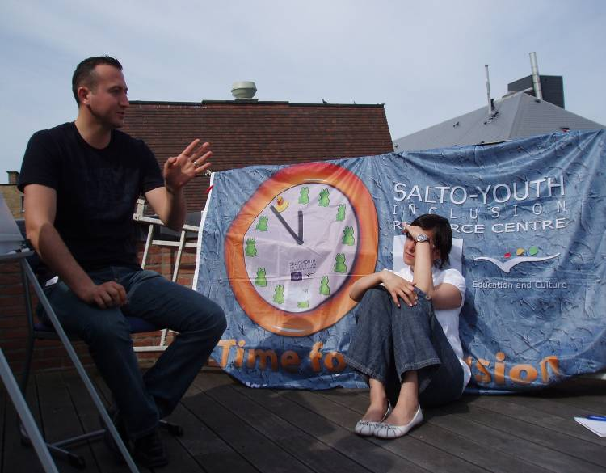

Using a Strategic Approach to Maximise Inclusion

In order to meet the expectations of the new Inclusion Strategy, National Agencies must find a way to continue making Youth in Action as inclusive (i.e. accessible) as possible but must also look for ways to ensure that individual activities make a clear contribution to the inclusion of a young person with fewer opportunities.

This is a considerable challenge and there is no standard method which will work in all situations. Because of this, National Agencies must now start to take a more structured approach to their inclusion work. It is necessary to more clearly define goals, priority groups and expected outcomes and to put systems into place for measuring and evaluating the effectiveness of YiA activities in terms of facilitating the inclusion process.

This implies that NAs need to take a more strategic approach to inclusion but in order to do this it is important to understand first how an effective strategy can be developed and how it should be implemented and ultimately evaluated.

The idea of developing a strategy can be quite intimidating but in fact a strategy is little more than a comprehensive working plan. In essence, a strategy development can be broken into four distinct phases:


- The analysis phase
- The planning phase
- The implementation phase
- The evaluation phase

Analysis Phase
Before making a concrete action plan it is important to first take stock of the current situation and to identify the concrete needs which the action plan will address. This calls for an analysis. In the private sector the analysis phase is often conducted on the basis of a market research or a “needs analysis”. Although a National Agency is quite different from a commercial company the concept of a “needs analysis” is still quite relevant and can be extremely helpful when considering inclusion issues. NAs should ask themselves: what are the real needs within our national context? Which problems or target groups require the most attention and support at this time? In order to answer these and other similar questions, it can be useful for NAs to first make an inventory of what has happened in their inclusion work in the past, to look at what is going on in inclusion today and to use that as the basis for determining where they wish to go in the future.

Participants were asked to work in small groups to share the methods their Agency has used in the past. How should a National Agency carry out an effective “needs analysis”?
- What concrete steps should be followed
- Who should be involved in internal level?
- Who should be involved on external level?

Inspiring results of the exercise can be seen in Annex 2.



Planning phase
The results of the analysis phase provide a solid basis of information. This information is vital for the second stage of strategy making, namely the planning phase. In the planning phase the information gathered earlier is used to make choices and decisions. It is in this phase that concrete goals are defined along with the concrete steps needed to reach them.

However, there is much more to the planning phase than just goal-setting. The most effective plan is a thorough plan. For National Agencies developing their own inclusion strategy, it is important to consider all the elements and players which might have an impact including resources, timeframes, limits, boundaries, etc. Finally, it is in the planning phase where decisions must be taken as to how the success of the strategy will be measured as well as how and when this will be done.

It should be kept in mind that it is not effective for an individual (e.g. an individual inclusion officer) to try to develop a plan on their own. It is important to involve those key players who will be directly impacted or involved in the implementation of the strategy. This means that in developing their plan NAs need to consult closely with their internal and external stakeholders.

external stakeholders


Internal stakeholders

To help make the theory of the planning phase more concrete, the seminar participants were asked to choose one specific target group of young people and to discuss and share ideas concrete plans for action with this group. Using the needs analysis as a base:
- Which internal stakeholders would need to be approached?
- Which external stakeholders would need to be approached?

A summary of the outcomes of the discussions can be seen in Annex 3.

Implementation phase
The analysis and planning phases require a considerable amount of effort but if the work has been done properly and thoroughly then the heaviest part of strategy development is complete. The next phase involves actively working towards the goals which have been defined. This is done in the implementation phase – the phase where the steps outlined previously in the planning phase are put into action.

Since most of the work of the analysis and planning phases has not yet begun in most NAs it is difficult to speak of implementing plans which have not yet been developed. However, one point which all NAs share in common at this time is the need for more clarity surrounding the tasks of inclusion officers. The task of implementing the national-level inclusion strategy in most NAs will likely be the job of the designated inclusion officer. To make sure that Youth in Action does not have 30 inclusion officers each doing their own thing, the participants were asked to take part in an exercise to determine (as far as possible) what the most important tasks of an inclusion officer should be.



The group of participants was asked to take part in an exercise with the objective of coming to a consensus about:
- The concrete tasks of an inclusion officer
- The skills and knowledge necessary to be an effective inclusion officer
- The resources needed to support an inclusion officer
- The limitations of an inclusion officer

Results of the exercise can be seen in Annex 4.

Evaluation phase
The final phase of strategy is the one which is most easy to neglect or even ignore: the evaluation phase. As in any type of project, evaluation of a strategy involves comparing the actual impacts and outcomes against the original plans. An NA evaluating their strategy should be looking again to see what they set out to do, to what extent those goals were (or were not) accomplished and how the goals were (or were not) accomplished. To do this, it is vital to have clearly defined concrete goals in the planning phase.

It is no accident that evaluation is so often overlooked. Evaluation in any task or project seldom receives the time and attention it deserves. When it comes to strategies the importance of the evaluation phase should not be underestimated. Without a thorough evaluation it is difficult to determine whether or not the defined goals have been reached and how it happened. This makes it virtually impossible to know whether the strategy itself was effective or ineffective. This does not bode well for the future as there is then no reliable basis for drawing conclusions or making choices.

It is still not easy to say to what extent inclusion was or was not successful in the past YOUTH programme. While there are a certain number of quantitative (statistical) results available even these have proven difficult to interpret accurately. More challenging still is the fact that very few measures were put into place to determine the qualitative results from 6 years of European-level activities. This situation has not yet changed within Youth in Action, so the start of the new programme is the perfect time for NAs to take the first steps to try and determine what evaluation methods and success indicators are now needed. As NAs will also be required to disseminate the results of their work, the need for evaluation methods is becoming even more crucial.

Participants were asked to choose one specific Action and to work in small groups to determine what forms social inclusion might take, which indicators could be used to recognize inclusion and what methods could be used to evaluate inclusion.

Results of the working groups can be seen in Annex 5.


Analysis
Evaluation

Planning

Implementation

Networking and partnerships between National Agencies

The last session of the Inclusion Staff Training event gave the participants space to allow them to network and discuss any other issues which they felt might be important to their inclusion work. The participants put forward a series of short workshops which included discussions on:

  - Exceptional Costs & Flexibility
  - Non-formal Education & Inclusion
  - Peer Projects
  - SALTO Workplan & Inclusion Strategy
  - Booklets for young people
  - Categorising projects
  - Target group discussion: Young People from Migrant Backgrounds
  - Target group discussion: Unemployed Young People

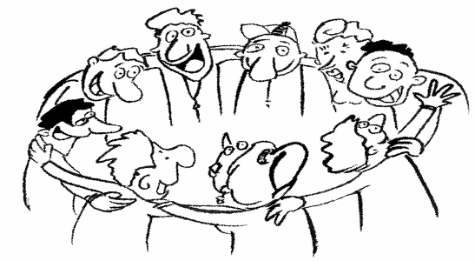

CONCLUSION

The Inclusion Staff Training provided a much-needed opportunity to address some unresolved issues in the field of inclusion. Participants learned to “break the code” of concepts like social exclusion/social inclusion and to understand the nuances in the “inclusive vs. inclusion” debate. Participants were also able to exchange methods for carrying out a needs analysis in the field of inclusion as well as the ways in which different NAs benefit from the expertise of internal and external stakeholders.

Participants were “code makers” as much as “code breakers” in that they successfully arrived at a definition of the tasks, skills, necessary resources and limitations of inclusion officers. In addition, the first steps were taken in establishing forms, indicators and methods for evaluating the inclusion impact of various European-level activities.

There is much work still to be done within Youth in Action on inclusion issues but this first Inclusion Staff Training provided an invaluable foundation for the future.

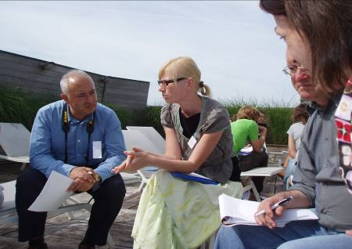

EVALUATION

A summary of feedback from participants’ written evaluation forms and the final team evaluation:

Comments on the programme
- The separate programme elements were evaluated very positively.
- The programme was a good mix of input and exchange of experience.
- This training event did what it could in a limited time; now we need to think about the next step. A follow-up training could pick up on topics like:
  - Returning to the tasks defined for inclusion officers – does the guideline work or not?
  - Where does the responsibility of an NA stop in terms of inclusion?
- It was planned to give Agencies more space to exchange ideas and plans for shared priority target groups, but this had to be dropped due to lack of time.
- The time allocated for exchanging examples of good practice between NAs was too limited.
- “Relevance of the training to my work” was not scored very high. It is not the case that the training is not relevant but rather that some participants do not yet see links. This can be due to the timing of the seminar – the introduction of strategic thinking might have come a bit too early for newcomers to the inclusion field.
- The horizontal theme of “gender equality” was not touched on.

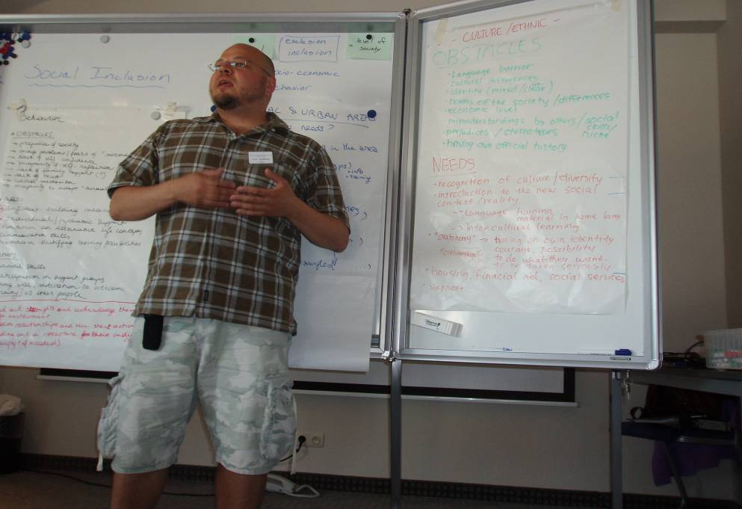

Comments on technical aspects
- One third of NAs were not present during this training – this is a substantial amount
- Objectives of the training were clearly communicated after being worked out in more detail, this turned out well.
- Information sent to pax beforehand was sufficient, clear, detailed, background documents relevant.
- The information requested from NAs in advance (as homework and in the application form) together with the snapshots of 2007 has provided a small indication of what is going on in the field of inclusion. Can be useful to follow this up and make a comparison in 2008. Also a message to those NAs who were not present.

Comments on the staff training concept
- Staff trainings are often overly-technical (e.g. youthlink)
- It is possible that the need for the next inclusion staff training will not be supported (by NAs, by EC…?) Inclusion is an ‘old’ topic that has already had much attention; NAs may chose to prioritise new areas like valorisation
- Support from the EC is a requirement for “official” staff training events; SALTO and other bodies need this support from the EC to “motivate” NAs to take part
- The positive reaction to this training is a clear sign for the EC that staff training and other efforts are important
- For work plans for 2008: inclusion will be mixed into the text, but interesting to make another analysis to see if there have been some changes on inclusion!

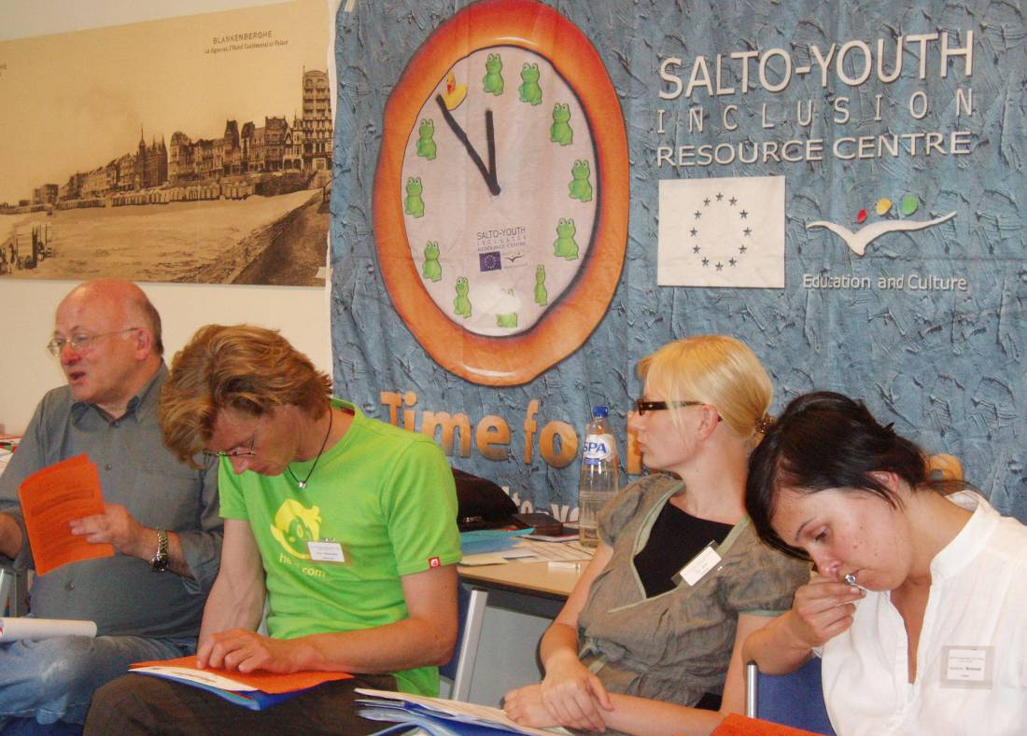

Possible next steps for SALTO Inclusion
- continue to promote the concept of non-formal learning as a good tool for inclusion
- help with translation of inclusion resources into other languages
- help NAs with the process of developing inclusion indicators developing expertise in evaluating inclusion; set up and/or contribute to a working group with social researchers to develop the indicators for evaluation
- help develop a strategy for Youthpass and how it can effectively be used with fewer-opportunity target groups. (SALTO can identify issues specific to the fewer-opportunity group. For instance many fewer-opportunity young people do not have the capacity to fill in Youthpass in a proper way – how can they be helped? When would fewer-opportunity young people actually use Youthpass? Is it of real benefit for them? If not, what improvements can be made? Etc.)
- continue to provide opportunities for smaller meetings (e.g. Round Tables) with very concrete discussions, coaching, …
- to concretely follow up this training event, send out the copies of the Personal Action Plans approx. 6 months later. Can be a positive confrontation for the participants – what has happened with all the good intentions?

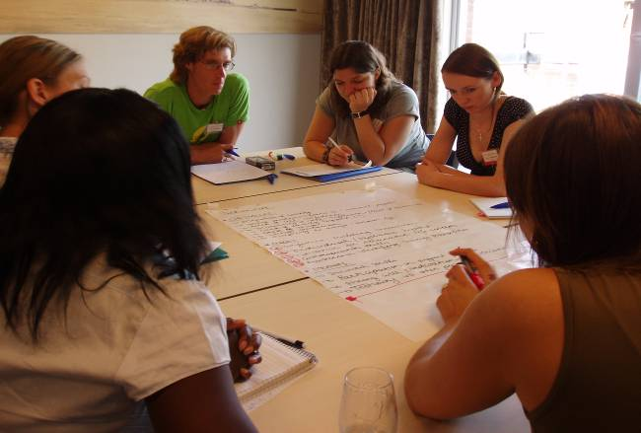

Future activities
- Follow-up Inclusion Staff Training – hosted by INJEP (France) June 2008?
- NA Estonia planning to put together an overview of good practices across the EU. Could be useful to link together with SALTO Inclusion’s booklet on good practices.
- NA Spain is considering organising a CMS based on good practices. What codes should be followed, what should be recommended to Agencies, keys for success, etc. Could be useful for SALTO Inclusion to stay in contact and follow developments.



* * * * *

ANNEXES

Annex 1 : Inclusion Snapshots – The Current State of Inclusion in National Agencies

Austria
1. Name the biggest successes and challenges in your inclusion work. | Successes:  - good conditions for making a strategy; Austria has a strong regional structure. The regional offices know the situation of young people in their area as well as their needs.  - There have been some good inclusion projects focusing on disabled young people.  - NA Austria has been involved in the Summer Tandem (EVS Short Term) projects  - The NA has some good trainers who are very experienced with inclusion target groups.  Challenges:  - the NA has come far without any strategy, but everything has been dependent on individuals, it has never been a structural approach.. This is the new challenge for the future.
2. Describe your NA’s future plans and concrete goals in terms of inclusion? | - Develop a more structured strategy for inclusion  - Raise awareness  - Improve the quality of inclusion projects  - Continue to work inclusively; YiA is the tool and we want to offer a supportive approach to the projects doing the actual work with the young people
3. Who is involved in inclusion work in your NA? Who is not? | - the NA is a small team of 4, so everyone is involved.  - regional offices need to be more implicated in inclusion discussions
4. Where does the inclusion officer fit in? What are the tasks and how much time can they give to the work? | - Austria got a new National Agency in 2007. There is still a lot to do and to develop to get the new programme running smoothly.  - There is one inclusion officer (Melanie). Thanks to her previous work in the field she was aware that an inclusion strategy existed, but knew nothing specific about it.
5. What are the most urgent questions concerning inclusion in your NA at this time? | - moving from field work to being inclusion officer in the NA is a field of new discoveries. There is much to be learned.

Belgium Flanders
1. Name the biggest successes and challenges in your inclusion work. | Successes:  - Establishing an inclusion sub-team in the NA; people from YiA, youth policy and other programmes come together to discuss developments in the inclusion field and to take further steps  - Establishing an Expert Group on inclusion – youth and social workers from the field come together to advise and write vision text  - strengthening synergies with international NGOs  - Action 1.1 and 1.2: 40% young people with fewer opportunities, due to structure of youth work in Belgium  - definition of young people with fewer opportunities = definition of the EC,  - High flexibility, good coherence about the groups and projects (their needs and activities); lots of motivation and explanation about why certain profiles are disadvantaged  - Translating some materials (e.g. SALTO Inclusion booklet) into Dutch  - Creation of the Summer Tandem system for EVS Short Term – partnering a short-term volunteer with a long term volunteer in a buddy system  Challenges:  - using YIA as a pedagogical tool for inclusion; lack of beneficiaries, also from young people with fewer opportunities, therefore emphasis is on promotion
2. Describe your NA’s future plans and concrete goals in terms of inclusion? | - writing a vision text to clarify within the NA what is inclusion, which target groups, which priorities and make an action plan  - seeing inclusion as a “red line” through all activities, communication and information  - including new and different target groups, talking to new networks and introducing them to the possibilities in YiA.  - Feel a “new wind” in inclusion discussions in YiA
3. Who is involved in inclusion work in your NA? Who is not? | - Officers on different levels  - Youth workers and experts  - SALTO Inclusion  - Inclusion officer works on different levels  - Not young people from target group
4. Where does the inclusion officer fit in? What are the tasks and how much time can they give to the work? | The inclusion officer’s task is to spread info on inclusion news in general; every individual officer is responsible for providing support towards inclusion applications. There is no specific time earmarked for inclusion. There is a need to work out the tasks in more detail.
5. What are the most urgent questions concerning inclusion in your NA at this time? | - no specific consensus on a general approach towards how to support inclusion projects  - no specific inclusion strategy  - lack of clarity about inclusion officer’s tasks  - how far should the NA go in motivating/pushing specific target groups to get involved (if they are not interested)?

Czech Republic
1. Name the biggest successes and challenges in your inclusion work. | Successes:  - seminar with orphans  - training for short term EVS  - Round Table meeting for NGOs who work with disabled and orphans to discuss their needs  Challenges:  - general lack of interest from young people; too lazy to do something themselves  - lack of knowledge about the YiA programme
2. Describe your NA’s future plans and concrete goals in terms of inclusion? | - regional consultants network  - external trainers who work for the National Agency  - compiling an NGO questionnaire to determining their needs  - hosting a seminar in September 2007 on inclusion  - hosting a Round Table meeting in October 2007 on EVS  - providing training for workers of NA and regional consultants on inclusion
3. Who is involved in inclusion work in your NA? Who is not? | Experts and regional consultants.
4. Where does the inclusion officer fit in? What are the tasks and how much time can they give to the work? | There is an inclusion officer in every action; there is no one “official” inclusion officer. Those responsible for inclusion from the different actions co-operate together. The co-operation depends on certain target groups or specific activities.
5. What are the most urgent questions concerning inclusion in your NA at this time? | No questions at the moment.
4. Where does the inclusion officer fit in? What are the tasks and how much time can they give to the work? | - the inclusion officer co-ordinates but co-operates with the other Action officers
5. What are the most urgent questions concerning inclusion in your NA at this time? | - interested in experiences with one of the 3 new target groups, especially young unemployed people  - how can the impact of inclusion be measured?  - trainers pool competence in the field of inclusion

Denmark
1. Name the biggest successes and challenges in your inclusion work. | Successes:  - Danish NA has started co-operation with the Ministry of Integration.  Challenges:  - The Danish NA has prioritised immigrants and young people of cultural/ethnic backgrounds. It is proving hard to reach this target group (particularly immigrants). It could be that the young people don’t know the Agency is there. So far we have seen that the best way to reach young people is through seminars.  - The NA wants young people to apply for projects themselves as often as possible, but so far they don’t do it. Why? It is possible they are intimidated by the bureaucratic image of the NA.
2. Describe your NA’s future plans and concrete goals in terms of inclusion? | - continue co-operation with the Ministry of Integration; expand to include the municipality of Copenhagen; continue on to other parts of the country
3. Who is involved in inclusion work in your NA? Who is not? | There are only 4 persons working in the NA. There is one designated inclusion officer (Andreas).
4. Where does the inclusion officer fit in? What are the tasks and how much time can they give to the work? | Andreas has been responsible for inclusion for approx. 2 months. In addition to YiA, he also works for a Nordic grant system – they have similar priorities to YiA, so in practice Andreas spends about 50% of his time working on inclusion. This involves making materials and responding to telephone and written inquiries (and there are lots of them!) The inclusion officer is not responsible for the applications, more for overseeing the inclusion topic in general
5. What are the most urgent questions concerning inclusion in your NA at this time? | How can the NA manage to reach more young people? They are not coming to us. Was recently a Nordic seminar organised which hosted a group of young people from different ethnic backgrounds. These young people were well educated and intelligent; yet even they felt that the programme was too difficult to access, too bureaucratic. They found the whole procedure difficult and were put off from applying

Estonia
1. Name the biggest successes and challenges in your inclusion work. | Successes  - consensus in the NA that inclusion is a big priority – this means that there is a clearly indicated inclusion officer and that there is support from team members  - time and resources given to pilot inclusion projects (e.g. young people in prisons, see report on website. Specific training developed for people working in prisons, lots of consultations carried out, participants sent to international courses, working on developing international partnerships. All of this is a long-term investment in the target group.)  - big variety of target groups participating in the programme: eg prisons, gay & lesbian (empowerment), blind young people  Challenges  - There are target groups we don’t yet reach – putting a new focus on reaching young unemployed people, rural youth, young people from Russian speaking background (provide information in the Russian language)  - There has been an Impact in quantitative terms (e.g. 50% first priority projects in youth initiatives – tend to work with ‘hard’ cases) but quality is more important than numbers  - Work closely with young people but there are structural problems to face (e.g. social benefits, social institutions, etc).
2. Describe your NA’s future plans and concrete goals in terms of inclusion? | - Increase work with young unemployed: call for participants for TC, specifically people working with unemployed from employment and activation agencies. This may lead to international co-operation  - Increase work with rural youth  - Increase work with youth from Russian speaking community
3. Who is involved in inclusion work in your NA? Who is not? | - everybody is involved in the strategic planning  - experts contribute to the strategic planning based on the evaluation of the past programme  - external partners from each of the target groups (e.g. prisons: officers, police,…)  - external resource groups

Finland
1. Name the biggest successes and challenges in your inclusion work. | Successes:  - A network of multipliers and specialists – e.g. municipal youth workers, experienced, NGOs, specialised organisations – they have the link to the target groups  Challenges:  - A regional network is needed (to cover large geographic areas) but the problem is that youth workers are not always equipped to deal with hard cases  - Immigrant organisations are not represented in the networks – no reliable contacts, hard to get in contact with the grass roots
2. Describe your NA’s future plans and concrete goals in terms of inclusion? | - To designate one contact person for inclusion  - To combine forces (e.g. more Nordic co-operation, possibly do a training course/CMS together)  - To work on promoting cross-community contacts and projects  - To expand the trainer pool - bring in trainers from immigrant backgrounds who could be more useful for working with specific communities
3. Who is involved in inclusion work in your NA? Who is not? | - a lot of the target groups covered (easy contacts – because in small countries there are close networks and people know each other)
4. Where does the inclusion officer fit in? What are the tasks and how much time can they give to the work? | - Inclusion officers tasks: no strategy yet for the inclusion officer’s tasks; this will be developed  - There is a lot to do so the time you have depends on the amount of time needed for other tasks
5. What are the most urgent questions concerning inclusion in your NA at this time? | - the work for the moment is more ‘inclusive’ but more thinking needs to be done about working towards ‘inclusion’, this will involve a strategic decision  - interested in more cross-Agency co-operation – need to transfer good ideas  - unsure about the gay & lesbian target group – is it an inclusion group?  - what about serious social cases/problems, is this covered?

France
1. Name the biggest successes and challenges in your inclusion work. | Successes:  - good rate of participation of young people with fewer opportunities (quantitative evaluation) in the different actions  - the French NA has been a motor behind European inclusion. Specific contributions include:  - Partnership 4 Inclusion seminar in 2005  - Introduction of reinforced mentorship  - Pushing for better and more creative use of exceptional costs  - Creation and maintenance of a national-level working group on inclusion  Challenges:  - determining how to evaluate the impact of the participation of young people with fewer opportunities in terms of inclusion  - re-energizing organisations to re-enter inclusion discussions and to create a new national strategy
2. Describe your NA’s future plans and concrete goals in terms of inclusion? | - improving follow-up of projects in general  - conducting a new pilot project between France, Spain and Italy + NGOs + local authorities including EVS and group exchanges with a training seminar and close follow up of the project  - continue networking and re-start the national inclusion working group  - targeting two priority groups: urban youth (young people living in the poor areas of cities); disabled young people (mental and physical):  - working to improve the problems in receiving volunteers, but also in sending volunteers (French organisations have not yet discovered the value of mobility for this group)  - developing the recognition of non-formal education (Youth pass for inclusion)  - seminar on urban youth planned for December 2007
3. Who is involved in inclusion work in your NA? Who is not? | - inclusion officer  - TCP officer  - All project officers  - Director and vice-director of the NA (often present at inclusion seminars, etc.)  - Staff from the regional offices – they are very close to the field  - A working group made up of four regional co-ordinators, the inclusion officer plus other stakeholders including representatives of the Mission Locale, Association of the Disabled, etc. (Working group currently under construction and is in line with the new priorities)  - new working group consisting of a network of different stakeholders and other Ministries  - also important to work with local authorities on this issue
4. Where does the inclusion officer fit in? What are the tasks and how much time can they give to the work? | - TCP officer  - developing short term EVS  - deciding on priority target groups in consensus with all colleagues
5. What are the most urgent questions concerning inclusion in your NA at this time? | - restarting the national working group  - developing qualitative indicators: how to make sure our work has a high level of quality for these young people

Germany
1. Name the biggest successes and challenges in your inclusion work. | Successes:  In most Actions there is a good percentage of people with fewer opportunities except in EVS.
2. Describe your NA’s future plans and concrete goals in terms of inclusion? | - Involving more young people in EVS projects  - Approached employers, schools, etc, to discuss the possibility to reach more young people who have just finished school. Many were open and reacted positively to the idea.  - Young people with fewer opportunities are best reached by others young people from the same group, so the German NA is looking into ways to promote “peer-ing for inclusion”
3. Who is involved in inclusion work in your NA? Who is not? | Five people in the NA form a kind of inclusion team, mainly supported by Guido and Karen at this time. There is also some input from sending organisations.
4. Where does the inclusion officer fit in? What are the tasks and how much time can they give to the work? | Inclusion is one of many tasks.
5. What are the most urgent questions concerning inclusion in your NA at this time? | - Is EVS the right way to achieve inclusion?  - How can we make EVS more flexible? Going abroad for a long period is sometimes a problem for people who live from social support.

Latvia
1. Name the biggest successes and challenges in your inclusion work. | Successes: Your biggest successes and challenges?  - The work with young people from rural areas (biggest group) is going well.  Challenges:  - Implicating more youth in prisons in the activities
2. Describe your NA’s future plans and concrete goals in terms of inclusion? | - More activities for youth in prisons. NA has already visited one prison. The first phase involved talking to the prison head about possibilities for future cooperation. A visit is planned to the Estonian NA which has already had some success in working with this target group.
3. Who is involved in inclusion work in your NA? Who is not? | - A voluntary social exclusion expert has been to training events.  - The head of the Agency is also involved and delegates tasks.
4. Where does the inclusion officer fit in? What are the tasks and how much time can they give to the work? | Karina (responsible for inclusion) is also in project officer for youth initiatives and democracy projects. In practice there is no time is left over for inclusion.
5. What are the most urgent questions concerning inclusion in your NA at this time? | - Working with youth in prisons seems to be “mission impossible”. How to ensure they are not excluded from our activities?  - When you help one group, what about the others?

Lithuania
1. Name the biggest successes and challenges in your inclusion work. | Successes:  - Development of a network of coaches/advisers/councillors throughout Lithuania.  - Targeting rural areas.  - Organising a special event for youngster with fewer opportunities.  Challenges:  - When applications are made by youngsters themselves it is difficult to let them tick the box “fewer opportunities”
2. Describe your NA’s future plans and concrete goals in terms of inclusion?
3. Who is involved in inclusion work in your NA? Who is not? | In the Lithuanian NA everybody is dealing with inclusion.
4. Where does the inclusion officer fit in? What are the tasks and how much time can they give to the work? | The person designated to follow inclusion (Loreta) coordinates inclusion information. It is only possible to devote about 5% of the job to inclusion.
5. What are the most urgent questions concerning inclusion in your NA at this time? | - How to find more time for inclusion?  - How to make the national strategy work?

Netherlands
1. Name the biggest successes and challenges in your inclusion work. | Successes:  - national umbrella organisations on special target groups: disabled(2005), migrants(2006).  - Workshops on national level. Working time of one year isn’t enough. Now longer periods.  - Group initiatives: good participation of migrant and disabled participants  Challenges:  - another 80 people in the Netherlands are supporting professionals who are working with young people. The Dutch NA has been part of that group since January, but communication is almost non –existent  - difficulties to involve youth with fewer possibilities in EVS projects.
2. Describe your NA’s future plans and concrete goals in terms of inclusion? | Further clarify the tasks of the inclusion officer. The current vision is that an inclusion officer would collect and spread information on inclusion topics.
3. Who is involved in inclusion work in your NA? Who is not?
4. Where does the inclusion officer fit in? What are the tasks and how much time can they give to the work? | There is no designated inclusion officer; inclusion is an extra task assigned on top of the other responsibilities. This means there is little time for inclusion, but within the team as a whole it is still seen as a priority.
5. What are the most urgent questions concerning inclusion in your NA at this time? | - How can we find more time for inclusion issues?  - What do we want to achieve in inclusion?  - How to convince people in an organisation of the importance of inclusion.  - EVS!

Poland
1. Name the biggest successes and challenges in your inclusion work. | Successes  - disability issues: most in EVS; no high %, but some interesting projects each year  - unemployment:  - some pilot projects on unemployment via labour offices and to encourage them to promote EVS and YIA in general;  - disability: seminar with FI and next year with NL (similar experience)  - rural areas: lack of information,
2. Describe your NA’s future plans and concrete goals in terms of inclusion? | 2007 is year to set the frame of the new programme; a new national-level inclusion strategy is under development. The main aim is to develop Polish strategy in line with the Inclusion Strategy of the European Commission and to ensure that the national strategy is based on consultation and evaluation with different actors. Another aim is to raise awareness of inclusion issues among other colleagues in the NA
3. Who is involved in inclusion work in your NA? Who is not? | - external experts (attached to the YIA)  - colleagues of NA  - beneficiaries of YIA  - NGOs consulted who are not beneficiaries but are active in the field of inclusion  - young people
4. Where does the inclusion officer fit in? What are the tasks and how much time can they give to the work? | There is an inclusion group within the NA with one person designated to lead this group of inclusion officers. The group is responsible for developing the strategy, monitoring the Actions and projects, consulting with other colleagues, financing the projects and setting priorities.  Time is too limited for this work. The inclusion officers are often responsible for other Actions, so this means they must divide their time and little is left over for inclusion.
5. What are the most urgent questions concerning inclusion in your NA at this time? | Organising an evaluation seminar for all interested NGOs; use the result of the seminar to develop inclusion strategy (young people will also be consulted in this evaluation seminar). The evaluation process will begin in July.

Romania
1. Name the biggest successes and challenges in your inclusion work. | - In 2005 many ethnic minorities applied for activities but they were not monitored afterwards.  - Many projects in rural areas.  - One good project about theatre and involvement of disabled in the local community. A good film was produced about the project  - Project conference with Roma people (centralised action). Result: common conclusions - we are actors ourselves. If we want to change something we need to do something ourselves, use their networks
2. Describe your NA’s future plans and concrete goals in terms of inclusion? | - make an inclusion strategy with colleagues of other Actions  - explore human resources in Romania; stay in touch with them and get feedback from them in the inclusion area; get input for the inclusion work of the NA  - Give monitoring more importance - keep a finger in the reality on the ground  - Recruit multipliers who are committed
3. Who is involved in inclusion work in your NA? Who is not? | - One inclusion officer, other colleagues including the NA coordinator  - Trying to contact someone from the National Authority to make a contribution from the political level as well as looking for other resources
4. Where does the inclusion officer fit in? What are the tasks and how much time can they give to the work?
5. What are the most urgent questions concerning inclusion in your NA at this time?

Slovakia
1. Name the biggest successes and challenges in your inclusion work. | Successes:  - Development project with the Roma community. Co-operation with Roma institute  - Info meetings and training.  - Support offered at every step.  Challenges:  - longer term projects for one target group.
2. Describe your NA’s future plans and concrete goals in terms of inclusion? | - To create a working group on inclusion for input from people from outside and to cooperate with them.
3. Who is involved in inclusion work in your NA? Who is not? | - The NA group is discussing about inclusion + creating a database showing which target groups are involved in each Action, which organisation is working with which target group?  - Lucia is working with Eurodesk: info of persons who are working on inclusion in Europe.
4. Where does the inclusion officer fit in? What are the tasks and how much time can they give to the work? | One person is responsible for inclusion which includes coordination and communication about trainings for specific target groups.
5. What are the most urgent questions concerning inclusion in your NA at this time? | - How can we find more time for inclusion?  - How to convince people to co-ordinate with the NA?

Slovenia
1. Name the biggest successes and challenges in your inclusion work. | Successes:  - While inclusion was not organised before, inclusion tasks have now been designated to a kind of “inclusion officer”  - Managed to find some participants for a small number of activities  - Most opportunities for inclusion exist in A1.1 and A2.  Challenges:  - To find more projects.  - Few organisations are working with young people with less opportunities; little improvement. More are coming.  - Difficult to motivate the young people in Slovenia
2. Describe your NA’s future plans and concrete goals in terms of inclusion? | - To put more effort into understanding/communicating the difference between inclusive work and inclusion work.  - Try to include inclusion in some training events.  - Want to make sure what inclusion means to organisations.  - Take the results of this training home to the Agency to restart inclusion discussions  - Start a new discussion on how to give points to project applications
3. Who is involved in inclusion work in your NA? Who is not?
4. Where does the inclusion officer fit in? What are the tasks and how much time can they give to the work? | There was previously no concrete action taken in the inclusion field;. Need now to find out what it means to be an inclusion officer and to take time to think about how to put ideas into practice.
5. What are the most urgent questions concerning inclusion in your NA at this time? | - Which approach will give the best results? (Collect some ideas from colleagues here.)  - Need a flexible way of doing things, our structures now are very rigid.  - Need to place and promote inclusion.  - Difficulties with working with organisations because inclusion means more work.  - Need to motivate more organisations who really work with the target group and get rid of those who only use inclusion as a way to get more money.

Spain
1. Name the biggest successes and challenges in your inclusion work. | Successes:  - some good experiences in working with the disabled, with young people from rural backgrounds, with inner city young people.  Challenges:  - Starting up new projects aimed at young people from immigrant backgrounds.  - For the Spanish NA it is still very relevant to talk about how the Agency can be more inclusive – how to get more young people into the programme.
2. Describe your NA’s future plans and concrete goals in terms of inclusion? | - There is no structured inclusion work going on in the NA at this time. In 2003-2004, The Spanish Agency had a “technical group” who oversaw some inclusion discussions. This group met two times in the two-year period. The group was made up of people from the regional offices. The technical group exchanged examples of group practice, organised one training seminar for EVS mentors and started a process to develop definitions and rules to help with the evaluation process. The group broke up once the leader had to take time off due to health problems; there have been no further meetings of the group since 2004. Javier would like to start this group again in future, connect technical discussions to issues of good practice and become active again in the JAMO project.  - Once reactivated, the technical group will propose national-level priorities and develop a strategy.  - The Spanish NA does not have a priority target group as such at this time. This and other issues will be discussed at the next meeting (scheduled for July).
3. Who is involved in inclusion work in your NA? Who is not? | - The Spanish Agency is set up on regional basis. This means that the regional offices are responsible for field work, while the Madrid office is the secretariat and is concerned with general co-ordination. The regional offices meet five times per year to take decisions.
4. Where does the inclusion officer fit in? What are the tasks and how much time can they give to the work? | - One “central” inclusion officer is elected by representatives of all the regional offices for an indefinite period. Since the demise of the technical group there has not been any clear task for the inclusion officer to do.
5. What are the most urgent questions concerning inclusion in your NA at this time?

Sweden
1. Name the biggest successes and challenges in your inclusion work. | Successes:  - Launching campaign in urban area with a lot of minority groups. (only inclusion activity in spring 2007)  - mapping of the working procedures for inclusion categorisation of projects (because of the need for common guidelines)  Challenges:  - making organisations take the step from being informed into action (in a shorter time).  - more resources.
2. Describe your NA’s future plans and concrete goals in terms of inclusion? | - An inclusion training (2 days – Sept. 2007) for beginners. Should show what possibilities exist and what YiA is trying to achieve in terms of inclusion  - A diversity training (spring 2008) together with other Nordic NAs.  - Making a strategy (but how? Hoping to find an answer here.)  - Improve info about inclusion on the web.
3. Who is involved in inclusion work in your NA? Who is not? | - The whole NA in involved with the priority.  - There is no reference group involved.  - No particular person in selection committee.
4. Where does the inclusion officer fit in? What are the tasks and how much time can they give to the work? | With all the other responsibilities the inclusion officer (Emmy) can only spend about 5% of her time on inclusion issues.
5. What are the most urgent questions concerning inclusion in your NA at this time? | Need to find time to concentrate on inclusion

Turkey
1. Name the biggest successes and challenges in your inclusion work. | Successes:  - the Turkish Agency has some experience with socio-economically disadvantaged young people, young people with lack of access to information and social spaces and also with young people with disabilities  - concrete actions in inclusion so far include:  - Support for the SALTO TC on Rural Youth  - Feel It TC – for youth workers working with young people with fewer opportunities  - European Youth Week – a big fair was organised with displays showing different examples of projects/activities. The fair was shown on national TV. A lot of peer-to-peer learning took place between the young people at the stands.  Challenges:  - With 25 million young people in Turkey and only 11 persons in the NA it is obvious that information cannot reach all the young people in the country.
2. Describe your NA’s future plans and concrete goals in terms of inclusion? | - So far implementing the programme and making it accessible (inclusive) was a clear first priority, with quality coming in second place. In practice, this took the form of the NA trying to encourage equal access to the programme for organisations from the 81 different cities across Turkey. The NA tried to keep space for projects from all different regions and to ensure that information was spread fairly. In this sense, the Agency was making real efforts to work inclusively; but this is not the same as having a clear inclusion strategy.  - The Turkish Agency hopes to gain many things through the EC Inclusion Strategy, but with the funding at the level it is at now, the Agency will likely be limited to organising some events to share information and change attitudes.
3. Who is involved in inclusion work in your NA? Who is not? | - The Turkish NA has 11 staff members – this small number makes it easy to meet together and discuss ideas.
4. Where does the inclusion officer fit in? What are the tasks and how much time can they give to the work? | - The Turkish NA has one person responsible for overseeing inclusion issues but the same person is also responsible for coordinating the different Actions, acting as information officer, for YouthNet, for managing the website and also for building up an audio-visual library of resources, so obviously time for inclusion is extremely limited.
5. What are the most urgent questions concerning inclusion in your NA at this time?

United Kingdom
1. Name the biggest successes and challenges in your inclusion work. | Successes:  - good regional networks (9 regions - each region has its own committee); lots of NGOs active  - ex-offenders pilot project leading to short term EVS projects  Challenges  - no inclusion strategy  - considering which group(s) to target, keeping in line with the EU outlines
2. Describe your NA’s future plans and concrete goals in terms of inclusion? | Increasing the participation of disabled young people in YiA activities; a pilot project in Action 2 EVS is planned in southwest England
3. Who is involved in inclusion work in your NA? Who is not? | Each separate Action has its own Inclusion Officer. The officers will meet together every couple of months and search for coherence and a common approach.
4. Where does the inclusion officer fit in? What are the tasks and how much time can they give to the work? | This needs to be developed. Up to now little time has been allocated to inclusion issues – hopefully this is about to change.
5. What are the most urgent questions concerning inclusion in your NA at this time? | - What groups have other National Agencies selected as priority groups?  - What inclusion strategies have been developed in other National Agencies?  - Where could we co-operate together?

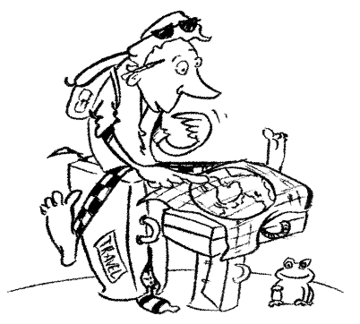

* * * * *

Annex 2 : Carrying Out an Effective Needs Analysis

Group 1

1. Look at the past:
- What have we been doing (actions, trainings, impact, projects, participants)?
- What groups have we reached (strengths)?
- What groups have we missed (weakness)?

The objective should be to cover the entire field, get a complete overview. To this end, you can use:
- Final reports, training reports, NA final report
- Questionnaires, interviews, comments from the field
- Feedback from different Actions: consulting colleagues, etc.

2. Look at the present:
- What resources exist in the NA?
- Who could be the NA’s potential partners?
- Identify target groups?
- What are the needs of the target groups? (determine these through research, meetings, evaluations, etc.)

On this basis, start to formulate an action plan. Which groups will be targeted? Which Actions? What kind of co-operation is needed? What timeframe will be defined?

3. Look to the future:
- How will the plan be implemented?
- What are the expected results?
- Identify expected follow-up projects
- Plan steps for evaluating, monitoring, adjusting, revision

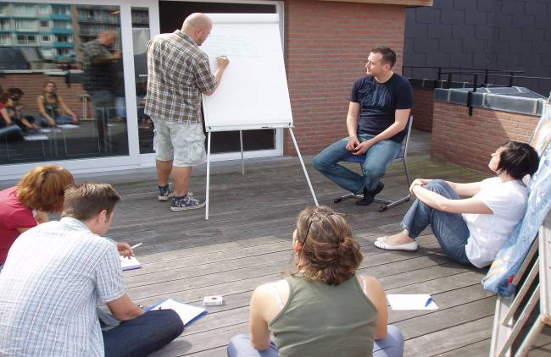

Group 2

Steps from the practices of our NAs:
- Conduct evaluation seminars with beneficiaries and actors from national youth/inclusion field
- Analyze data and evaluation results of previous activities of the NA (e.g. TCP) & trends in Actions during the previous period
- Carry out consultations with external experts (incl. those experts with academic/strategic planning/evaluation…backgrounds)
- review (national) policy documents & priorities
- Conduct research on inclusion practices

WHO should be involved?
- Inclusion team of the NA or the full NA team (if appropriate) depending on the situation… but not individually by the inclusion officer!
- Trainers
- Teams of accreditors and monitors (project visitors)
- Regional networks
- Selection committee
- Key actors (both youth & organisations; from local governments, ministries; professionals from the field (including but not limited to direct beneficiaries of the programme)
- Experts from academic backgrounds (policy makers, etc.). These should NOT be only from the Youth and non-formal learning fields!

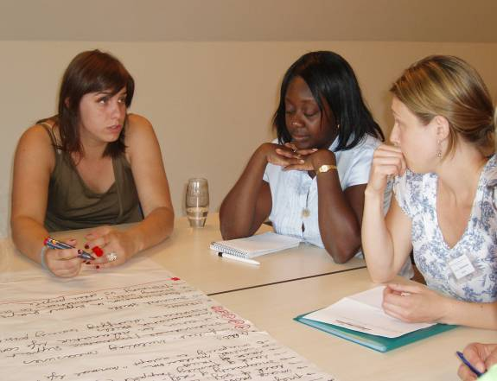

Group 3

Concrete steps to be taken:
- Collect data in order to analyse the real needs. Do this by means of:
- Compile statistics
- Ask for youth workers/experts point of view
- Establish quality questions
- Consider situation/issues specific to your country
- Determine the main areas of interest of the NA

* Set objectives on the basis of the needs analysis
→ what is the GOAL → why do we need a STRATEGY?
→ Internally: carry out an intense discussion with the programme officer responsible
for prioritised area/Action. Include the head of NA as much as possible.

Group 4

- Thorough evaluation of youth program → provides a quantitative basis for results so far
- Carry out a qualitative analysis → to determine good practices
- Share NA priorities

Group 5

How to achieve needs?
- Awareness-raising of all involved in the area
- Spread information on programme and funding possibilities among groups which are not yet represented (info campaigns, training, etc.)
- Create/develop networks
- Active key players (intermediaries, teachers, etc.)
- Bring info and good examples

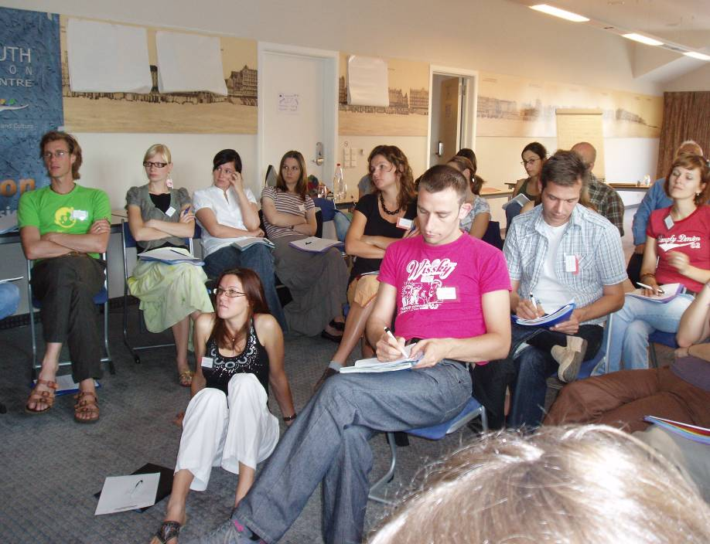

* * * * *

Annex 3 : Potential Stakeholders

Group 1

Internal stakeholders | - Inclusion officer  - Action 2 project officer (team decides who: SO? HO? ST? LT?)  - A manager / the head of NA / co-ordinator  - Selection committee  - Make use of resources from colleagues  - Consider financial management (allocated funds, etc.)
External stakeholders | - NGOs from target areas*  - Local/regional authorities responsible for youth affairs  - Network of local contact persons  - youth workers, youth leaders, coaches, resource persons…  - Secondary school contacts  - ex-volunteers/other EVSers  - sports organisations  - trainers  - Employment offices  - SALTO(s)  - Other NAs dealing with the same target group(s)  - Youth division of political parties

Group 2

Your key stakeholders are dependent on:
- The specific target group(s) you choose to work with
- The national situation and structures in your country (related to youth work and youth policy)
- The position and resources of the inclusion office in the NA

Group 3

Internal stakeholders | All project officers need to be involved!  - Ask their opinions  - Offer trainings  - Encourage continuous co-operation with inclusion officer
External stakeholders | - Social workers  - beneficiaries  - NGOs (working with inclusion)  - Institutions working with target groups  - Local/national authorities  - Other NAs  - National networks  - Relevant ministries  - Funds (national programs, etc.)  - Experts/trainers

Group 4

Internal stakeholders | -Action officers  -information officers  -trainers  -head of NA  -regional contacts/offices  -Eurodesk  -selection committees
External stakeholders | -experiences organisations (steering group?)  -local, regional, national authorities  -ex EVS Association  -priority group (? How?)  - youngsters in general

Group 4 - a country-specific overview:

 | Internal | External
France | - Regional correspondent | - local missions  - Res. Dep. INJEP  - Multipliers at local/regional level
Spain | - Technical committee  - Regional. Correspondent | - Youth council in every region
UK | - Regional committees | - Probation service for ex-offenders
Austria | - Regional structures
Netherlands |  | - national umbrella org for YP with physical disabilities (newsletters, database, training)  - national institutions for multicultural development.  - Dutch youth institutions.
Turkey | - PR Co-ordinator
Lithuania |  | - Coaches / multipliers at local level

* * * * *

Annex 4 : Tasks of an Inclusion Officer

Tasks of an inclusion officer

Essential tasks | - reference point for internal and external players:  - collecting statistics for basic analysis (will contribute to the first phase of needs analysis)  - creation and co-ordination of inclusion strategy  - co-ordinating a working group  - maintaining awareness of inclusion as a priority in the NA; alarm bell in the elaboration of the inclusion strategy
Important tasks | - ongoing monitoring and valorisation (documenting examples of good practice)  - proposing inclusion trainings and capacity building  - developing information materials  - updating listings/contacts with stakeholders
“Nice-to-have” (extras) | - translation of existing good practice documents  - knowledge of NA priorities in other countries (not a top priority; while it may be helpful to have info about other NAs when implementing your own national inclusion strategy, it is not essential)  - Be active in a network of inclusion officers

Remarks
- Is it essential for an inclusion officer to learn about what is happing in society in the field of inclusion or not? Policy development is ongoing; monitoring changes & developments on national (even on global) level can be relevant for the activities and priorities in the NA
- An inclusion officer should have a broad understanding and knowledge of what is happening in inclusion in different Actions in their own NA
- This list of tasks seems very far-removed from real young people – where are young people involved and where can they take on a role in an NA’s strategy development?
- The point “knowledge of NA priorities could be categorised as an “important” task instead of a ‘” nice to have” task. National strategies are a result of the EC’s Inclusion Strategy and should be designed to deal with international EU projects, therefore a national strategy is not an isolated island.
- Role for SALTO: to update a list of the NAs priority target groups once a year on youthnet
- A big chance to exchange plans for the coming year during the yearly TCP meeting


Skills and attitudes needed for an inclusion officer

Essential skills/attitudes | - knowledge of the YIA programme  - open-minded  - empathy towards the target group  - flexible  - communication and networking skills  - motivation: even when you have not so much time  - being familiar with national inclusion realities and adapt it to the needs of the young people in your country
Important skills/attitudes | - the ability to balance idealism and realism. If you limit yourself from the beginning you will not come very far  - organisational skills  - delegation skills
“Nice-to-have” skills/attitudes (extras) | - language skills: several minority languages in your country  - training competencies  - mediation skills: conflict competencies

Resources needed for an inclusion officer

Essential resources | - good partnerships with stakeholders, municipalities, key social workers, experts, young people, …  - overview of inclusion status and good practices in your programme country  - staff training: e.g. job shadowing on inclusion officer level  - time  - team support
Important resources | - SALTO Resource Centres  - Other NA colleagues abroad / inclusion officer network  - Youthlink / Youthnet  - information materials  - budget (huge increases are not necessary but current budgets are not sufficient)
“Nice-to-have” resources (extras) | - peer information strategies (peers are information providers)  - linking with other programmes, resources and best practices  - volunteer support

Limitations for an inclusion officer

- time
- money
- number of staff available: number of inclusion staff or other staff
- lack of support (internal level):
  - not enough staff
  - lack of cooperation
  - lack of interest
- lack of support (external level):
  - no national/political interest:
  - political obstacles
- lack of belief (among stakeholders, lack of belief yourself)
- lack of knowledge (about the reality, actual situations, ways of working, strategies, etc.)
- inclusion is just one of many priorities in the programme



* * * * *

Annex 5 : Forms, Indicators and Methods for Evaluating Inclusion

Working Group # 1 - A1.1 Youth Exchanges
Forms of social inclusion | - development of “hard” skills (e.g. project management, financial management, etc.)  - development of “soft” or social skills (e.g. partnership-building, self confidence, self-development, tolerance, etc.)  - communication skills (language skills, etc.)  - attitude changes
Indicators | - increase in activities on local level  - partnership building: continuing the partnership, recruiting new participants (motivating other young people); taking part in other Actions, being active in the local community  - communication: capacity to express oneself, capacity to communicate to others, capacity for public speaking, representational skills  - self-development: learning a new language or new skill, developing (new) social relationships, showing tolerance towards other people
Methods of evaluation | - good old questionnaire  - evaluation seminars (for young people, group leaders and youth workers)  - on-site visits & follow-up meetings  - statistics

Remarks:
- Difficult to measure inclusion: no hard evidence; meet the people in co-operation with a follow-up meeting
- The Leonardo programme includes a 3 month follow-up of its participants involving the collection of information and stories, one-on-one evaluation and follow-up
- Statistics combined with a short questionnaire to find out who was taking part in the activities
- It can be useful to refer to unusual indicators – for instance the fact that the amount of fights in certain suburb decreases after a project can be an inclusion indicator
- Make more use of social scientists with experience in good practice: they have a big variety of methods and can conduct research on personal level. When budgets allow for it, social scientists are able to use correct methods
- Longer term impact of youth exchanges (and other activities) will become much clearer by applying for social science research

Questions:
- Should indicators be decided/determined when developing the strategy? Elements which need to be judged during evaluation should be set up in advance before launching a project.
- What kind of indicators we would like to see? Need to define indicators beforehand does not mean reinventing the wheel – some indicators have been set before.
- Different types of exchanges will demand different indicators and different outcomes.
- The more we go into the question of evaluation we realise that we are unclear about what we must look for. European Commission is asked to give a clearer indication of what they want to see in terms of inclusion as an outcome of a YiA activity.
- There is a risk in defining too many indicators. We cannot solve this during this training course. While it is difficult to have clear indicators there is a lot of pressure on NAs to produce but it is not known exactly what should be produced.
- The indicators listed above are relevant for all groups – not specifically relevant for inclusion groups.
- The starting position of each project is so different that if indicators are too general then little can be determined in an evaluation. Therefore it may be necessary to choose between either very general indicators for all projects or else very specific indicators for each separate project.
- If indicators are too global / too general they will not benefit the young people and will have no meaning. Difficult to find the middle path.
- How often do we have to measure to determine the long-term effect of an activity?
- Since different target groups have different needs (e.g. needs of a disabled youngster are totally different from a drug user) indicators should be defined per target group and need to be flexible.
- What do we need and what kind of messages would politicians like to hear? It would be useful to document success stories and successful projects more in-depth.
- There are two different kind of data and we need both of them. We may be concentrating too much on quantitative data and not enough on a qualitative point of view. One possible method could be to analyse a few projects from start till finish and compare the outcomes.

Working Group # 2 - A1.2 Youth Initiatives
Forms of social inclusion | - To be inclusive is the first step in achieving inclusion  - Change of attitude in society  - Level of satisfaction  - More active participation in society by young people with fewer opportunities  - Willingness to continue (participating in other projects or continuing the initial project)  - Valorisation by young people with fewer opportunities to spread the project and the message  - Informing about their possibilities in YIA  - Visibility of social inclusion projects in order to motivate other young people
Indicators | - number of projects, participants, organisations, different institutions, target groups  - progressing from being a participant to being an organizer  - budget: how much do NAs invest in inclusion in terms of printed material, trainings, support, … how much do NAs invest in order to have more inclusion projects  - level of participation in trainings for social inclusion  - appearances in media  - valorisation (web, books, …)  - level of satisfaction (determined by questionnaires)  - awareness of social inclusion in (local) society
Methods of evaluation | - statistics  - number of newcomers/new inclusion projects  - personal interviews, consultative meetings, questionnaires  - monitoring/on- site visits  - final reports  - media analysis

Questions & comments:
- the forms of inclusion listed above apply to all young people but are also about accepting these particular types of young people
- The level of inclusiveness of an activity can be determined on the basis of numbers and quantitative data. The level of inclusion of an activity is made up of two elements: knowing how far a young person moved forward but also knowing what, if anything, was changed on the level of society. Numeric indicators can form a part of this, however measuring a change of attitudes is a different dimension in measuring social inclusion.
- To work for inclusion you need to be inclusive! Without inclusiveness there is no inclusion.

Working Group # 3 - A2 European Voluntary Service
Forms of social inclusion | - step by step approach (from one Action to another or from Short Term to Long Term EVS)  - combination of short term and long term volunteers in EVS projects  - testimony versus others
Indicators | - examples of life changes  - the value of little changes which are not quantifiable  - employment  - social relations  - engagement in civil society  - indicators are target group-specific
Methods of evaluation | - tailor-made evaluation of impact of the EVS activity on personal life (e.g. AVSO evaluation method)  - annual monitoring or evaluation meetings with beneficiaries (individuals or organisations)  - qualitative research (case studies, interviews, …)  - Youthpass

Questions & comments
- research has already been done on the effects of EVS and other Actions. It is not necessary to re-do the research but rather to translate it into easier-to-use methods
- there has not yet been much valorisation of this research; this should be changed if we hope to influence changes in policy
- evaluation is an ongoing process so it is likely that indicators will change and be adapted over time

Working Group # 4 - A4.3 Youth Support Systems
Forms of social inclusion | - working with multipliers / intermediaries  - work with the final target group  - more and better inclusion projects
Indicators | - good links to the final target group: when youth worker has weak links with the target group then you can assume that the effects are lessened  - increased competencies in matters of inclusion  - packages of inclusion competencies  - the number and rate of inclusion projects (% of concrete inclusion projects as result of training)  - the number of rejected projects (could indicate % of low-quality projects?)  - tools for inclusion assessment  - the number of youth workers coming from the target group itself (linked with discussion where the finish line is? When is social inclusion finished?)
Methods of evaluation | - self-assessment methods  - project visits  - evaluation of competencies  - surveys of projects  - analysis of application forms, evaluation forms, final reports

Questions & comments
- the methods listed here are very far away from real young people
- this Action’s focus is on youth workers and multipliers (presumably somewhat older than the target group…)
- At the moment there is no minimum age defined for participants in this Action. This means that, for instance, a 15-year old multiplier can participate in the Action. The definition of participants in A4.3 (at least at this time) depends on the terminology you use. An “intermediary” can be someone of 18 years old and is not always someone with vast experience. In principle, everyone who has an organisational function with young people can take part in A4.3 activities so we must be careful not to make assumptions. (An open debate may take place at EC level to discuss the participation of young people with fewer opportunities in this Action.)
- There are no exceptional costs included in this Action so this could block the participation of a large number of young people in A4.3 activities.



* * * * *

Annex 6 : Final Programme

 | MON 18/06 | TUE 19/06 | WED 20/06 | THU 21/06 | FRI 22/06
8h-9h | Arrival participants  Arrival participants | Breakfast | Breakfast | Breakfast | Breakfast
9h15 | Arrival participants  Arrival participants | Put the training into context  - History of the training  - Aims & objectives  - Expectations | Using a strategic approach to maximise inclusion  - Analysis Phase - determining the real needs | Using a strategic approach…  continued  - Evaluation Phase – concentration on quality; setting future objectives | Departure participants  Departure participants
 | Arrival participants  Arrival participants | Intercultural | Coffee Break | Coffee Break | Departure participants  Departure participants
 | Arrival participants  Arrival participants | Towards a European understanding of Inclusion  - Inclusion vs Exclusion  - Inclusive vs Inclusion | Using a strategic approach… continued  - Planning Phase – developing a common approach for common priority groups | …. Continued | Departure participants  Departure participants
13h | Arrival participants  Arrival participants | Lunch | Lunch | Lunch | Departure participants  Departure participants
14h30 | Arrival participants  Arrival participants | The Inclusion Strategy of the European Commission  - Background  - Aims & Implementation | Using a strategic approach… continued  - Implementation Phase – what is the role of an Inclusion Officer? | Networking and partnerships between NA’s  - European-level co-operation  - Personal action plans | Departure participants  Departure participants
 | Arrival participants  Arrival participants | Intercultural | Coffee Break | Intercultural | Departure participants  Departure participants
 | Arrival participants  Arrival participants | Inclusion Snapshots  - The current state of inclusion in different NAs  - National priority target groups, etc | … Continued | Evaluation & closing | Departure participants  Departure participants
19h | Welcome dinner | Dinner | Dinner | Dinner | Departure participants  Departure participants
21h | 20:30h Welcome evening | NA Good Practice market | Free evening | Good-bye party | Departure participants  Departure participants

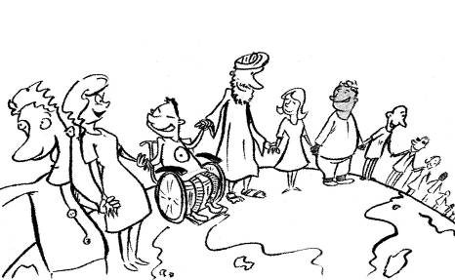
Annex 7 : List of participants

1 | Gilles | Baccala | M | French | French NA (INJEP)
2 | Emmy | Bornemark | F | Swedish | Swedish NA (The Swedish National Board for Youth Affairs)
3 | Ülly | Enn | F | Estonian | Estonian NA
4 | Liliana | Cruz | F | Portuguese | Portuguese NA
5 | Andreas | Bruun | M | Danish | Danish NA (CIRIUS)
6 | Pam | Simpson | F | British | British NA
7 | Paavo | Pyykkönen | M | Finnish | Finish NA (CIMO)
8 | Agnieszka | Moskwiak | F | Polish | Polish NA
9 | Melanie | Jacobs | F | Dutch | Austrian NA (Interkulturelles Zentrum)
10 | Yunus Alper | Altay | M | Turkish | Turkish NA
11 | Laura | Laver | F | British | British NA
12 | Astrid | von Jacobs | F | German | French NA
13 | Karina | Sulzanoka | F | Latvian | Latvian NA
14 | Peter | Barendse | M | Dutch | Dutch NA (NJi)
15 | Camelia | Lupu Lordache | F | Romanian | Romanian NA (ANPCDEFP)
16 | Magali | Raynaud | F | French | Belgian/fr NA (Bureau Interantional Jeunesse)
17 | Lucia | Csajkova | F | Slovak | Slovakian NA (IUVENTA)
18 | Loreta | Eimontaite | F | Lithuanian | Lithuanian NA
19 | Liezelot | Simoens | F | Belgian | Belgian/fl NA (Jint vzw)
20 | Pavlina | Lebruskova | F | Czech | Czech NA
21 | Katrine | Daviknes | F | Norwegian | Norwegian NA (Norwegian Directorate for children, youth and family affairs)
22 | Mateja | Demiar | F | Slovenian | Slovenian NA (MOVIT NA MLADINA)
23 | Guido | Kaesbach | M | German | German NA
24 | Peggy | Genève | F | French | European Commission
25 | Kathy | Schroeder | F | Canadian | Trainer
26 | Tony | Geudens | M | Belgian | SALTO RC Inclusion
27 | Ann | Hendriks | F | Belgian | SALTO RC Inclusion
28 | Nele | Melkebeke | F | Belgian | SALTO RC Inclusion – logistical support person

* * * * *

Editorial Info

Published in October 2007
by SALTO-YOUTH Inclusion Resource Centre
www.SALTO-YOUTH.net/Inclusion/
(Support & Advanced Learning and Training Opportunities within the YOUTH Programme)

SALTO-Jint, Grétrystraat 26,
1000 Brussel,
Belgium
Tel: +32 (0)2 209 07 20 - Fax: +32 (0)2 209 07 49
inclusion@salto-youth.net

Coordination & Editing: Ann Hendriks, ann@salto-youth.net
Author & facilitator of the Inclusion Staff Training: Kathy Schroeder, kathy.schroeder@planet.nl

With the support of the European Commission, DG Education and Culture
With special thanks to Peggy Genève from DG Education and Culture

Reproduction and use for non-commercial purposes is permitted provided the sources
www.SALTO-YOUTH.net/Inclusion/ and European Commission are mentioned and inclusion@salto-youth.net is notified

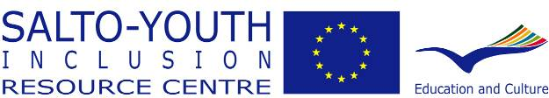

* * * * *

This issue will be covered with the publication of a short leaflet on the Inclusion Strategy addressing young people in a user-friendly way.

