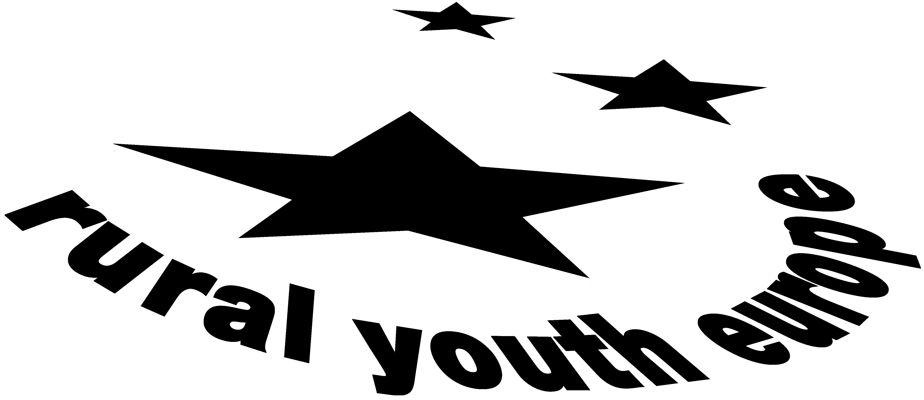

European Youth against Racism and Xenophobia

Report of the study session held by
RURAL YOUTH EUROPE
in co-operation with the
European Youth Centre
of the Council of Europe

European Youth Centre Strasbourg
30th January – 6th of February 2005

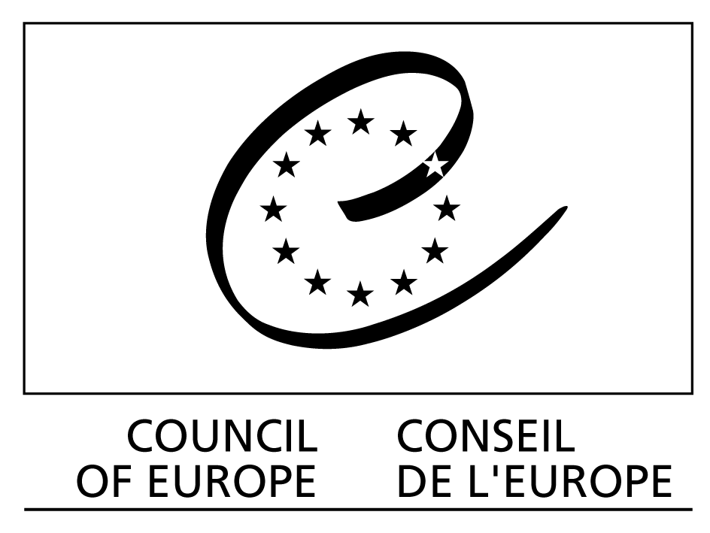

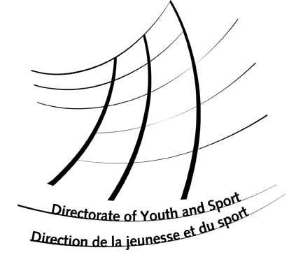

This report gives an account of various aspects of the study session. It has been produced by and is the responsibility of the educational team of the study session. It does not represent the official point of view of the Council of Europe.

DJS/S (2005) 7 Strasbourg, February 2005

European Youth against Racism and Xenophobia

Report of the study session held by RURAL YOUTH EUROPE
in co-operation with the
European Youth Centre Strasbourg
of the Council of Europe

European Youth Centre Strasbourg
30th January – 6th February 2005

- Team
Sabine Klocker (Austria) - course director
Zanete Zaharova (Latvia)
Oyvind Saebo (Norway)
Sanil Modessa (UK)
Alexandra Raykova (Bulgaria) – educational advisor

- Editor
Sabine Klocker

Rural Youth Europe
Schauflergasse 6, A-1014 Vienna
Tel: +43-1-53441-8600; Fax: +43-1-53441-8609
E-mail: office@ruralyoutheurope.com
Website: www.ruralyoutheurope.com

FOREWORD

Dear friends and members,

This seminar has been a major effort of Rural Youth Europe, dealing with Human Rights Education in co-operation with the Council of Europe. In 2002 we had the last explicit seminar on Human Rights, and with this study session we decided to focus especially on DISCRIMINATION, RACISM and XENOPHOBIA. Discussing in many of our prior activities during the past couple of years about the expansion of the European Union and possible effects, the mentioned topics were very often touched and participants stated that they want to explore and discuss them further.
In this study session we experienced that it is not an easy topic to deal with, because it is difficult to discuss and admit that each one of us discriminates and has certain stereotypes, for example. This seminar has been a big learning experience for all of us, eye-opening for many involved parties and completely new for some participants to experience the situation of a refugee, a homeless or a disadvantaged person of whatsoever kind. Being aware of discrimination of women, racial discrimination or discrimination of any other type is highly important – also for young people in the countryside (where the mentioned issues might not always be that evident?! - and not that much action is taken in the field so far).
Rural Youth Europe also contributes with this activity to the European wide focus in 2005 to act against Racism. The European wide action week against Racism takes place from the 14-21st of March 2005, with the 21st of March being the International Day for Elimination of Racial Discrimination.
I hope that many of our members and associated organisations will take the opportunity to contribute to the mentioned topics this year (and in the future) too and I know that many of our seminar participants will – as they’ve worked out great projects plans resulting from the knowledge they’ve gained during the seminar.
I would like to thank ALL INVOLVED PARTIES who made this seminar a success – first of all, 31 great participants who were very enthusiastic and motivated (also in compiling part of this report!!); secondly, the hardworking prep team (Zanete Zaharova - Latvian YFClubs, Oyvind Saebo – Norwegian 4H, Sanil Modessa – Minorities of Europe, Alexandra Raykova – trainer CoE) with whom it was a great pleasure to work; thirdly, Inge Stuer as the educational advisor (furthermore, Silvia Volpi, external trainer) and last but not least, the staff of the EYC Strasbourg. It’s been an unforgettable experience, a LOT of FUN, and a VERY productive session.
I hope all participants will put their project ideas into practise and expand the European network with the new friendships gained during this study session!

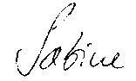
Sabine Klocker
Secretary General – Rural Youth Europe

Table of Contents

- Executive Summary
- Why this Study Session
- Overall Aim
- Objectives
- Profile of Participants
- Learning Outcomes of Participants
- Furter Outcomes
- Methodology
- Educational Approach
- Follow up
- Daily programme

- Day – by – Day Reports

- List of Participants

European Youth against Racism and Xenophobia
Rural Youth Europe – Study Session
European Youth Centre, Strasbourg
(30th Jan. – 6th Feb. 2005)

Executive Summary

Why this Study Session?
As mentioned in the foreword Rural Youth Europe has worked in co-operation with the Council of Europe on similar issues before and aims at developing strategies of mainstreaming Human Rights and Intercultural Dialogue and fight against Racism and Xenophobia. Rural Youth Europe is committed to supporting the work of the Council of Europe, Directorate of Youth & Sports and in particular the Human Rights Education Programme. With this years’ study session we decided to focus especially on DISCRIMINATION, RACISM and XENOPHOBIA, as this was an expressed need by our members when discussing about the expansion of the European Union, migration and related effects in prior activities.

Overall Aim of the Study Session:
- To prepare young people from rural youth organisations to act against the growing Racism and Xenophobia within their local environment and the society in general, through strengthening their capacities to deal with these issues and to organise relevant activities within their organisations or/and Rural Youth Europe.
In pursuing this aim, we’ve made use of the special experiences of Council of Europe Youth Directorate Human Rights Education Programme, as well as previous and current experiences within activities of ‘Rural Youth Europe’.

Objectives of the Study Session:
- To provide the participants with possibilities to get to know each other as well as their organisations and realities.
- To examine participants’ perceptions about Racism and Xenophobia.
- To analyse the challenges faced by the young people in rural areas in relation to the topic.
- To provide some theoretical and practical knowledge on the concepts and how to deal with these and related phenomenon, such as anti-Semitism, discrimination, social exclusion, etc.
- To raise their awareness on the importance of ICL as a tool to combat /fight against racial prejudices, intolerance, xenophobia, etc.
- To define relevant strategies and to prepare concrete projects related to the theme of the seminar, which can be implemented within the framework of their NGOs and Rural Youth Europe.
- To provide them with some relevant tools such as information (funding, relevant programmes of the CoE,..) and skills + training materials.
- To promote exchange of good NGO practices in dealing with the issues.
- To increase pax motivation to work against Racism and Xenophobia.
- To introduce Rural Youth Europe and the CoE.
- To strengthen networking between the NGOs and within Rural Youth Europe.

Profile of participants:
Participants came from a diverse range of youth organizations across Europe, covering 14 different countries (19 different youth organizations). These included Austria, Armenia, Bulgaria, Estonia, Finland, Germany, Ireland, Latvia, Norway, Slovenia, Sweden, Republic of Macedonia, Ukraine and the United Kingdom. Regarding their profile one can point out that they all were interested in the theme and in becoming active at European level; they were motivated for a possible follow-up and the multiplication of the topics of the seminar; they were multipliers active at local/regional/national level in a (rural) youth organisation; members of Rural Youth, Young Farmers’ or 4H Clubs or any other youth/minority organisation; aged 18-30; motivated to develop their knowledge and competence in human rights education and to share their experiences with other participants.

Learning Outcomes of Participants:
The participants took to chance to deepen their knowledge on Racism, Xenophobia and Discrimination as well as Human Rights and Human Rights Education in general; furthermore it was important for participants to analyze how this can be used in their future work with young people.
Intercultural learning was one of the central learning experiences for the participants and the organizers’ put a major effort on the various workshops and inputs in this field. Simply for the reason that only through a good intercultural knowledge und understanding barriers can be solved, as well as prejudice, discrimination, racism and xenophobia avoided. During the intercultural learning simulations, participants stepped into the shoes of a refugee, a homeless person, an unemployed person, a gay or a prostitute for example. Those simulations were followed up with fruitful discussions and participants learned in many ways that they can help friends/people from other ethnic groups/etc. It broadened their mind and made the participants aware of many different issues related to the topic. Moreover, it made them very much reflect upon their own values and life in their communities.
During the seminar participants gained a basic understanding of human rights education approaches and also got acquainted with the “Compass Manual”. They learned about many different ways to present / work with topics related to racism and xenophobia with young people in youth organizations and how to get these across without being boring.
Participants stated that they enjoyed very much getting an overview of discrimination, racism and xenophobia issues, because until now many of them haven't thought about it much and nevertheless, they are convinced that these issues should be covered more within rural youth work.
In addition, participants learned about funding projects and project development, when towards the end of the study session they also started to put their knowledge into practice by developing projects (many of them European cross-country group projects, but also national, regional, and local ones) which are to be realized within their youth organizations back home.

In working groups on ‘conclusions’, participants developed concrete answers and solutions on questions like: What are the major challenges, faced by young people in Europe in relation to the topic of the session? What are the main strategies that young people in rural areas have in order to address these? How can these strategies be implemented?

For many young people participating in the study session, it was also a completely new experience to communicate with people of different English ability (e.g. some native speakers having to speak slower) which was also part of the on-going Intercultural learning process. Moreover, the learning about other organizations, cultures and about European (rural) youth in general was a very intense and challenging experience for all participants.

Further outcomes:
In achieving the aims and objectives of the study session, “RYEurope” targeted to strengthen and enlarge its existing European network and encourage new partnerships.
The organisation Rural Youth Europe managed to expand its networks in several directions:
First of all, with involving several organisations and individuals who are not members of Rural Youth Europe and are active in the field of HRE and/or working with minorities. Secondly, a new effort was put on mainstreaming human rights education in the activities of RYEurope. Thirdly, RYEurope continued to further develop the concept to network with countries where the movement doesn’t have any member organisations yet (e.g. Macedonia, Albania, Russia).
As a matter of fact, with organisations like ECRI (European Commission on Racism and Intolerance), NYC of Armenia, DROM Macedonia, Minorities of Europe and the European Roma organisation Rural Youth Europe co-operated for the first time during this activity and those will definitely also be an important link for the organisation in the future.

Methodology of the Study Session:

The working methods of the study session were to facilitate the exchange of information and to bring people to the attention of the work of the Council of Europe, Directorate of Youth & Sports and in particular the Human Rights Education Programme. Contributions by participants and team members have given a broad picture of existing initiatives, projects and approaches to work with young people on the issues of Anti-Racism, Xenophobia and Discrimination.

Educational approach of the Study Session:
The working methods of the study session facilitated exchange of information and knowledge among participants, and between team and the participants. The study session profited from the educational approaches of the Manual on Human Rights Education “Compass”. In addition, Domino, the Education Pack and the T-Kit on Intercultural Learning were used. Throughout the session, a variation of exercises was used and background material was distributed. Towards the end of the study session, project development methodology was used to assist participants to develop their own individual or group projects on human rights education.

Follow-up:
Seminar reports and interviews were published in newsletters and websites of many involved parties. Rural Youth Europe will follow-up this study session with a multicultural youth exchange in July 2005 involving 120 people: “Expanding Horizons - One Europe. Many Cultures”. Moreover, in July 2006 a youth exchange, called “One World. Two Faces” in Latvia, will deal with the problems (discrimination, racism) between city and rural youth.
In addition, in Autumn 2006 we will have a seminar in Wales, where we will work on the issues of this year’s study session again, but the seminar will take place in the city centre, where our rural young people will work together with disabled people, drug addicts, people from ethnic minorities, refugees, etc. Furthermore, many follow-up projects (project work mentioned before) will be taking place within or member organizations on local/regional/national/European level and will be supported by Rural Youth Europe. This concretely should lead to further development and enlargement of Rural Youth Europe’s work in the fields of intercultural learning and human rights education.

Daily programme:
The programme developed by the prep team aimed at exploring and exchanging the experiences of the participants in relation to the topic; explaining, discussing and partly experiencing (during Intercultural learning workshops) Racism, Discrimination, Anti-Semitism, Romaphobia and Xenophobia ; learning about relevant institutional programmes and activities (CoE, YSD, ECRI, RYEurope), as well as Human Rights Education in general; getting to know relevant funding programs – EYF and the “YOUTH” Programme; Furthermore, a focus was put on skills development and the presentation of good practices. Exploring links between intercultural learning and human rights education was of major importance, as well as Social inclusion and different ways to address discrimination and isolation. In the end-phase of the study session project development (concrete projects in human rights education) was in the centre of the attention, as well as networking, follow-up and evaluation (for details refer to the programme on the next page).

Study session of Rural Youth Europe: “EUROPEAN YOUTH AGAINST RACISM AND XENOPHOBIA”
30th January - 6th February 2004; Programme

Sunday 30/01 | Monday 31/01 | Tuesday 01/02  ‘Int. Breakfast’? | Wednesday 02/02 | Thursday 03/02 | Friday 04/02 | Saturday 05/02 | Sunday 06/02
9.30 | Opening  Introduction  Participants+Team  Aims+Objectives  Council of Europe  Rural Youth Europe | Analyse the challenges (perceptions)  Theoretical input on Racism and Xenophobia | ICL (Intercultural Learning) simulation  (ICL practice)  ICL theory | Workshops:  Human Rights Education  Intercultural Learning | Funding:  European Youth Foundation  Youth Programme | Project Presentations in Plenary  Follow-up  Networking  Re-groups | Departure
Lunch 13 – 14.30
Arrival of participants  Preparation of Exhibition | Group building  Sharing realities and perceptions in working groups  Re-groups | Info: Council of Europe  Excursion to Council of Europe building + ECRI  Re-groups | Good practices  Workshops:  Anti-discrimination  Youth Participation  Re-groups | Free Afternoon in town | Project work  Re-groups | Evaluation of the week
Dinner 19.00 |  |  |  | Dinner in town
Welcome Evening + Icebreaking | International Buffet/Evening | Info Market | Evening progr:  Social committee | Evening in town | Evening progr.  Social committee | Farewell Party
Breakfast: 8.00-9.00, Coffee Breaks around 11h in the morning and 16h in the afternoon; Programme ends around 18.30.

European Youth
Against Racism
& Xenophobia

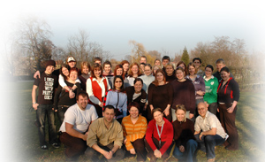

DAY-BY-DAY REPORTS

30th January – 6th February 2005

Monday 31st January 2005

1. Title of the session:
- Welcome and Opening
- Introduction
- Getting to know each other, teambuilding

2. Objectives:
- To introduce PAX and the team;
- To introduce them to the seminar – aims & objectives; programme of the week;
- To introduce PAX to the Youth Centre (admin. announcements, etc.)
- To introduce the CoE;
- To introduce RYEurope;
- To get to know each other; (ice-breaking, team building)
- To learn more about participants’ expectations, motivations and fears;

3. Programme:
The programme started with getting to know each other activities, followed by the official welcome and opening of the course. The aims and objectives (Appendix 1) as well as the programme (Appendix 2) were introduced, an introduction of RYEurope and practical info given; furthermore, the expectations, motivations and fears of participants were discussed. The afternoon focused on team building (SWAMP exercise) and sharing realities within small working groups. The day was finalised with Re-groups and later in the evening specialities were offered at the International Buffet.

4. Educational methods used
- Ice-breaking, getting-to know each-other and team-building activities (newspaper/’bedlinen’) (Appendix 3)
- name game, “swamp”
- Working in pairs (shield exercise)
- Individual work (expectations/motivation/fears)
- Group work / discussions (sharing realities and perceptions in working groups)
- Presentations in plenary (done by facilitators for the various introductions);

5. Thematic discussions or inputs:

5.1. INTRODUCTION TO RURAL YOUTH EUROPE (Appendix 4)
An introduction to the NGO Rural Youth Europe – formerly known as “European Committee for Young Farmers and 4H Clubs, ECYF4HC (the name was changed last year) – of which most participants are members through their national organisations, was given.

The structure of the org. is very similar to most national Young Farmers and Rural Youth organisations, consisting of a Chairman (Franz Fensl from Austria), a Vice-Chairman (Delme Harries from the UK) and four regional board members, representing the British Isles and Malta, Scandinavia, Eastern and Central Europe. The board members work on a voluntary basis, whereas Sabine Klocker as Secretary General is the only paid staff (the office of RYEurope is currently situated in Vienna).

The organisation was founded in 1957, has at present around 500.000 members, coming from 24 different member organisations working/situated in 20 different European countries and regions. (list of member organisations attached in the Appendix).

Rural Youth Europe wants to:
- Educate and train young people and create an awareness of the issues of the countryside
- Actively counteract rural depopulation
- Help to develop new rural youth organisations
- Take an active role in the development of environmental and agricultural issues and policies
- Network with other European NGOs
- Lobby and focus the attention of international and national bodies, as well as the general public, on the problems and needs of rural youth

As a member you can
  - take part in
- Our STUDY SESSIONS for rural youth leaders in co-operation with the European Youth Centres of the Council of Europe in Strasbourg and Budapest. These courses cover themes like leadership training, organisational development, organising international youth activities etc.
- The annual EUROPEAN RALLY (hosted every year by a different country) as a team in the many group activities, like workshops, excursions, host family stays, intercultural and social activities
- Our TRAINING COURSES about specific themes of interest for rural youth like sustainable regional development, working with disabled people in organic farming, etc.

  - contribute to
- Our E-NEWSLETTERS, the PUBLICATION of RURAL YOUTH INFO, our HOMEPAGE, reporting about Rural Youth Europe and its member organisations’ activities, as well as current topics and events in European youth work

  - attend
- Various training courses and seminars organised by the Council of Europe, the European Youth Forum and other international NGOs.
- Various exchange programmes as we actively co-operate with organisations like IFYE and IAEA furthermore, with MIJARC and CEJA.

5.2. Aims and Objectives of the Study Session were presented and discussed.

AIM
To prepare young people from rural youth organisations to act against the growing racism and xenophobia within their local environment and the society in general, through strengthening their capacities to deal with the issues & to organise relevant activities within their organisations or/and Rural Youth Europe.

OBJECTIVES
- To provide participants with possibilities to get to know each other
- To examine participants perceptions about Racism & Xenophobia
- To analyse the challenges that are faced by young people in rural areas
- To provide theoretical & practical knowledge on the concepts
- To raise the awareness on the importance of ICL
- To develop relevant strategies & to prepare concrete project ideas
- To provide the relevant tools and skills
- To promote exchanges of good Non – Governmental Organisations (NGO) practices
- To increase participants motivation to work against Racism & Xenophobia
- To strengthen the network between NGO’s and Rural Youth Europe

6. Recommendations and outcomes of group discussion:

6.1. EXPECTATIONS – MOTIVATION – FEARS of participants regarding the one-week study session of Rural Youth Europe and the EYC:

Participants reflected on an individual basis about their expectations/motivation/fears regarding the study session – they wrote their concerns/opinions/statements on post-its which were all put on huge posters in the plenary room, where everyone can read and reflect upon those. The comments were the following:

MOTIVATION – “What is your motivation to participate in this seminar?”

- Interest in the theme
- A good chance to improve my English and talk with other people about different topics
- To meet new people / from different countries – International environment
- Xenophobia is a big problem back home. Many people fear foreigners just because they don’t know anything about them.
- To ensure that my org. is represented
- To raise awareness of the topic in my org. back home
- To learn more about other rural youth organisations in Europe
- Someone thought I am the right person to be sent to this seminar and finally motivated me
- To discuss a problem that concerns us all
- To gain new experiences
- To get more knowledge
- My own study background and experiences in my organisation
- That I can take back home what I’ve learned here and help in my org. + rural area in the battle against Racism and Xenophobia
- Considering the fact that Roma are the most discriminated nation in Europe and they are living with a constant influence of racial discrimination and other type of stereotypes – I think most people don’t know about this
- Spread and promote information about the Council of Europe and RYEurope in the Ukraine
- Interesting topic and it is related to my work. Meet people from other countries.
- Learning more about how people live in other countries.
- Where I live you don’t see so many different people - they don’t like it there because the inhabitants have so many perceptions.
- Develop contacts and Networks all across Europe.

EXPECTATIONS – “What do you want to gain from the study session?”

- To gain new ideas and hear about experiences from different countries.
- To learn more about racism and xenophobia.
- To get useful information for implementation.
- Learn about other Countries.
- To learn other peoples’ way of dealing with problems and learn from their experience.
- Have fun, meet new people.
- Getting inputs on human rights.
- Getting to know good examples on how to avoid racism and xenophobia.
- To understand differences between people and understand that they have different cultures.
- To speak English for a whole week.
- Information on European Youth Foundation, different possibilities on funding projects, camps, gatherings etc…
- Learn how young people can affect the way the EU is working / ruled.
- Compare other organisations with my own NGO back home.
- To learn something new.
- Understand the reasons why racism and xenophobia exists.
- How to involve young people from Eastern Europe within RYEurope.
- Creating a similar youth movement in the Ukraine.
- I want to learn some methods to discover discrimination and to make people aware of it.
- Develop my limited knowledge on racism and xenophobia and bring it back to my own organisation.
- The future is in our hands, all the solutions for the problems depend and on us. That’s why we need to join and engage ourselves to get/reach good results.

FEARS – “Do you have any fears related to this seminar?”

- some vocabulary problems / knowledge of English not good enough to discuss all related problems connected with Racism and Xenophobia
- that I won’t understand well enough
- that I don’t find the rights/expressions – that others don’t understand me
- not being able to learn from the seminar
- speak English for one week
- too little sleep
- too little time
- too much to discuss
- not to participate in the discussions enough – miss out on something
- travelling alone – not knowing anyone here
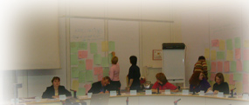
- get lost / don’t find the EYC, the right train/plane/bus
- ‘the unknown’ – having never attended a seminar before
- To have to sing / dance
- Not knowing any energizer
- Having to perform in the crowd

6.2. ‘Shield’ exercise

This exercise focuses on getting to know each other better. Participants are invited to close their eyes and once opening them again to focus on the person standing right opposite themselves (everybody was sitting in the plenary which is formatted in a circle). The person on the opposite side was therefore chosen their partner for the shield exercise. Participants were given the drawing of a shield – which was divided into four segments. The four segments included discussions around, 1) their personality, 2) hobbies, 3) dreams/visions, 4) personal motto. Pax were asked to discuss with their partner on an interview basis the mentioned 4 areas/headings and had to write (draw) it within the 4 squares of the shield. As a result of this pax were then asked to present their interview partner + shield to the rest of the group in the plenary.
In the middle of every shield, pictures of each participant were put, in order to guarantee to promote dialogue between the participants (shields were then put up in the plenary room for everybody to view and find out more about their colleagues).

6.3. Swamp Exercise

The swamp exercise was introduced to help facilitate the objective of group building. It would familiarise a better understanding of leadership, listening, communication and visual skills.
The aim for the participants was to get through the swamp (Fig 1) from side to the other without taking the wrong step all together without any verbal communication. The steps that they could take were only forward, left or right. They were not allowed to step backwards. If during the process of the exercise the participant who is leading the group takes the wrong step, that person has to go to the back of the line and then the next person is to restart the flow all over again.

Each participant has to take exactly the same step as the person in front of him or her. If they also take the wrong step, the whole group re-starts.

Fig 1.

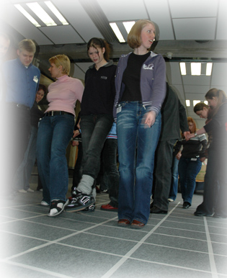 |  |  |  | END
 |  |  |  | 20
 |  |  | 19 | 18
 |  |  |  | 17
 |  |  |  |  | 16 | 15
 |  |  |  |  |  |  | 14 | 13
 |  |  |  |  |  |  | 11 | 12
 |  |  |  |  | 9 | 10
 |  |  |  | 7 | 8
 |  |  |  | 6
 |  |  |  |  | 5
 |  |  |  | 4 | 3 | 2
 |  |  |  |  |  | 1
 |  |  |  |  |  | START

Debriefing

Participants felt that they had so much responsibility for them to lead and guide the others across without the taking the wrong step. They felt insure, frustrated and very opportunistic. This meant that with their insecurity they also felt they had too many options to choose from.
Swamp was also good for all the participants to work collectively and challenge their mental ability and thinking. Their difficulty was the communication barrier, which they found exasperating without any speech.

To find the acceptable solution they were not afraid to taking the wrong step and making mistakes.

Conclusion of the swamp exercise: Leaders come and go, but the unity of a group still remains in focus and doesn’t depend or rely on the leader for dictatorship and guidance. This means the co-operation of team is more important than a leader.

6.3. Sharing realities and perceptions in working groups:

Participants looked at a variety of pictures indicating different types of discrimination, racism and xenophobia, and this was the outcome – relating those pictures pictures with the participants’ realities back home:

Group 1:
- “What happens in our communities?”

The visa problem.
In Ireland there are a lot of refugees. They are allowed into Ireland with full benefits yet are not legally allowed to work. Thus people think that they are taking benefits from the native population.
Visas will always be present as countries will want to keep their own identities in the ever growing European Union.

The minority problem.
In Albania there is a minority problem but no visa problem.

The difference between the sexes
We have to look at the two approaches to the above situation – men against women as well as women against men. In Armenia sexual minorities may be there but they are not seen.

As a discussion group we believed that all the problems in the pictures occur in our communities but we tend to just live with them, and not deal with them as we should. Attitudes are different for different cultures, i.e. Russia and Armenia. In Russia, Russians are the doctors and policemen, Armenians are simple peasants.

- Causes of these situations.
- Prejudice
- Ignorance – lack of education and knowledge.
- Stereotypes
- Selfishness
- Fear
- Misunderstanding
- Confusion
- Problem of minorities.

- “Is your Organisation working in these areas?”
All our organisations, Rural Youth, 4H, YFC, and Macra ne Feirme do not generally work on these themes but in daily work we meet these situations. We have a lot of opportunities to do something with these themes in our organisations. Multicultural training for members/ leaders would be advised as a lot of rural people need more information on these topics. People from rural areas haven’t even met foreigners in some countries.

- “What is your role in the Organisation?”
There is no discrimination within the organisation yet there are no special programmes to deal with these situations. Racism and Xenophobia in the UK tends to belong with the unemployed class of people where there is high unemployment there is racism and xenophobia. With the older generation there tends to be more of a problem than with the younger generation. We can look at Eastern and Western Germany- the countries were reunited in 1989 but in people’s minds they are still separate. Are Nazism and Racism equal?

- “Should we as an organisation do anything about these situations?”
We could try and find a balance between them – some we may choose to accept and some we will try to do something about them. These issues may not be high on the agenda of some organisations – i.e. Macra and YFC, where agricultural issues remain the main issues. Regardless we would deal with these situations if they arose in our communities/ organisations.

Overall the motto of our group can be summarized as

Lead by Example.

Group 2:
- Finland – immigrants are not a big issue in Finland but a lot of Russians want to go to Finland.
- Estonia – they are not accepted in other countries, i.e. at the border you are asked a lot of questions and also to show your identification. This can make you feel threatened and this is when you can experience discrimination. Since May 2004 this has changed since the country joined the European Union. This is a great opportunity for more investment, more jobs, more benefits and a better standard of living.
- Northern Ireland – lots of immigrants coming into the country in order to work, racism has already occurred with people feeling the threat of losing their job. Some racism attacks have occurred because of this. These workers are being paid less wages, so a lot of companies/businesses are very keen to employ them.
- Germany – There is a fear that companies will move to other countries in order of cheaper labour. There is a fear that people will lose their jobs.
- Norway – Homeless/drug users is a big issue in Oslo, they are being removed from the streets because they are not a good image for tourists. These people should rather be helped than discriminated against.
- Sometimes women can be discriminated against but we think this not occur as much nowadays, women have more rights/opportunities.
- Politics can be a big issue – If a person from a different country committed a crime, it would be a big headline on the news or local newspapers.
- If you are in another country and a crime has been committed, people naturally point the finger at the person from an ethnic minority.

Group 3:
- When we looked at the pictures there were a number of issued raised. Things discussed, were the countries different political status. It was mentioned that in Macedonia the Roma people are discriminated against. Legally everyone is equal but in everyday life they are not. Roma people are discriminated against. There are certain stereotypes that men can do certain jobs and not women and the other way around. We said that everyone should be treated the same regardless of who they are.
- Homelessness is quite a big problem in Austria. When people have problems, they become lonely and then lose their jobs and then become homeless.
- We discussed the causes of these issues raised and we said that everyone has the right to a good life. People always want better lives but this affected by the political and economic state of the country.
- Women have particular problems getting jobs when they are pregnant because no one wants to employ them.
- There is a big difference between situations in the city and in rural areas.
- On the news we sometimes only see one side of the whole picture and this is often a negative picture and then people think this is how it is all the time.
- It is good to keep tradition but people sometimes get too carried away in not wanting to accept change and they need to keep integrating new ideas.
- We discussed different aspects of violence and how people accept violence when they should stand up to it or take action against it.

Group 4:
- Homeless Man
Has obvious problems but is not noticed by others, and because he is homeless, he has no address and therefore no way of obtaining help or getting a job. Again this is emphasized with the second sketch which shows the poor treatment of the homeless because of their status.
- Sexual Discrimination
This is represented in many European Countries by the presence of the so-called ‘glass ceilings’ which mean that women can only reach a certain level within the workplace and no further, with top management positions still being held by men.
- Street Violence
This drawing shows the fear of people who witness violence on the streets but do not help because they are afraid of being attacked themselves.
- Visas
This relates to the problems many European countries have with their members trying to obtain visas to travel. Often, those who obtain tourist visas abuse them and use them to travel to another country in order to obtain employment. Because of this, it is very difficult for them to obtain a visa. It is also bad for the traveller’s home country as people of working age leaving to work elsewhere cripples the economy of the home country.
- Reasons for these problems
Politics and economics are quite often the reasons for the most of these problems. Unfortunately they remain largely unsolved because many people look away and ignore them happening. Situations can also be made worse because victims do not have basic rights and therefore turn to crime or drugs. In the case of homelessness, people feel that they quite often get themselves into this position because of family problems, or alcoholism. In the case of sexual equality, problems of discrimination arise from historical problems.
- How these problems are addressed
- Homelessness
There are not enough shelters in many areas to help house those on the streets. Some organisations have already collected money to donate to charitable organisations which deal with this problem

7. Evaluation, conclusion and follow-up:
Participants commented in their lab-groups that time was running throughout the day – in addition they stated that they liked the variation in the programme, especially all the ice-breaking and teambuilding exercises. Regarding the ‘swamp’ exercise participants were very positive about it – the only criticism was that they would have liked some more explanations in the beginning – they felt a bit lost and did not develop a group strategy how to solve the ‘problem’. The group atmosphere was experienced as being very positive by the participants and they are feeling more and more comfortable being at the EYCS.

8. Resources used
Info-folder of Rural Youth Europe; website: www.ruralyoutheurope.com;

Tuesday 1st February 2005

- Title of the session
Introductions to CoE and ECRI.
Racism and Xenophobia – challenges and perspectives

- Objectives
- To provide space for exchanging and analyzing the realities of the rural youth related to the topic;
- To provide theoretical knowledge (Appendix 5) on the concepts related to the topic such as:
- racism
- xenophobia
- discrimination
- ethnic discrimination
- cultural fundamentalism
- To introduce the CoE (Appendix 6) and its relevant framework;
- To introduce ECRI;
- To inform the participants about the possibility to initiate co-operation between their NGOs and ECRI while working on issues related to the topic of the seminar;
- To get to know the relevant mechanisms that ECRI and the CoE in general are using in the promotion of actions against racism, xenophobia, etc.
- To provide the pax with some relevant publications of ECRI/CoE in this field.

- Programme
Participants opened the session with a Finnish energizer. The work programme started with working groups, which presented their findings doing creative presentations. This was followed-up with an input on the concept of Racism and Xenophobia. The afternoon was dedicated to the Council of Europe, visiting the actual CoE building, as well as ECRI (European Commission Against Racism and Intolerance) and having a presentation and discussions on the spot. Re-groups and a very interesting organisations market rounded up the programme of the day.

4 Educational methods used
Educational methods used included group energizers, talks from invited guests and one from our team leaders. Group discussions, teamwork, thematic presentations and we had the opportunity to ask questions to gain more knowledge.

5 Thematic Discussions or Inputs

Group discussions
We began the day with discussions within our groups on racism and xenophobia and the effect they have on our own community. Most issues raised included minority groups and verbal and physical discrimination. To combat racism and xenophobia in our communities, we discussed methods which are already in place such as human rights declaration, changes in the law and representatives for the minorities.

Thematic presentations
Each group performed a short sketch on different aspects of racism and xenophobia such as problems which are faced by immigrants going to a different country, homelessness, job seeking, bullying in our communities and language barriers.

An input on racism, discrimination and xenophobia presentation (Appendix 5) was given and the concept of racism and xenophobia explained. Furthermore, racial discrimination, discrimination against women and other types of discrimination such as social level and disability were discussed. We covered the causes and actions of discrimination and looked at the immigration situation. We looked at two specific examples of discrimination in Europe in Anti-Semitism and Romaphobia.

The Directorate of Youth and Sport of the Council of Europe (Appendix 6) with its member states policies and constitution were introduced to us by Inge Stuer. The Council of Europe deals with Democratic Ideals and Standards, European Cultural identity, Co-operation on relevant issues for societies and the Universality of Human Rights. More details are given in the Appendix.

Moreover, we went to see and learn more about the European Commission against Racism and Intolerance (ECRI) at the actual Council of Europe building. ECRI is the CoE’s monitoring body, combating racism, xenophobia, anti-Semitism and intolerance in greater Europe, from the perspective of the protection of human rights. They do this by a country-by-country approach, working on general themes and relations with civil society.

In the evening an Information Market where all participants were asked to produce a display on their country and organisation, was held. This gave everybody an opportunity to learn something about their fellow team members and their organisations. We were divided into two groups with one group manning their stands and the other had the chance look at the different displays, we then changed around (when the music stopped) after half an hour. Everyone had the chance to ask questions on the respective organisations and collect advertising merchandise i.e. stickers and pens.

6 Recommendations and outcomes of group discussion
As a whole the team believes that group discussions are a good opportunity to talk and exchange views as the team members are from all over Europe, where different issues occur. Although we are from different backgrounds we seem to come across similar problems in our communities with relation to the theme of our seminar. We discovered that the language barrier is a major problem in many countries within the EU.

Group discussions are a great way of getting everyone involved as the themes discussed are major issues in all our countries and it gives us a good opportunity to get to know each other.

7 Resources used
- International Convention on the Elimination of All Forms of Racial Discrimination
- Convention on the Elimination of all Forms of Discrimination against Women
- “Declaration on Race and Racial Prejudice” adopted by the General Conference of the United Nations Educational, Scientific and Cultural Organisation, Article 1
- Council of Europe www.coe.int
- Directorate of Youth and Sport www.coe.int/youth
- European Youth Centre Budapest www.eycb.coe.int
- Human Rights Education Youth Programme www.coe.int/hre
- “Covenant” with European Commission www.training-youth.net

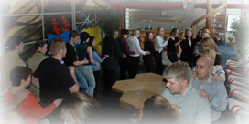 | 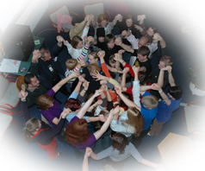
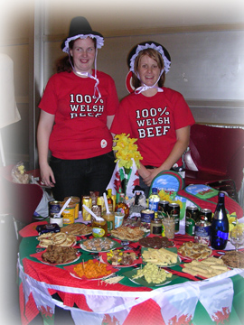 | 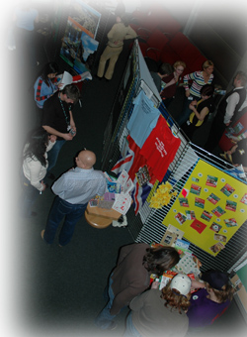
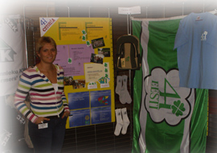 | 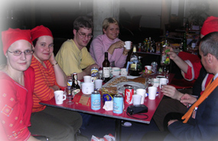

Wednesday 2nd of February 2005

- The title of the session
Introductions to ICL
- ICL Practice
- ICL Theory
- Examples of good Practices
Antidiscrimination and Youth participation
- Objectives
- To understand the variety of approaches and understandings of intercultural learning in non – formal education
- To foster tolerance and empathy
- To be able to step into another person’s shoes/reality
- To cross one’s comfort zone – experience personal limitations
- To further develop an awareness of difficult cultures
- To learn from each other (to experience the group as a source of learning)
- To experience multi – cultural realities
- To get to know yourself better through the self – reflection
- To provide the opportunity for participants to share ideas of good practice from their own organisations on the topics related to the study session
- To provide the participants with theoretical and practical experience on the following topics
- Antidiscrimination
- Youth Participation
- Human Rights Education
- Intercultural learning
- To improve the participants’ skills to deal with the mentioned

- Programme

Participants decided to start the day with the ‚Nordic knot’. The morning was dedicated to ICL and two simulation exercises (Take a step forward, Can I come in?) were experienced by the participants. In the afternoon a presentation on best-practise examples of participants, as well as workshops on Anti-discrimination and Youth Participation were offered. The day was concluded with Re-group meetings.

- Educational methods used
- Ice–breaking, getting to know each other better
- Working in groups

- Discussion
- Presentation in plenary

- Thematic Discussions or Inputs
After the energiser we were split up in two groups, to learn about Intercultural Learning (ICL). There were two parts in this session; during the first part we had an exercise called “Take a step forward”.
We all got a little sheet of paper there was a society role written on it. Then we were asked a few questions, and then we were supposed to think like the person on the sheet.
We were not allowed to show anybody who we were. After thinking about, we formed a line and the facilitator read some statements and if the statement fit to the person whom we represented, we were supposed to step forward. After the statements each person had a new position and we started a discussion about social status.

Objectives
- To develop knowledge and understanding about refugees and their rights
- To understand the arguments for giving and denying refugees entry into a country
- To promote solidarity with people who are suddenly forced to flee their homes.

The roles taken over by the participants were the following ones:
  - You are an unemployed single mother.
  - You are the daughter of the local bank manager. You study economics at university.
  - You are the daughter of the local bank manager. You study economics at university.
  - You are the 19-year-old son of a farmer in a remote village in the mountains.
  - You are a disabled young man who can only move in a wheelchair.
  - You are a 17-year-old Roma (Gypsy) girl who never finished primary school.
  - You are an HIV positive, middle-aged prostitute.
  - You are an unemployed schoolteacher in a country whose new official language you are not fluent in.
  - You are a 24-year-old refugee from Afghanistan.
  - You are a homeless young man, 27 years old.
  - You are the daughter of the American ambassador to the country where you are now living.
  - You are an illegal immigrant from Mali.
  - You are an unemployed schoolteacher in a country whose new official language you are not fluent in.
  - You are the president of a party-political youth organisation (whose "mother" party is now in power).
  - You are the owner of a successful import-export company.
  - You are a 17-year-old Roma (Gypsy) girl who never finished primary school.
  - You are a 22-year-old lesbian.

The second practise called “Can I come in?” started by getting a card describing a social position (refugees, observers and immigration officials). Then we had to act out our roles split up in these three groups. And then together we acted the sketch and the observers had to watch and criticise in the following discussion. The refugees were a family with 2 children and a grandmother. The husband was a doctor and the mother looked after her children. The family was poor and it was a dark cold night.
The immigration officials decided to allow the husband to come to their country because he can work and the wife had to decide between her husband and her children.
The rest of the family was not allowed to come to the country (grandmother &children).
Objectives
- To develop knowledge and understanding about refugees and their rights
- To understand the arguments for giving and denying refugees entry into a country
- To promote solidarity with people who are suddenly forced to flee their homes.

After lunch we listened to a very interesting presentation about different cultures and backgrounds which we are not able to realize. An example for such an illusion was shown: a picture with a fence with a whole in it was presented and we all thought that a cow would be behind the fence, but finally there was a drunken man behind.
Then we had three short presentations about best practise examples realized by participants from Finland, Estonia, Macedonia and the UK. One was for example a self-made movie, which was about interfaith and showed examples of how we can fight discrimination.
In the second part of the afternoon we are asked to choose among the following two workshops:

Youth participation workshop

The first workshop was dealing with Youth Participation. We were given a sheet with questions which we had time to think about and then we moved around the room in a carousel-type effect and discussed the answers to these questions with different people in the room. The questions were about youth participation and how we can involve the youth of our society and educate them on issues. Now we know that there are a lot of possibilities how Youth Participation could be.

This was followed-up by an explanation of the ladder of participation and what each rung of the ladder meant. We discussed the different rungs and gave examples of these in society. (Appendix 7.1, 7.2)

Anti-discrimination workshop

In the second workshop on Anti-discrimination the group started out with a brainstorming session. Mostly expectations and opinions were mentioned; what Anti-discrimination could be. Later in this workshop group was split in three smaller groups. Each group got one situation (case study) showing different kind of discrimination. Each group had 45 minutes to come up with the strategies that could resolve these issues. This was presented and discussed with the group to see how realistic these strategies can be. After that tools and instruments such as laws, media, education, political participations, and states of ratification that can be used in the fight against discrimination, were introduced to the group.

The strategies are outlined after each case study below.

Case study 1
You are the team of a Rural Youth Organisation, which is based in a village in the countryside.
You were informed that two days ago a young homosexual man from the village was attacked and now he is in the hospital with serious injuries.
The results from the police investigation showed that 2 members from the Rural Youth Organisation were among the perpetrators of this criminal act.
You have called a meeting with all people responsible within the organisation in order to decide how you will react as an organisation and to prepare a concrete plan of action.
The strategies in this case by working group:

- Campaign of information;
- Invited experts to deliver on hire;
- Publicity materials;
- Media promotion;
- Inviting two members of incident to review
- According to review:
- Education;
- Dissemination.

Case study 2
You are members of a Young Farmers organisation, which recently announced a vacancy for a technical assistant in the office.
There were only two candidates for this position – very skilled young woman, which is also member of the organisation and a young man, which is not equally competent, but is close friend of the President of the organisation.
The woman was rejected from your President, who was in charge of the selection. On the ground that she is just married and she will probably have to go on maternity leave and this is not appropriate to the plans of the organisation.
The female candidate has turn to you as members of the organisation and asked you to react.

In this case:
- Raise the matter at executive level;
- Nez interview panel
- Re-advertising;
- Speaking to an equality commission

Case study 3
You are leaders of a 4H camp, which is taking place in the countryside. Among your participants there are 3, which are from an ethnic minority background.
On the second day of the camp the 3 children from the ethnic minority background come and tell you that the others do not want to play with them and are making jokes about them. All of them were feeling isolated and even verbally harassed and therefore they want to get in contact with their parents and to leave the camp as soon as possible.
You organise a team meeting in order to decide how you will react to this situation.

In this case:
- Resolving internally;
- Dividing the core of the bullies;
- Keeping the three ethnic children together to build a bond;
- Group building exercise’s;
- Creating a pen pal;
- Learning;
- Monitoring.

- Recommendations and outcomes of group discussion
The exercise “Take a step forward” showed us the big differences and that not everybody can use his right. In the end of the exercise some of our group had step very often and other ones just had step one or two times.
7. There is a big gap between all social levels in each society. It is really hard to be both, refugee and immigration officer, they can not believe each other. For the immigration officer it is very hard to forbid the refugee to enter the country.
Concerning on case studies during a workshop called Anti – discrimination, workgroups found certain solution for each case. And they are:
8. Evaluation, conclusions and follow-up
- ICL Simulation
This exercise was very interesting and got everyone involved. The role play made it easier to understand the difficulties that people face.
- Input on ICL and examples of good practices
This was very informative and educational. The diagrams made it easier to understand the concepts of ICL.
- Workshop
- Anti-discrimination – The most effective way of how to solve problems is to educate.
- Youth Participation – This made everyone discuss about the problems and remedies in society and was very effective in making people take part in discussions.
- Resources used
- www.coe.int
- compass (page 217 and 98)
- The European Convention on Human Rights (page 407)
- The Universal Declaration of Human Rights (page 402)
- Status of ratification of major international human rights instruments (page 401)
- Framework convention for the protection of national minorities (Compass page 915)

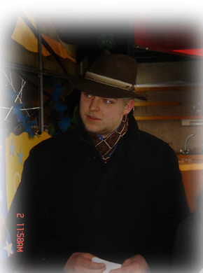 | 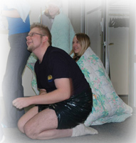
Immigration officer in Can I come in? Refugee family in Can I come in?

Thursday, 3rd February 2005

- Title of the session
  - Human rights education
  - Intercultural learning

- Objectives
- To increase awareness and understanding on human rights issues
- To make people more open-minded
- To give advice for action
- To find examples from reality
- To make participants think what kinds of discrimination exist?
- To provide the participants with theoretical and practical experience in
- intercultural learning
- To improve the participants skills to deal with different situations

- Programme
All morning participants participated in workshops. Some technical announcements were made, regarding travel reimbursement and the free afternoon in town and participants upon that were free all afternoon – a common meeting was scheduled for dinner in town.

- Educational methods used

- Educational methods used included an energizer, talks from workshop leaders and an expert, group discussions, working in pairs and presentations. As one manifestation of discrimination we considered how people imagine heroes and heroines to be.

B) Educational methods used included group energizers, and input from our prep-team. Group discussions, teamwork, thematic presentations and we had the opportunity to ask questions to gain more knowledge.

- Thematic Discussions or Inputs

A) Prejudices
We began with a test of prejudices based on certain texts. We tend to use our own perceptions and stereotypes when judging for example texts and people. We discussed whether we all are equal. We came into conclusion that we all are different, because we have different knowledge, information and skills, but we are equal in our human rights. The inequality in human rights is the possibility to claim them.

Gender based discrimination
The next issue was equality and inequality. First we figured out heroes and heroines in our own countries. Then we discussed of our results in pairs and collected some heroes and heroines on the flipchart. There were more heroes than heroines. We also found some world heroes. We also found some adjectives to describe the heroes and the heroines. The most of the heroes and heroines were persons in history, politics and culture. We use our own background, education and roots to define our heroes.

Different types of discrimination
After finding out that in most of the participants´ society’s gender based discrimination is not a major problem anymore. We talked of other types of discrimination, which are again Turkish especially in Germany and discrimination on ground of disabilities, language, religion and age. Also discrimination on families was briefly discussed.

Different types of human rights education
Next we heard about the human rights education point of view of the Council of Europe. We learned about formal, non formal and informal human rights education. Human rights education provides awareness, understanding and action, and one can learn both through, about and for human rights. We also heard that there is a certain publication, called Compass, to give guidance in human rights education. The most important point is to involve young people to promote human rights. The power point presentation about the topic is attached. (Appendix 8)

B) Intercultural learning
The seminar dealt with the theme of intercultural learning. The nature of the topic was introduced by a prep team member.
The question “what is the meaning of Intercultural learning? “was raised.
Thereafter the participants were split into four groups. The division of the group took place by means of playing cards, on which were four groups of animals, that were distributed randomly between the participants. Each group received a copy of the below story to analyze.

Somewhere in someplace lives a beautiful girl Abigale. She loves handsome Tom who lives on the other side of the river. In early spring a terrible flood has destroyed all bridges across the river, and has left only one boat afloat.
Abigale asks Sinbad, the owner of the boat, to bring her to the other side. Sindbad agrees, but with one pre-condition: he insists that Abigale has to sleep with him in return.
Abigale was confused; she does not know what to do and runs to her mother asking her for advice. Her mother tells Abigale that she doesn’t to interfere with Abigale’s own business.
In her desperation Abigale sleeps with Sindbad who, afterwards, brings her across the river.
Abigale runs to Tom to happily embrace him and tell him everything that has happened. Tom pushes her away roughly and Abigale runs away bursting into tears.
Not far from Tom’s house, Abigale meets John, Tom’s best friend. She tells everything that has happened to him as well.
Getting to know about it John hits Tom for what he has done to Abigale and walks away with her…
Source: (http://www.training-youth.net/site/publications/tkits/tkit4/Tkit4.htm) T kit 4 intercultural learning

Participants were asked to rank the five characters in the story from 1 to 5 (with 5 representing the worst and 1 representing the best of behaviour). Each group was given 40 minutes for discussion. Subsequently, the group was re-united and a member of each of the four groups was asked to present the findings of the group. From this exercise all the groups had different results from the group work.

- Recommendations and outcomes of group discussion

A) We came to the conclusion that there are different expectations about male and female heroes. With the outcome of this we got into the topic of role expectations on women in modern society. We talked a lot about the role women play in society and that structural gender discrimination is decreasing, but there is still some discrimination on individual level. That is only the case in certain European countries. One strong thing, which shows that there is still discrimination, is lower salaries of women in many workplaces.

NGOs have to fight against the discrimination of women and also all kinds of other discrimination which were mentioned before.

B) Exercise 1

Results from the different groups

Role | Group1 | Group2 | Group3 | Group4
Abigale | 2 | 2 | 2 | 3
Tom | 1 | 4 | 3 | 2
John | 4 | 1 | 1 | 4
Mother | 5 | 5 | 5 | 1
Sindbad | 3 | 3 | 4 | 5

The conclusion from the discussion was
Different people have different opinions based on their personal experiences, different cultures, religions and traditions.
- The story was very general and the perception of the variants in the situation (for e.g. The nature and extent of relationships) had a bearing on the results). The story pertained to friendship, love, cheating, families and relationships.
- These are values associated with human beings. Values are stable, but they are also change over time.
- We are all individuals
- There is cultural diversity among us

Exercise 2

The participants were split in two groups. The division of the group was realized with numbers 1 and 2. being allocated to each person. The participants formed two parallel lines according to the group number, and sat on the floor facing forwards. The exercise involved the passing of a symbol successively through each line by tracing the symbol on the back of the person in front. At the back of the lines a prep team member began the process by initiating the sequence at the back. In addition to receiving the symbol in this manner, the person at the back of group 1 also was told what the symbol was. The member on the back of team to was given no information. The result from the first group was smiley man. The second group has circle with two lines in side. The original symbol was actually a circle with a triangle inside.

From the discussion we agreed the follow objectives

- Different people get different meanings from things
- It is very important the way how is present the information
- We can get wrong information

Then Alexandra and Zanete explained the meaning of Formal education (formal education is planned), Informal education and Non formal (it is emotional learning which stems from personal experiences. The seminar is also part of this education because you are planning the performance, briefing etc.)

The next input was related to the levels of learning.
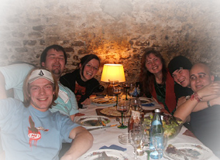
There are the following types of learning

* Cognitive (acquirement of knowledge- school learning)
For example a theoretical input

* Emotional - we are learning, try our life it is changeable

* Behavioural - we are learning from the visible perspective
For example, how to hold a pencil
> Free afternoon and dinner in town

7 Evaluation, conclusions and follow-up
The participants of the workshop liked the methods used and were satisfied with the outcomes.

8 Resources used
- www.coe.int/compass

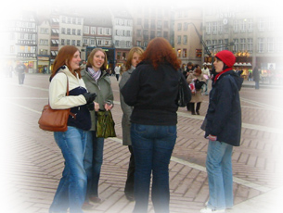 | 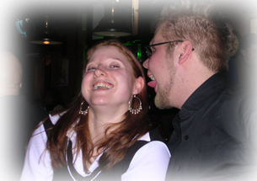

Friday 5th of February 2005

- Title of the session:
Presentation of the projects

- Objectives:
- To introduce relevant funding programs
- To provide concrete information about the relevant programs, actions, which they can address with projects related to the topic of the seminar
- To introduce concrete tips for applying to the above

- Programme:
‚Action’ began with the ‚back to back’ energizer. Participants worked in groups and presented their findings in a creative way. This was followed by a session on follow-up and networking. The afternoon was dedicated to the evaluation of the course and meetings in Re-groups.

(Explanation of the energizer ″back to back″: All participants stand in two lines back to back and poor hang up, in kneels go, and they should try to get up without any help.)

- Educational methods used
- Introduction to the subject
- Working in groups
- Workshops
- Project work
- Energizers
- Group discussions

- Thematic discussions or inputs:

  - Introduction of the European Youth Program:

A quiz related to the youth program was presented as follows:

1.The Youth program is a program promoted by:
  - Council of Europe
  - Soros Foundation
  - European Commission
  - United Nations

2.The Youth Program was born in 2000 and it will end in
a 2010
b 2006
c it is a never ending story
d 2005

3.The Youth Program refers to:
- young people between 15 and 25
- NGO’s
- Youth workers
- Young people between 15 and 25, NGO’s, Youth workers, Local authorities

4. Who’s responsible for the co ordination of the Youth Program:
- European Commission
- National Agencies
- Young people
- European Commission, National Authorities, National Agencies (and national coordinators)

5.Which are the main objectives of the Youth program:
- To permit young people to acquire knowledge, competences and aptitudes.
b) To promote an active role of young people in the construction of
Europe (international exchanges)

c) To facilitate their spirit of initiative and creativity.

d) All the previous answers and also to support the fight against
racism and xenophobia and for the development and respect of
human rights

  - A Workshop dealing with the European Youth Programme was offered

There are five actions, supported by the EU:
- Youth Exchanges:

- Group exchanges.
- The majority of the participants has to be between 15 and 25
- The number of participants has to be between 16-60
- Bilateral, trilateral and multilateral exchanges
- 70 % of the travel costs can be reimbursed
- Fixed amount of money per participant and day (for food and accommodation; depends on the country organizing the exchange)
- Travel costs for prep-meeting before the exchange is 100% reimbursed (plus fixed amount for food and accommodation)
- Exchange could last between 6 and 21 days
- Before you apply you need to decide on partners, countries, topic, target group, costs and budget, place and dates, program, methods
- Application deadlines to the national agencies are 1st February, 1st April, 1st June, 1st September and 1st November and for the EU 1st Feb, 1st June, 1st September

- EVS (European Voluntary Service):

  - A project that involves a partnership between a volunteer, a sending organisation and a host organisation.
  - The volunteer should be aged between 18 and 25

3. Youth Initiatives:
- Local actions (e.g. support for a theatre in kindergarten)

4. Joint Actions:
- Youth
- Socrates: Erasmus and Leonardo Da Vinci

5. Support Measures:
- International training courses for youth leaders or youth workers
- Seminar
- Study visit
- Contact training seminar

  - Introduction to the EYF (Appendix 9)

Karen Palisser made an introduction of the European Youth Foundation that was established in 1972 by the Council of Europe to provide the financial support for European Youth activities. The EYF annual funding is 3 Million Euros. The EYF is funding approximately 300 projects per year.
The EYF provides financial support to the following types of activities undertaken by non-governmental youth organisations or networks or by other non-governmental structures involved in areas of youth work relevant to the Council of Europe’s youth policies and work;

- Educational, social, cultural and humanitarian activities of a European character
- Activities aiming at strengthening peace and co-operation in Europe
- Activities designed to promote closer co=operation and better understanding among young people in Europe, particularly by developing the exchange of information
- Activities intended to stimulate mutual aid in Europe and in the developing countries for cultural, educational and social purposes
- Studies, research, documentation on youth matters.

The EYF may contribute to the financing of the following activities:

- International youth meetings;
- Youth activities other than meetings;
- Administration of international non-governmental youth organisations and networks;
- Pilot projects;

International youth meetings and youth activities other than meetings
Project organisers/applicants:
- one or more international non-governmental youth organisations or networks;
- national or local non-governmental youth organisation in co-operation with at least three other youth organisations/networks from different countries or with an international youth organisation/network;
- another non-governmental structure involved in areas of youth work relevant to the Council of Europe’s youth policies and work, involving at least four countries in the project.

Working priorities of the EYF 2003-2005:
- Intercultural Dialog and Peace,
- Participation and Active Citizenship,
- Dignity and Cohesion.

International youth meetings
- meet the Council of Europe’s work priorities, particularly of its youth sector;
- be likely to make a useful contribution to the objectives of the work of the Council of Europe’s youth sector;
- be attended by nationals of at least four member states of the Council of Europe (balanced participation); it may also include participants from non-member states;
- have duration of at least 4 working days;
- be, at least for one third of its total cost, financed by from other sources than the European Youth Foundation;
- be attended by participants of whom at least 75 % are under the age of 30;
- be held (a general rule) in one of the member states of the EYF; a venue in a non-member state must be justified accordingly;
- be likely to have a multiplying effect;
- be run in accordance with the educational principles of the Council of Europe’s youth sector and, in particular, promote education for youth participation as well as intercultural learning.

Youth activities other than meetings

The EYF may provide financial support to studies, research projects and the production of information and documentation on youth related issues. For example

- specialised publications (such as training manuals);
- newsletters or magazines produced by international youth organisations and networks;
- information campaigns;
- exhibitions and the production of audio-visual materials etc.;
- the development of websites or the production of CD’s;
- the production of posters, badges and stickers;
- Research projects on youth related issues.
- The EYF can also grant study visits enabling youth organisations and networks to make new contacts in Europe and, thus, expand partnerships and develop co-operation.
- The EYF contribution may not exceed two-thirds of the total costs of projects financed in category

European Youth Foundation Funding criteria

- Administration of international non-governmental youth organisations and networks:
  - The EYF can allocate annual grants to international non-governmental youth organisations and networks to cover part of the administrative costs related to activities for which the EYF provides financial support.
- Category C
  - Financial support for the administrative costs of international non-governmental youth organisations and networks with an established European structure
- Category B
  - Financial support for the administrative costs of international non-governmental youth organisations and networks to help them set up European structures

Administration of international non-governmental youth organisations and networks

- An administrative grant can only be allocated to organisations and networks
  - whose members have joined voluntarily;
  - which have European structures or a European secretariat;
  - which received a contribution from the EYF under category A or B during the year for which the administrative grant is requested;
  - which have active branches in at least seven member states of the Council of Europe, and at least 100 active members in each national branch;

- An administrative grant under category C bis can only be allocated to organisations and networks, during a maximum period of three years,
  - which received a contribution from the EYF under category A or B during the year for which the administrative grant is requested;
  - which have active branches in a minimum of three and a maximum of six member states of the Council of Europe, and at least 100 active members in each national branch.
  - whose aim is to promote youth participation;
  - which have a democratic structure;
  - which reflect the Council of Europe’s values and are capable of contributing to its youth activities sector.

Pilot Projects

Pilot projects are youth meetings or activities other than meetings (as described under A and B), which are likely to contribute to the following objectives of the Council of Europe youth policy:
- to help young people, in particular the disadvantaged, to find ways of meeting both the challenges facing them and their own aspirations;
- to encourage new forms of youth participation and organisation;
- to contribute to social cohesion, in particular by combating exclusion and by preventing phenomena specifically affecting young people;
- to adapt and open up programmes and structures to the changes in society.

In order to qualify for support, an international youth meeting must:
- be youth activities (by, with or for young people);
- have a European dimension, either by involving more than one country, and/or by taking into consideration the European context;
- be innovative in terms of methodology for the target group and/or organising body;
- contribute to youth participation;
- follow the basic educational principles of the Council of Europe youth sector’s work, in particular the promotion of intercultural dialogue and understanding.

EYF Application deadlines

Category A
- 1 April for activities to be carried out between 1 October of the current year and 30 June of the following year;
- 1 October for activities to be carried out between 1 April and 31 December of the following year.
- No fixed deadlines for first applications. These will be examined at the following meeting of the Programming Committee (June and December – “ad hoc procedure”).
- In urgent cases, for grant requests not exceeding 7,600 Euros, decisions can be taken by the Programming Committee via a written procedure.
- In exceptional and justified cases, any application can be considered under an ad hoc procedure.

Category C: 1 April for the running year.

Category D: General Pilot Projects - no fixed deadline;

Category D-HRE: Human Rights Education Pilot Projects -
1 April for the second half of the current year
1 October for projects taking place between 1 January and 30 September of the following year

Activities which could be financed by the EYF
- International youth meetings (category A)
- Youth activities other than meetings (category B)
- Administration of international non-governmental youth organisations and network (category C)
- Pilot projects (catergory D)
- Pilot projects on Human Rights Education (category C)

5.4 Workshop of EYF

The webpage http://www.coe.int/youth was introduced in the EYF workshop. Furthermore, the possibilities of using the webpage in order to fill in the applications online were presented to the participants. The procedures of funding 4H, YFC or rural youth organisations avtivities’ applications are the following.

Education → Youth → Financial support and activities → European Youth Foundation

From there you can grant applications and also follow up the projects. On this web site we will be able to register with the EYF, submit the projects online and also monitor the progress of the applications and the administrative things.

The Youth Foundation will transfer the funding in case of positive feedback within 10 weeks before the event. The financial report, also report about activities taken place on the event needs to be reported during the following 3 months of the event.

The decision of funding will be made within 2 months after applications have arrived. The decision is made by 16 people divided into two decision-groups.

The applicants must follow the priorities given by youth sector of Council of Europe.

Introduction to project work

One of the team members made a conclusion about our working week and program. We started on Sunday with getting to know each-other; sharing about racism and xenophobia situation in our home countries. We continued with international evening in order to get to know other countries habits, food and culture.

First there was sharing, then analyzes. We talked about ECRI, and then experienced intercultural learning – role plays. Also learned how ICL can be used in our organisation.
There were two workshops – Anti Discrimination and Youth Participation. Today there will be important information about different possibilities for funding projects.
Now we are entering in the conclusion part. It is time to put the knowledge into practice. We will be working with projects throughout the afternoon and finish project presentation tomorrow.
Splitting into groups (everyone was choosing cards with animals on it and finding the partners by making the certain noise) and answering three questions, given by Alexandra:
- What are the major challenges, faced by young people in Europe in relation in topic to the session?
- What are the main strategies that the young people in rural areas have in order to address these?
- How these strategies can be implemented?

Groups were selected by handing out cards with different animals on them. The team were made by participants making the noise of certain animal.

- Horses:
- What are the major challenges, faced by young people in Europe in relation in topic to the session?
    - Discrimination against woman – government or capital city is far away and decisions do not reach rural areas
    - Challenge of learning about different cultures and ethnic groups
    - Discriminating immigrants – bad jobs
    - Religion – two different religions and been religious
    - Rural vs. urban – lack of respect and knowledge

    - What are the main strategies that the young people in rural areas have in order to address these?
    - Learning about different cultures and ethnic groups
    - Intercultural learning
    - Trainings for job seekers
    - Experience the country
    - Use organisation to get to people by seminars, information

    - How these strategies can be implemented?
    - Use the organisation to make the point
    - Stop ignoring the situation
    - Think outside the box

    - Dogs:
    - What are the major challenges, faced by young people in Europe in relation in topic to the session?
    - Different cases of discrimination
    - Lack of knowledge and information
    - Fear of cultural and traditional changes (new things in the environment)
    - Media influences – bad influences to the youngsters
    - Environment – school, family, etc.

    - What are the main strategies that the young people in rural areas have in order to address these?
    - Education through campaigns, school, etc.
    - Young people need to understand different cultures and traditions
    - Media is not telling the full story

    - How these strategies can be implemented?
    - Organizing campaigns
    - Inform youngsters
    - Foreign exchanges
    - Education

    - Sheeps:
    - What are the major challenges, faced by young people in Europe in relation in topic to the session?
    - Exclusion of minorities, strangers, foreigners, refugees
    - Unemployment – no future
    - Poverty
    - Rural areas are compared to the urban areas
    - Prejudices

    - What are the main strategies that the young people in rural areas have in order to address these?
    - Support groups, e.g. red cross
    - Involving them in societies
    - Create jobs and find other possibilities
    - Developing the social system
    - More active local societies and funding
    - Media and internet (goal for a country to encourage free education)
    - More information

    - How these strategies can be implemented?
    - Involve social workers
    - Involve youth in organisations, e.g. YFC
    - Encourage employers to employ local people
    - Regular advertising of vacancies
    - Organisations creating jobs within the communities
    - Involve young people in improving in social system
    - Funding goes to the appropriate place (choosing the important issues)
    - Applying to organisations to provide technology, equipment, grants – experts, volunteers and people from minorities

    - Cows:
    - What are the major challenges, faced by young people in Europe in relation in topic to the session?
    - Discrimination (e.g. against disabled persons, woman,…) and social exclusion (e.g. immigrants do not get integrated)

    - What are the main strategies that the young people in rural areas have in order to address these?
    - Education
    - Racing awareness
    - Mixing different organisations or groups

    - How these strategies can be implemented?
    - Through NGOs
    - Workshops
    - Training
    - Seminars
    - Disseminating information – promotional effects
    - To motivate and encourage people to get involved
    - Funding

    - Cats:
    - What are the major challenges, faced by young people in Europe in relation in topic to the session?
    - Conflicts
    - Isolation
    - Unknowledge
    - Discrimination

    - What are the main strategies that the young people in rural areas have in order to address these?
    - Education by schools, seminar, human rights and intercultural learning
    - Information
    - Contact
    - Promotion

    - How these strategies can be implemented?
    - Attitude
    - Sharing experience
    - Communication

Project ideas to market:
In the afternoon the participants had a brainstorming about different ideas for actual project that could take place in their local communities or outside it. The project could be done between different countries or inside your own local group. The chosen projects of the participants are the following ones:

- Cross Community exchange
- Club exchange to Eastern Europe
- Weekend workshop CZK, AUT, HUN, SLO
- Discrimination in our society
- Combining different cultures
- Nordic program of multicultural learning

- Evaluation, conclusion and follow-up:
All participants commented in the re-groups that it was very useful and interesting to learn about different possibilities of funding youth programs. It was also very enjoyable and informative to work with concrete project every team worked out on the spot. The outcome of those team projects seems to be promising and interesting. The group atmosphere is excellent and warm.

- Resources used:
http://www.coe.int/youth
http://europa.eu.int/comm/youth

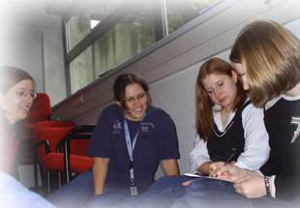 | 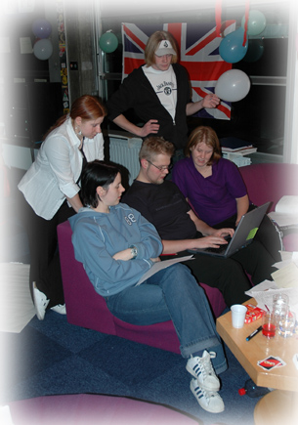 | 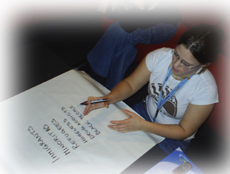

Saturday 5th of February 2005

- Title of the session:
- Project presentations
- Follow-up
- Networking
- Evaluation.

- Objectives:
- To gather information and to elaborate the feasible project idea in a creative way
- To ensure a continuation of the topic of racism, anti-discrimination and xenophobia within Rural Youth Europe and its member organisations
- To motivate youth leaders to build up a network and organize cross-country projects
- To create a concrete action plan and time plan for the project
- To reflect upon members own future work and the personal learning experience of seminar.

- Programme:
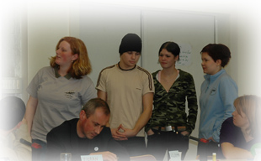
Upon getting energized, participants continued the work on their
Common projects and action plans. In addition, those were
presented in an informative and creative way. The afternoon was
dedicated to follow-up and networking, as well as the evaluation
of the course. Upon having the last Re-group meeting, the course
was closed in plenary.

- Educational methods used:
- Group work (elaboration of projects’ work as creative presentation)
- Presentations (done by participants for introduction of projects’ work results)
- Motivational letters (both personal and to individual organisations)
- Questionnaires
- Presentations in plenary (done by facilitators for the various introductions).
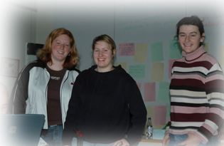
- Thematic discussions or inputs:

5.1. Presentation of project proposals

Seven different project proposals were presented. These were:

- “Combining different cultures” (Appendix 10)

This project has been developed between the Swedish 4H, Finish – Swedish 4H clubs and DROM in Macedonia in order to increase youth knowledge of different cultures to break down stereotypes and prejudices between these cultures, to increase intercultural learning between these groups, to increase the interest about youth in the governmental constitution and also to develop and maintain networks between participants and their clubs. This programme will be implemented over one year and will take the form of training, using experts, and an evaluation, both of which will take place in Finland and Macedonia.
This will lead to the creation of a web page and network of contacts, along with the opportunity to present the project activities in the media, and may eventually lead to organising various the formation of a 4H organisation in Macedonia.

- “Discover 2together” (Appendix 11.1, 11.2)

Due to the enlargement of the European Union, the Austrian Rural Youth Club focused on a method to include Rural Youth Clubs in the Czech Republic, Hungary and Slovenia. In order to avoid prejudices and discrimination, it is important to promote intercultural learning between these organisations. The group analysed the differences and common interests among the different organisations to provide a better understanding of their culture and needs of the organisation. This project focused on a weekend seminar which would be funded by the European Youth Programme and would be evaluated by means of workshops and questionnaires. This project is expected to lead to further exchanges with other participating countries alongside the organisation of summer camps and festivals.

- “Discrimination in our society” (Appendix 12)

This project has focused on hidden discrimination within the participant’s environment, which has arisen from growing globalisation and has led to people feeling frightened and insecure. The project focused on the need to educate people on how to recognise and overcome discrimination. The presentation has proposed the need for a seminar, with the following learning objectives; how to identify what discrimination is, how to recognise discrimination and the methods which will be used for these purposes. It was also explained that government funding will be available and that human rights experts will also be available to provide instruction in this topic. Participants will also be able to develop projects to tackle discrimination within their own countries and will be assisted in this by experts.

- “Multicultural learning in the Nordic Countries” (Appendix 13)

This is a multicultural learning project, which involves the 4H in the Nordic countries, Estonia and Russia. The countries are divided into three areas; north, west and east, and these groups would work together in order to identify, learn about and to accept people of different backgrounds. These areas would take part in separate workshops, which will deal with addressing different issues relevant to the specific area. These sub-groups would also exchange knowledge between each other in order to promote ‘learning by doing,’ and all groups would meet up at a Nordic camp in 2007.

- “Seminar on racism and xenophobia in European Countries” (Appendix 14)

This is a seminar which would be organized to disseminate what participants have learnt during their time at the Spring Seminar 2005. The seminar would be aimed at members of a local rural community and would inform them of the huge problem of racism and xenophobia, both in their own community and in Europe in general. The seminar would include theoretical input, workshops and a presentation of the findings from the spring seminar on racism and xenophobia held in Strasbourg in February 2005.
- “Breaking Boundaries” (Appendix 15.1, 15.2)

This would provide the opportunity for two rural organisations; Macra na Feirme and YFCU, to host several exchange visits between Northern Ireland and the Republic of Ireland. The project is designed to promote intercultural learning between two different cultures, and to strengthen links between both organisations. The exchanges would provide an opportunity to get to know a specific group of 50 members who would be expected to share their experiences in the form of a presentation.
Follow up would be in the form of a review meeting, and funding would be obtained from Governmental organisations in Northern Ireland and the Republic of Ireland.

- “Club Exchange” (Appendix 16.1, 16.2)

In order to overcome discrimination against people from different cultures and societies, through a lack of knowledge and information of these cultures, a club exchange between two countries has been suggested. This will broaden the minds of those who participate in the exchange, along with others who will learn from the presentations given by those who take part. The activity will take the form of a one week exchange to any country in Europe, and will involve keeping a diary, collecting information and recording video footage of activities completed.

5.2 Networking and Follow-up
Everyone was thanked for presenting their projects on the various different activities and events related to the seminar theme of “European Youth against Racism and Xenophobia”. The Secretary General continued by outlining the following steps in order to follow-up the study session.

Support for Projects
- Participants to write a letter to the Presidents of their individual organisation requesting support in completing their projects in their individual countries.
- Letter will be posted from the Rural Youth Europe office thus highlighting the European Councils endorsement of the project.
- If requesting funding the secretary general of Rural Youth Europe can give advice regarding European Youth Foundation and Youth Programme applications.

If organizing a seminar dealing with European Rights or other topical issues send information to the secretary general of Rural Youth Europe. The information will be distributed as follows:

- All organisations which are members of Rural Youth Europe will receive information.
- Information will be placed on the Rural Youth Europe website.
- During study sessions it is recommended to compile a list of individual contact and organisation details and distribute to all participants for future contact.
- Maintain a regular contact with Rural Youth Europe by sending in photographs, articles and updates on projects from your organisation.

Follow Up to this Study Session:
Each of the participants were invited to write a letter to themselves detailing there hopes and aspirations following the completion of the study session. Within this letter they were asked to outline their thought process to allow them to complete their projects when they return home to their own organisation. Each participant was also asked to include a reflection on their interpretation of the study session and how it will influence their lives in the future. This letter will remain at the office of Rural Youth Europe a period of five months after which time it will be posted to each of the participants. The idea behind this letter is that participants can review their letter and examine where they are in relation to completing their projects as outlined at the seminar.

Rural Youth Europe activities in 2005

- Study/Pilot-Project “Change the village challenge yourself –you(th) can make a difference” – about the needs and positions of rural youth all over Europe in cooperation with MIJARC (European Catholic Rural Youth).

- Summer Seminar “Do it locally! - Youth - an important ingredient in sustainable regional development!” 29th of May - 5th of June 2005, Schlierbach/Austria

This seminar is part of a range of activities organized in conjunction with MIJARC (European Catholic Rural Youth). This seminar will deal with questions, such as:
- What is sustainable regional development?
- What are the social, economic and environmental dimensions of regional development?
- What is the current status of LA 21 projects in the various European countries?
- How can young people become active in their communities?
- How to raise awareness among young people for sustainable regional development?
- What is participation? - How can it prevent brain-drain in the countryside

    - European Rally “Expanding Horizons. One Europe. Many Cultures.” 16th - 23rd July 2005. Strathallan School/Forgandenny/Perth/Scotland.

This is hosted by the Scottish Association of Young Farmers’ Clubs. This event will look at the expansion of the European Union - and its effects – along with the many different cultures within Europe.

    - Autumn Seminar “Youth for Rural Development – Local Initiatives”.
22nd - 29th of October 2005. Waide/Estonia.

This seminar is a follow-up to the ‘Do it locally’ summer seminar. This seminar will further develop possibilities of involvement of young people in the field of local rural development: ideas, EU and national financing and local initiatives in practice. The seminar will focus on the rural development opportunities for new EU member states, like Estonia.

Rural Youth Europe activities in 2006

- Spring Seminar „Change the village challenge yourself. You(th) can make a difference!” Double Study Session at the EYC Budapest; this seminar is part of a range of activities organised in co-operation with MIJARC Europe (European Catholic Rural Youth).

- European Rally “Pearls in contrast – multicultural aspects in rural youth” To be held in Saulkrasti, Latvia (15-22 July).

- Autumn Seminar “Breaking the barriers” (15-22 October).This seminar will follow-up this study session and deal with discrimination between rural youth and city youth, people with fewer opportunities, etc; this activity will take place in the city centre of Cardiff (Wales) where rural youth participants will be actively working with city youth and also get in contact with refugees, migrants, drug addicts, etc.

More information can be obtained from the following website www.ruralyoutheurope.com

5.3 Evaluation of the Spring Seminar 2005

This entailed the following:
- Pictorial review of the week’s activities.
- Reflection of participants Expectations/Motivations/Fears (see section 5.5.1)
- Individuals complete the attached evaluation form (see section 5.5.2).

Expectations – Motivations – Fears - participants regarding the one-week study session of Rural Youth Europe and the EYC:
Each participant reviewed their individual expectation, motivation and fear as outlined at the beginning of the week. (See Daily Report for the 31st of January 2005) All participants agreed that all of their goals had been achieved and that they had over came their fears during this seminar with the exception of the following:

Expectations not met
- How to involve young people from Eastern Europe within RYEurope
- Creating a similar youth movement in the Ukraine.
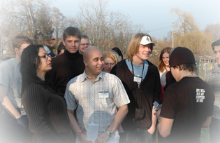

Fears not overcome
- I don’t find the right expressions – that others don’t understand me
- Not being able to learn from the seminar
- To have to sing and dance
- Not knowing any energizer
- Having to perform in the crowd

Participant’s motivations have already been fulfilled through the attendance of this seminar.

5.5.2. Evaluation Questionnaire (Appendix 17)
Participants were asked to feedback on their own personal views, thoughts and experiences.

- Recommendations and outcomes of group discussion:

Visual Evaluation:

For visual evaluation the “dartboard” method was used. Participants were asked to form a large circle. The facilitators asked a number of questions regarding their opinion on the weeks study session. If the participants were satisfied and agreed with the question they stood in the middle of the circle, but if they disagreed with the question they had to stand outside of the circle.

- Do you think that objectives of this study session were met?

Participants unanimously agreed that all of the objectives outlined at the beginning of the study session were met during the seminar.

- Do you think that programme was structured in right way?

Participants liked the content of the spring seminar programme. It was good from the participant’s point of view and it was felt that there was a good contrast between technical sessions and practical workshops.

- Did you like the food in European Youth Centre, Strasbourg?

Most of participants didn’t like the meals during the week of the study session. But there were some participants (5) whom said that the food was quite different from what they usually ate in their native countries. They were happy to try some “French cuisine”.

- Did you agree with the methods and style which were used during the study session?

Participants liked the style and methods which were used by team during the study session. Participants liked the learning tools used in these study sessions and workshops, and they hope to bring back these study aids to their organisations and implement them during future study sessions with their members.

- From the projects and the implementation plans formed during this seminar. Do you think that the projects are achievable within your community?

Participants felt that all of the projects were achievable but some felt that modifications would be required before implementation, for example it would be more feasible for countries in Eastern Europe to carry out intercultural exchanges or host joint seminars among themselves. This conclusion was drawn because of visa restrictions and the large expenses incurred when participating at these events in other parts of Europe.

- Do you feel that attending this study session has changed your views and perceptions of racism, antidiscrimination and xenophobia?

The majority of participants felt that they improved their understanding of racism, antidiscrimination and xenophobia during the study session. However participants felt that their attitude to the latter had not changed as they felt they were very open minded coming to this seminar.

- Do you think that team performed very well?

Participants were very happy with the team and felt that everyone contributed to the study session and formed some life long friends in the process.

- Evaluation, conclusion and follow-up:

Participants were asked to describe their feelings and what they had learnt. All had felt that the week was a success, that they had learnt something new and made many new friends, as well as potential collaborators for future events. All participants thanked the team for their help and for organising a very successful seminar. Group leaders also thanked the participants for making the event an enjoyable experience, and the Secretary General advised participants that she was available to answer any queries and to provide advice on how to carry projects further following this seminar. The general consensus from both the participants and group leaders therefore was that the seminar was a great success.

- Resources used:

Rural Youth Europe website: www.ruralyoutheurope.com

Study Session: "European Youth against Racism and Xenophobia" - Rural Youth Europe
PARTICIPANTS LIST
Mr. | ATANASOV | MISROSLAV | Agrarian Youth Union of Bulgaria | Bulgaria
Ms | BORGAN REILING | HEGE | Norway 4H | Norway
Ms | BOYD | JANET | Young Farmers' Clubs of Ulster | UK
Ms | BRENNAN | FIONA | Macra na Feirme | Ireland
Ms | CUK | ERIKA | Slovenian Rural Youth | Slovenia
Ms | DAVIES | SIAN | Wales Young Farmers' Clubs | UK
Mr | DEMIRTSHYAN | Tigran | Federation of Youth Clubs of Armenia | Armenia
Ms | EVANS | REBECCA MARY | Wales Young Farmers' Clubs | UK
Ms | FASCHING | BARBARA MARIA | Austrian Rural Youth | Austria
Ms | FLYNN | BRID | Macra Na Feirme | Ireland
Mr. | GUNNARSON | DANIEL | Swedish 4H | Sweden
Mr. | GUSTAVS | MARTINS | The Latvian Young Farmers' Club | Latvia
Ms | HAUSDOERFER | KIRSTEN | Bund der Deutschen Landjugend | Germany
Mr. | JOUTSENVAARA | JARI | Finnish 4H Federation | Finland
Ms | KAUNISKANGAS | EIJA | Finnish 4H Federation | Finland
Ms | KLOCKER | SABINE | Rural Youth Europe | Austria
Ms | KOTHRADE | ANDREA | Bund der Deutschen Landjugend | Germany
Ms | LEONHARDSBERGER | ANNA | Austrian Rural Youth | Austria
Ms | MERIHEINA | JANNICA | Finland's Svenska 4H | Finland
Ms | MLAKAR | EVA | Slovenian Rural Youth | Slovenia
Mr. | MODESSA | SANIL | Minorities of Europe | UK
Ms | MOORTIS | MARIS | Estonian 4H | Estonia
Ms | OTTEWELL | JENNIFER | National Federation of Young Farmers' Clubs | UK
Mr. | RAKSTIS | JANIS | The Latvian Young Farmers' Club | Latvia
Ms | RAMMEL | THERESA | Austrian Rural Youth | Austria
Ms | SAARINEN | JENNI | Finland's Svenska 4H | Finland
Mr | SADNYTSKKY | VOLODYMYR | World Peace Prayer Society | Ukraine
Mr. | SAEBO | OYVIND | Norske 4H | Norway
Mr. | SCHWAB | MICHAEL | Bund Deutscher Landjugend | Gemany
Mr. | SIRA | TOLLEF | Norway 4H | Norway
Ms | SJOBACK | SANNA | Swedish 4H | Sweden
Ms | SKENDEROVSKA | SEBIHANA | RCC DROM "Kumanovo" | Macedonia
Ms | SMYTH | DIANE | Young Farmers' Clubs of Ulster | UK
Ms | TAPANILA | PAIVI | Finnish 4H Federation | Finland
PREPARATION TEAM:
Mr. | MODESSA | SANIL | Minorities of Europe | UK
Ms | ZAHAROVA | ZANETE | Latvian YFC | Latvia
Mr. | SAEBO | OYVIND | Norske 4H | Norway
Ms. | KLOCKER | SABINE | Rural Youth Europe | Austria
Ms | RAYKOVA | ALEXANDRA | External Trainer | Bulgaria
Ms | VOLPI | SILVIA | External Speaker | Italy

