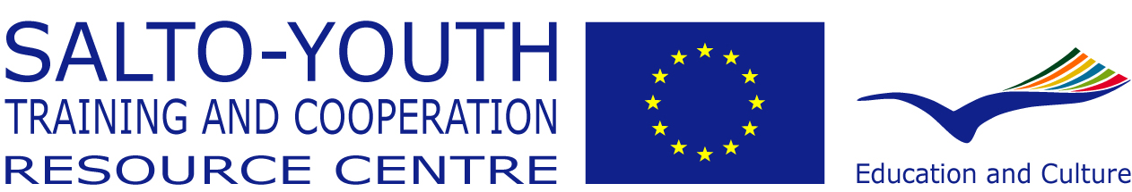

Supported through the YOUTH Programme
of the European Commission

ToM - Report

Training of Multipliers 2006



1st seminar from 8-16 June 2006 in Asenovgrad/Bulgaria
2nd seminar from 27 November till 3 December 2006 in Turunc/Turkey

1. General introduction

1. The aim of the training module

To train reliable, credible and capable persons who can support the work of National Agencies in order to improve the national implementation of the YOUTH/Youth in Action Programme both in quantitative and qualitative terms.

2. Objectives of the Training of Multipliers

To give the participants the opportunity to develop their knowledge, skills and competencies:

- knowledge of the YOUTH/Youth in Action Programme
- understanding of the concept of non-formal education and active citizenship/participation
- knowledge of youth work realities in different European countries
- intercultural competence
- skills to gather, select and give information
- skills to present the specific relevant information and ideas to others
- skills to discover, analyse and adequately address needs of potential Programme users
- skills to motivate others
- skills to plan, run and evaluate multiplying projects

8 different roles of multipliers
Eight different roles of multipliers have been defined that can have an impact on the improvement of the quality and quantity of projects within the YOUTH Programme:

Needs analyser
It’s important for multipliers to be able to analyse the needs of their target group in order to choose the appropriate approach for their multiplying activities

Motivator
For multipliers its essential to be familiar with the key principles of ‘how to motivate’ people also seen as a result of listening to their target group and analysing their needs.

Networker
To be involved in different networks, as well on local, regional, national and international level, is a vital aspect of the work of a multiplier.

Information provider
Multipliers should be able to give the right information at the right time

Counsellor
Multipliers will find themselves every now and then in situation where they are expected to counsel actors in the YOUTH programme.

Initiator
Multipliers sometimes have to take the initiative to organise meetings, to bring people together. Multipliers should at the same time be aware that there role is to motivate people to become active in the YOUTH programme and should therefore not step in the role of organiser of YOUTH projects.

Resource person
A multiplier should know where to find relevant information to provide resources to the target group when needed.

Learner
Multipliers work in a field, which is always ‘in change’. New developments are always there. To carry out his/her job the multiplier needs to have a ‘learning attitude’

2. Group
All in all 19 participants from 12 countries (3 x HU, 2x TR/DE/MT/SL/NL, 1x BG/LT/NO/IT /CY/ES) came to the first seminar in Bulgaria, 11 of them female and 8 male.
They were building a very motivated and close group and with Bulgaria, Spain, Malta, Slovenia and Germany we had again some new countries/NAs in this ToM round.
Already the 1st phase of ToM went very well: applications where of a high quality Most of them were in contact with the responsible contact person from the National Agency to talk about their project ideas and multiplying strategies.
Even more then in the last ToM edition the chosen participants matched the profile of a multiplier very well. Due to short term cancellations (4 pax) and difficulties of some NAs finding appropriate and/or enough candidates the original group size of 25-30 participants was not reached.
During the first seminar participants jelled as a close group. They were very enthusiastic and positive. According also to their self-evaluation most of them are very skilled and experienced with the YOUTH programme, so that they could gain a lot through the exchange with the others.
As well the team worked well in the group and contributed to build a good atmosphere from the starting.
Due to health problems and final examen at the university 5 participants couldn’t visit the 2nd seminar, which was compared to previous years’ attendance at the 2nd seminar a high number of cancellations. This had an impact on the group cohesion, which was perceived smaller in Turkey and led to a different dynamic, where participants were looking for more safety in couples and/or small groups.
Having said that the team intends in future to pick up more the “negative” group dynamic coming up and address them openly in the group.

3. Outcomes of 1st and 2nd seminar (Bulgaria/Turkey)

According to participants’ seminar evaluation, their expectations towards the programme of both seminars and adaptations of previous editions were fulfilled.

Having a Training of Multipliers in the transition period between the old and the new programme was a special characteristic of this training. The team was aware that multipliers have to be able to communicate the concepts of European citizenship and participation to their target group. That meant that they got the chance to develop an understanding of the topic and the educational implication for the different actions in the new Youth in Action programme. Therefore the new "YOUTH in Action" programme with special focus on "citizenship & participation" has been installed already in the first seminar. This topic has been deepened in the second seminar through the participatory method of “World Café”.

A very strong element again was the work in international teams to prepare and present multiplying activities. For sure the outcomes have been used for their own innovative and new multiplying projects.
As well, the exchange about National Youth work realities as a tool for multipliers matched the needs of participants.
A question which still needs to be clarified is what to do with the market of participants’ organisations since multipliers usually run projects on their own? What is the real purpose? One idea is going in the direction of a project market in order to find partners and the potential target group.

In the context of valorisation, a session on using best practise has been implemented in the first seminar. With the experience of their multiplying projects, participants had the opportunity in the 2nd seminar to analyse and compare them in order to identify their own good practise so that the others could make use of it.
In this context also critical issues which participants identified during the project phase have been addressed in topic sessions aiming to improve their work in future. People were very much involved in these sessions and they experienced different and new methods, although time was too short. In general multiplying projects can be characterised as interesting, diverse and very innovative. Those who didn’t finish yet theirs were very motivated to realise them.
Looking into future, the team still intends to further improve this programme part by:
- working more on possible new cases of multiplying projects. Therefore good examples coming from previous ToM should be used more and should be related to the roles of multipliers
- updating the material used for the “Good practice”, maybe also by using resources from previous Multiplying projects.

Another subject getting more and more into focus in the context of non-formal learning within ToM is the way how the learning process of participants can be created in this long-term setting. The team realised that – also in previous ToM editions - the 1st seminar is in that way too much dominated by trainers that we create expectations there by designing attractive learning moments, but we don’t give over so much responsibility participants have to take for their learning.

Therefore it needs to be paid more attention on what participants define, what they want to learn in terms of multiplying. Especially in the 2nd seminar, where participants expect that they get offered a fully prepared programme they just have to follow, they are more requested to take over learning. For sure the approach of participants as self-directed learners is coming to a higher importance and probably needs to be made more transparent already in the beginning of the 1st seminar. The team should be more explicit at the beginning of ToM about the approach as trainer and the way how this team is working.

One answer to a more self-determined learning can be the parallel topic sessions we implemented in the 2nd seminar in order to analyse and compare participants projects. Another idea is to address more topics in future ToM according to participants needs. Supplementary the team thinks about how to give more literature, references names of the theories on topics such as project management, intercultural learning as well as hand-outs during the seminar (and not only to provide it at the end on a CD).

In the previous report about ToM 2005-2006 some changes concerning the 8 roles of a multiplier have been proposed. In this edition they were adapted and helped to deepen the understanding of tasks of a multiplier.
Participants evaluated to which extend they have been performing the different roles in the project practice phase, which the following graphics is showing (average):

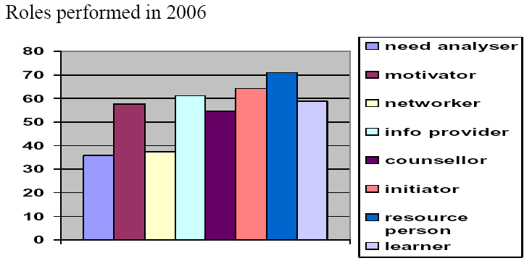
To which extend did you perform the different roles? (out of 100 %)
%

Still further adaptations of the roles are foreseen:
- The part about Motivation and Needs Analysis connected with the roles of a multiplier should get more time and the approach should be more creative (like using role play and other more active methods….). Concerning the method it makes sense and it’s useful to use an input about open questions and active listening to be prepared for partner interviews on motivation, but due to participants experience they could be more challenged.
- Instead of counsellor the term “consultant” will be used in future, since it better fits and describes the tasks required to a multiplier

National Agencies
The support of the Bulgarian and Turkish NA was great and very helpful. Staff members were present during the whole seminar and even it was really nice it was already pointed out that it is not necessary that one member of the NA remains for the whole seminar in the location, as long as there is somebody from the country that can also help with the language and the problems that might happen on the spot.

Team
This has been already the 3rd ToM edition that this trainer team is working together, and this is also one of the reasons that there is an extremely good collaboration and interaction between us. Each member of the team has a clear role, we can complete each other, support and enjoy to work together. The gender balance is also an extremely important element for the success of the work.
This level of confidence is also coming from the work we did and the special attention we put on our learning process by having team feedback sessions after the trainings.

Relating to this seminar we could build from the beginning a good atmosphere in the group that helped them to learn and to feel safe.

Constant adaptations, new approaches and a critical view on that what we ‘usually’ do is necessary in the context of such long-term training course and a quality criteria the team is going along with when (re-)designing the concept of ToM. To say it in different words: we are prepared for the new “Youth in Action” programme, which for sure needs multiplying, so that potential users getting to know it and make best use of it.

4. Annexes

4.1 Summary Tom Evaluation
The following information is extracted from filled in evaluation forms by the participants.
(1: poor > 6: fully relevant)

Part A) Preparation
I. Preparation

- How do you evaluate the national preparation regarding its relevancy for the first seminar in Bulgaria?
Average: 4,16

Comments:
- I’m provided with all necessary information (6 participants)
- I missed NAs expectations from me and project (2)
- I would like to have the contact to other participants especially from my country
- One meeting with practical information about the trip
- No input by the NA
- Only that I was chosen
- Need more financial support

2. How informative were the documents that you received before the training course from the respective National Agency and the trainer team?

Average: 4,90

Comments:
- No documents from the NA (5)
- Very informative (3)
- Needed more information regards to weather and other facilities in the monastery (2)
- Very helpful, understandable, clear (2)
- From trainers I would have expected more documents with content for the seminar
- Most information was given by the trainers
- All information from trainers was useful and placed me in the necessary framework

Part B) Summary SALTO Pre - and Post - EVALUATION QUESTIONNAIRE

- When acting as a multiplier I rate my skills in the following roles as (average):

- I rate my project management skills as:
- Intercultural Learning is for me

- Non formal education is for me:

Part C) General Evaluation of ToM 2006

1. Looking back at the process how do you evaluate this training course? (1: poor, 6: great)

 | 1 | 2 | 3 | 4 | 5 | 6 | What should be kept for the future? | What should be done differently?
Preparation on national level |  |  | 3.2 |  |  |  | - NA was very efficient  - Personal meeting  - Communication NA perfect  - Personal contacts  - Link between trainets and NA | - more contact with my NA  - NA should contact me  - More involvement NA  - NA should ‘push’ more  - NA should be more clear about what they expect  - Earlier info about ToM
International training (Seminar 1, Bulgaria) |  |  |  |  | 5.2 |  | - different backgrounds  - trainers  - was an excelent seminar  - topics that are related to Mpwork  - trainers being close to pax | - - methodology could be more introduced
Practical experience  (multiplying projects on national level) |  |  |  | 4.2 |  |  | - nice opportunity  - ideas  - can use the idea again  - the contacts | - more time for preparation  - planning  - could not discuss with my NA  - better timing  - more involvement NA  - finish the project and wait for results
International training (Seminar 2, Turkey) |  |  |  | 4.3 |  |  | - such a good place for training  - activities  - trainers  - future projects and networking | - more creative methods  - a pitty I didn’t do my project  - more challenges  - more time talking about Europe

2. How do you evaluate the co-operation with your NA?

3.75
Comments:
- during the project it was really good
- lack of NA strategy
- NA never expressed their needs and expectations
- Friendly but meaningless
- They should be more pro-active
- Were there when I had questions
- No relation at all

3. How do you value the support and information by the ToM coordinator and trainers before the training seminars and in the project practice phase? (circulation of relevant documents, internet platform, general information about training courses…)

5.0
Comments:

- got everything I needed
- follow up after the 1st seminar was great
- excellent job
- Dirk was incredible
- ‘contact trainers’ should have contacted us
- Very useful but to be honest didn’t have always time to follow

4. As a result of this training (all IV phases), what do you feel more confident in doing and undertaking as a multiplier?

- more self-confident
- more knowledge about other countries
- analysing
- know better now my role as multiplier
- more sure about the new programme
- more confident about non-formal education
- to organise exchanges
- evaluation

5. What further support would you need as a multiplier on national and/or international level?

- colleagues in my region
- experiences and financial support
- support from my NA
- networks
- updated info
- a national MP structure
- an NA strategy
- material like posters and flyers
- exchange of experiences

6. Generally speaking, how far has this training course responded to your needs and expectations?

0 % ( not at all)→ ------------------------------------------------------→ 77% 100 % (fully)

Comments:

- still have some needs but motivated now to search myself
- first seminar fulfilled my needs more than the second
- a very good team

4.2 Types of multiplying projects realised by multipliers

- using and producing media to spread information on YOUTH:
  - interviews in local TV and articles in newspaper
  - EVS clip
  - virtual library in many languages for all youngsters, youth leaders and NGOs
  - promotional movie on YOUTH produced with young people
- Networking:
  - establishing a regional network of multipliers
  - create a regional network to develop information on the opportunities of the Youth in Action for young people with less opportunities
  - set up a pool of peer-coaches for Youth in Action
- working with role models and peer to peer approach:
  - infosessions on EVS by volunteers during a Youth information fair of NGOs
  - Workshops for young people
  - Training of peer to peer coaches for youth initiatives
- Info-sessions and consultation of the Youth and Youth in Action Program:
  - in highschools, colleges, universities
  - for youth communities
  - for youth workers
- Training weekends and workshops for youth workers about non-formal education, intercultural learning, application procedures within the YOUTH Programme and showing best practice through professionals and experts
- Consultation on YOUTH projects:
  - of young people initiating own projects
  - youth workers

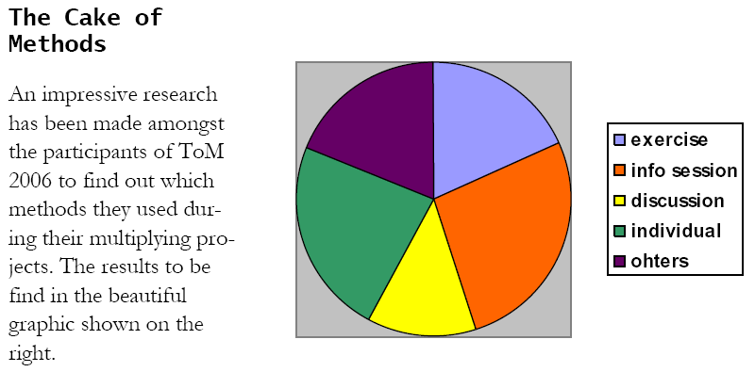

Please have a look on the ToM Journal 2006, giving more information around multiplying and participants’ projects.

You can find it and further information resources concerning ToM on a Yahoo
web site. For getting access to this web site, please contact the ToM trainer Lidija Buric (lburic@inet.hr). She will provide you with further information needed.

