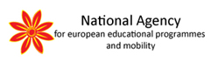
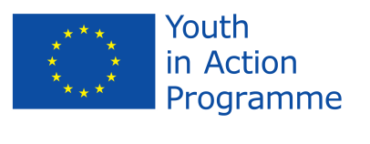
International contact making seminar

12 December -14 December – 2012, Skopje, Macedonia

APPLICATION FORM

PERSONAL DATA

First name:
Family name:
Date of birth:
Nationality:
Gender: | Female Male

PRIVATE ADDRESS

City:
Street:
Postal code:
Country:
Tel:
E –mail:

INDIVIDUAL BACKROUND AND MOTIVATION
Since when have you been involved in youth work?

What is your level of knowledge in the Youth in Action Programme? (low, medium, high)
Have you participated in any other activities within the Youth in Action Programme? If yes, please specify:
Please describe you personal motivation to attend this activity:
Please describe how you can contribute to this activity:

LANGUAGE PROFICIENCY:
Please indicate your level of spoken English

SPECIAL NEEDS OF REQUIREMENTS
(Dietary restrictions, vegetarian, health, disabilities, etc..)

INFORMATION ABOUT THE SENDING ORGANIZATION

Full name of the sending organization
Address of the sending organization
Telephone
E – mail / Web site
Responsibilities in the organization

Type of your organisation

governmental | non-governmental | other

Level of activities of your organisation

local | regional | national | international

What are the objectives of your organisation?

What are the main activities of your organisation?

What is the main target group of your organisation's activities?
Travel informations will be requested additionally upon final selection of participants

Disclaimer
I herewith commit myself to participate in the whole process of this activity, including prior preparation.
I am aware that obtaining a health and a full travel insurance is my own responsibility and at my own expense. I understand that the information I provided on my special needs does not remove your own responsibility on my health.
I authorise National Agencies, SALTO Resource Centres and the European Commission to publish, in whatever form and by whatever medium, including the Internet, my correspondence address and pictures taken at the course.
I agree with the conditions above:
Yes No

Confimation on the organisations awareness and willingness to participate in this activity
I herewith confirm that I have informed the person responsible of my organisation about my application to this contact-making seminar. I as well confirm, that I have support of my organisation for my application, and that I have obtained permission to be released from my usual duties to take part in this activity.
I agree with the conditions above:
Yes No

Please return this form before 21 st November 2012 by e-mail to National Agency for European Education Programme and Mobility in Macedonia.

E-mail: youth@na.org.mk

