Application Form

REactor

conference and workshops on media in youth work with disadvantaged groups

Full Name
Your age
Country & city of residence
Email address
Phone number
Level of English
(rate yourself from 1 – poor to 5 - great)
Are you working/volunteering in an organization, formally or informally? If yes, name the organization.
What is your role there?
Special diet, needs
Food, health, support needed, …
Motivation to participate in the conference (personal and professional)
Describe briefly your relationship to:
Media
Disadvantaged groups
Youth work
Human rights

Describe briefly your skills and experiences
Your most important experience related to the theme of the conference
Workshop you offer for the meeting (theme, method, outcome)
Materials you can bring for the exhibition (photo, video, booklet, etc.)
Provide a link for a video and/or piece of audiovisual product you created or use for educational purposes
Name any topic you are passionate about!

Send the filled out application form until the 12th of April 2012
by email to reactor.application@gmail.com

The project is funded by the European Youth Foundation www.eyf.coe.int/fej and the Youth in Action Programme, Action 4.5 http://eacea.ec.europa.eu/youth/index_en.php

The European Youth Foundation was established in 1972 and is celebrating its 40th anniversary this year.
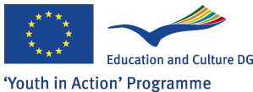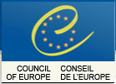

Partners

