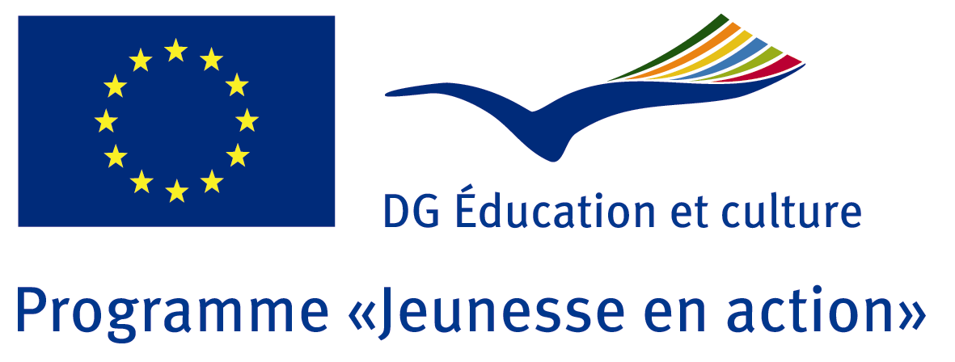
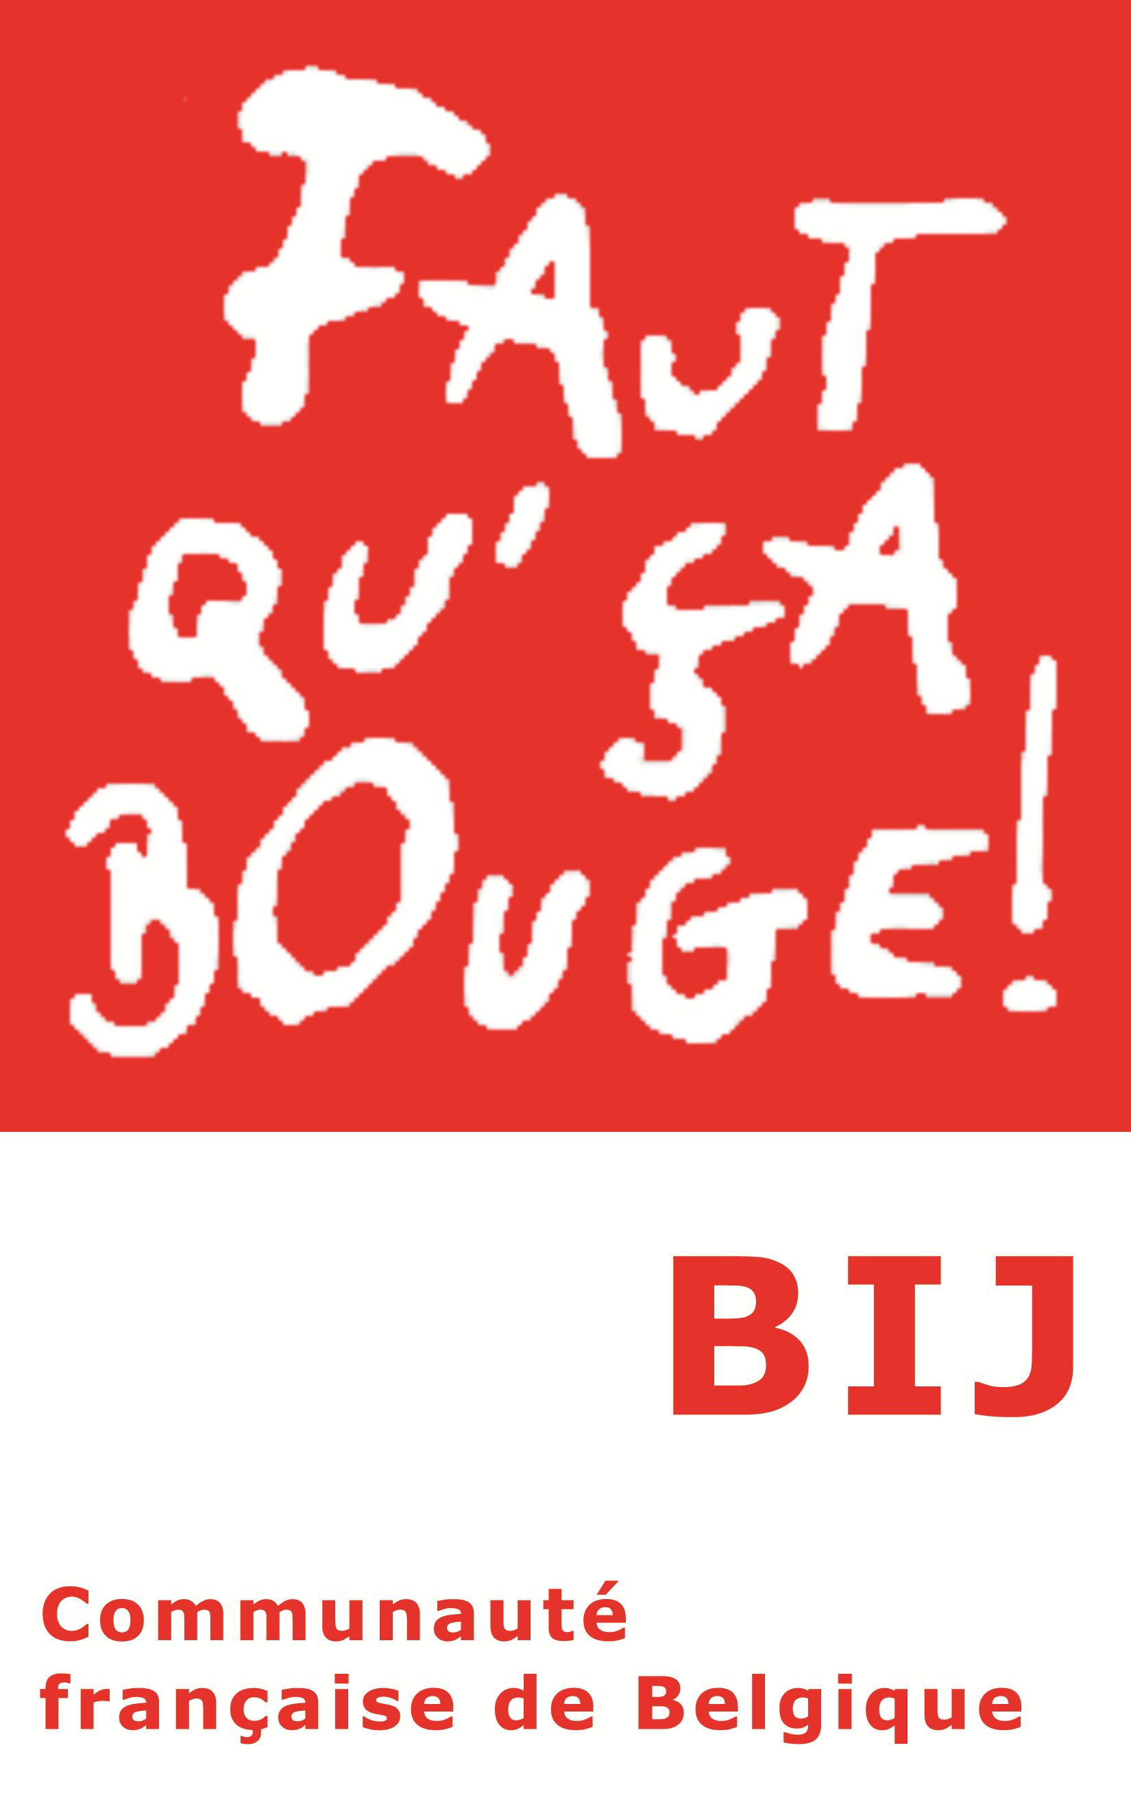

“LOVE ME GENDER”
Gender Equality Seminar

Namur, from 19 to 23 June 2012

Aim

Exchange experiences between youth workers and young people confronted to the difficulties to find a gender balance in terms of participation in local or international youth projects, spaces, organisations and activities, in order to open ways allowing to work on equality at the level of citizenship and participation.

Objectives

- Intercultural discovery, of realities, issues and priorities of the participants
- Sharing of experiences, of practices and tools in the field of gender balance in youth projects/activities
- Open ways to work on solutions through networking and creating future cooperation projects between the participants in the frame of international granting programmes

Methodology:

The tools and methods used are based on the principles of the non formal education: exercises, games and group dynamics, in committee or in subgroups, and the participants are invited to produce the content of the training rather than passively consume the information.
The main language which will be used is English.
Nevertheless, as far as there will maybe be an important number of French speaking participants, cooperation and linguistic solidarity between French and English will be a major challenge.

Profile of the participants:

- You are at least 18years old
- You are a youth worker or responsible for young people, representative or volunteer of associations, young people active within a group or a structure
- You are interested in and active in the field of the issue of gender balance in youth activities/projects
- You come from Programme countries of the Youth in Action programme (consult with your National Agency), from an EECA or SEE country.

Duration of the activity:

19/06/2012 (arrival date and evening activity) – 23/06/2012 (departure) – 3 days of activity
You are expected to arrive before 18.00 on 19th of June.

Conditions of participation

As far as the Programme countries of Youth in Action are concerned, the costs of the activity (programme, accommodation, food) are taken in charge by the BIJ.
The costs of transport are taken in charge by the respective National Agencies.

For the SEE and EECA countries, the costs of the activity (programme, accommodation, food) are taken in charge by the BIJ as well as the international transport (but not the visa costs).

Location:

La Marlagne- Namur : http://www.lamarlagne.cfwb.be/
Centre culturel Marcel Hicter La Marlagne
Chemin des Marronniers, 26
5100 Wépion
Tél: 081/ 46 05 36

Organizer:

Bureau International Jeunesse and DG Education and Culture of the European Commission, programme “Youth in Action”.

The team:

Céline LESPAGNARD, Noémie CHEVAL, Jean-Marc BLAVIER (freelance trainers)
Pascale SAMYN, Isabelle DEGULNE (BIJ).

Procedure and deadline:

The Programme countries applicants have to apply on the Salto website (through electronic form).
SEE and EECA countries applicants, send also your application form to SALTO website.
This activity in on SALTO training calendar.

DEADLINE: 7th of May 2012

Final list of participants: 15th of May (final selection).
As soon as this selection will be made, participants will receive all necessary practical information.

Download the call for application in French and in English.

Contacts:

Any question? Do not hesitate to contact:
Isabelle Degulne (BIJ, BEFR NA): isabelle.degulne@cfwb.be – 32-(0)2-548.38.88
Thierry Dufour (BIJ, BEFR NA): thierry.dufour@cfwb.be – 32-(0)2-548.38.81

For the applicants of the Belgian French Community: send the form back directly to Salto website for the 7th of May.

