CALL FOR PARTICIPANTS Training Course

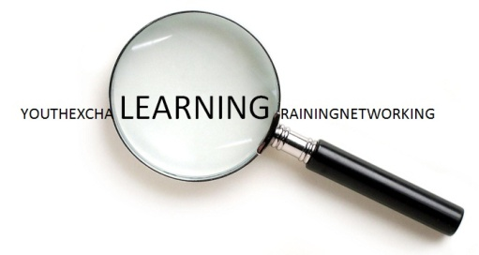
FACILITATING LEARNING
How to design and manage learning / educational processes in short-term Youth in Action projects?

3rd – 7th March 2012, SLOVENIA

Introduction
As Youth in Action is an educational programme, “learning” and the development of competences are or should be core elements of each Youth in Action project. But as so often, this is more easily said than done, especially when the activity itself is as short as the average youth exchange or training and networking activity. So how to make them a real learning process for participants in spite of their short duration?
In order to answer this question the training course will first look into learning in general, exploring how learning works for each of the course participants, then supporting the findings with a bit of theory about learning, and then transfer all this to the specifics of facilitating learning in international activities. On this basis the training course will have a deeper look into each phase of a short-term activity (preparation, activity, follow-up) and explore how it can be used to support the participants’ learning process.
We are convinced that all the phases of a project are important for the participants’ learning process Therefore, “ Facilitating Learning” consists not only of the training course itself, but includes a preparation phase with an introduction into the topic of learning and follow-up / mentoring phase with support and feedback for the development of participants own projects (until June 15th 2011). It is therefore required that participants contribute actively to all the phases of the training course.

What’s in it for me?
The training course “Facilitating Learning” aims at developing competences to facilitate learning processes within short-term Youth in Action Projects, with a particular focus on youth exchanges.
Participants will have the opportunity to:
- develop competences to create and support structured non-formal learning / educational processes in the framework of short-term Youth in Action projects;
- explore the concept of key competences for lifelong learning and its relevance for short-term Youth in Action projects;
- understand the importance of the different phases of the learning process (preparation, activity, follow-up) and the participation of young people in each of them;
- explore the specific learning potential of international projects (in comparison to national ones);
- experience Youthpass as a tool for the recognition of non-formal learning in Youth in Action.

Participants’ profile:
“Shaping learning” is an international training course open for youth workers in charge of managing short-term Youth in Action projects.

The participants should:
- be in charge of managing short-term Youth in Action projects;
- have at least once applied for a short-term Youth in Action project (e.g. youth exchange, training and networking activity);
- be engaged in all three phases of the activity (preparation phase, activity, follow-up / mentoring phase supporting the further development of own projects);
- attend the TC in full length and actively participate in all activities.

The course is open for 25 participants from Programme countries and neighbouring partner countries of South East Europe of the Youth in Action Programme and be over 18 years old.

Working language of the TC:
The working language of the TC will be English. Participants do not need to be advanced English speakers; however, they should be comfortable expressing their thoughts and ideas in English.

Application procedure:
Participants have to apply online via SALTO-YOUTH application system. Direct link to the application form: http://www.salto-youth.net/mySALTO/applicationonline/779/
The application form must be completed till the 18th of November 2011 at the latest. You will receive feedback about the selection until 15th December 2011.

Venue of the TC
The TC will take place in Bled, Slovenia. http://www.bled.si/en/

Participants are expected to arrive to the venue on 2nd of March, leaving on 8th of March 2012.

Financial considerations:
The hosting costs (accommodation, food, programme activities, local transport) will be covered by the Slovenian and German National Agencies and the SALTO South East Europe Resource Centre.
Participants from programme countries please contact your National Agencies to find out if travel and visa costs (public transport – 2nd class or economy) can be (partly) covered by them and if which participation fee is required. (see contact details in the YiA Programme Guide, Pages 128-130: http://ec.europa.eu/youth/youth-in-action-programme/doc/how_to_participate/programme_guide_11/programme-guide_en.pdf)
Participants from neighboring partner countries from South East Europe pay a participation fee of 10.- €. Travel and visa costs will be reimbursed by the Slovenian NA.

Organisers:
TC Facilitating learning is organised by:
- Movit NA Mladina - Slovenian National Agency for the Youth in Action Programme (info@mva.si)
- JUGEND für Europa - German National Agency for the Youth in Action Programme (jfe@jfemail.de)
- SALTO South East Europe Resource Centre (see@salto-youth.net)

Contact:
Should you have any questions about the TC, please contact Mr Tadej Beočanin at tadej.beocanin@mva.si (Slovenian NA).

Welcome to Slovenia!

