TC Formal Education Meets Non Formal Learning: The Competence-Based Approach
Kalamata, Greece – 3rd – 11th November 2012
EXERCISE: MAPPING THE COMMUNITY
GROUP 1: OBSERVATION

TASK: Walk at the pedestrian street of Aristomenous and observe the people.
What about the ages?
What about their face expression?
What about their clothes?
What about their voices?

TC Formal Education Meets Non Formal Learning: The Competence-Based Approach
Kalamata, Greece – 3rd – 11th of November 2012
EXERCISE: MAPPING THE COMMUNITY
GROUP 2: INTERVIEWS

TASK: Using the method of the interview, try to identify the
needs of the local community.

TC Formal Education Meets Non Formal Learning: The Competence-Based Approach
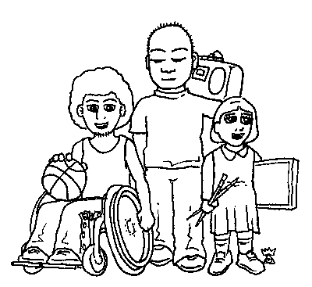
Kalamata, Greece – 3rd – 11th of November 2012
EXERCISE: MAPPING THE COMMUNITY
GROUP 3: TYPICAL WEEK OF YOUTH

TASK: In your own way, try to find out the typical week of 5 young people

TC Formal Education Meets Non Formal Learning: The Competence-Based Approach
Kalamata, Greece – 3rd – 11th of November 2012
EXERCISE: MAPPING THE COMMUNITY
GROUP 4: AWARENESS ABOUT NON-FORMAL EDUCATION

TASK: Using your own method try to identify the level of awareness of the local community about non-formal education. If they don’t know what it is, ask them what they think it could be.

