4 Ears

Good communication is critical to effectively working with diverse groups. But, what is good communication?

One simple answer could be – effective communication is when what you say is being understood the way you meant it. Just like with the radio waves being transmitted from the sender to a receiver. If for example weather conditions are bad, the receiver would most probably get a distorted message. The message would not reach the destination the way it is supposed to!

Human communication is even more complicated than radio waves. We communicate not only by the spoken word, but also using our whole body giving non-verbal signals. The German communication theoretician Friedemann Schulz von Thun states, that every message has at least four aspects.

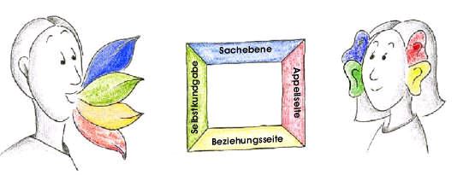
From www.schulz-von-thun.de (25.01.2006)

- plain content
- revealing sentiment
- request
- relation between the actors.

For example, if you tell your friend “It is 5 o'clock” , maybe you just want to state this fact, but maybe saying this, you want say that you are in a hurry, revealing your sentiment. Another possibility is that actually you want to say: “Now I prefer doing something else instead of spending more time with you”, stating your relation to your conversation partner. Or maybe saying this short sentence you want to ask your conversation partner to hurry up?

Anything we say, we stress on one or the other aspect of the message. Misunderstandings occur, when we send a message meaning one thing, but the “receiver” hears it differently, as if it would hear it with a different “ear”.

According to this model, effective communication can take place, when the message is being received with the same meaning “code” that it has been sent.

What can a “sender” of the message do, in order to make sure, that the message reaches the recipient the way it is supposed to? First of all, even if it sounds obvious, it is essential to send a message the way the addressee can understand it. It means talking to a person clearly in a language the person can understand, using the terms the person can understand, so that s/he makes the same sense out of the words s/he heard.

Depending on our personal development we tend to pick up on certain or specific aspects of a message. There are people, for example, who hear everything that is said to them, as if it would be an accusation, even if it was not meant to be. There are other people, who hear everything as a command they have to obey, and so on. If you reflect upon some misunderstandings you have experienced, try to identify how you tend to hear?

Sure, these are just a few examples of what the message could contain. The code of the message depends on the context, body language and many other things. If you learn to “send” your messages expressing the code as clearly as possible, you help your conversation partners to understand you correctly. “Decoding” messages of the others could be a little bit more difficult. If you do not know the person, or s/he comes from a different cultural background than you, it could be difficult to understand the “code” of the message straight away. If you are not sure, instead of giving your reaction, the best way is to ask first: “What did you mean?”

