How many steps are required to break an 4 × 3 sized bar of chocolate into 1 × 1 pieces?  You can break an existing piece of chocolate horizontally or vertically.  You cannot break two or more pieces at once (so no cutting through stacks). | 11 steps are required.
There is a room. In each corner of the room, there is one cat. Each cat is sitting on the tail of a cat. Each cat can see three cats.  How many cats are there in the room? | There are 4 cats.
You are at an unmarked intersection ... one way is the City of Lies and another way is the City of Truth.  Citizens of the City of Lies always lie.  Citizens of the City of Truth always tell the truth.  A citizen of one of those cities (you don't know which) is at the intersection. What question could you ask to them to find the way to the City of Truth? | You ask "In which of those two directions do you live?"  A Citizen of the City of Lies will point to the City of Truth  A Citizen of the City of Truth will point to the City of Truth
Here is an ordinary cross. You are allowed to make two straight cuts across it. How do you cut it to make the most pieces?   | 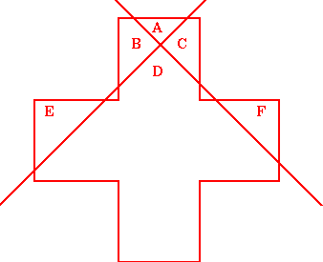
A man works on the 10th floor and always takes the elevator down to ground level at the end of the day.  Yet every morning, he only takes the elevator to the 7th floor and then walks up the stairs to the 10th floor, even when in a hurry.  But he will go all the way to the 10th floor when others are in the elevator with him or on a rainy day.  Why? | He is too short to reach the "10" button.  But when others are with him, he can ask them to push the button for the 10th floor.  And on a rainy day he has an umbrella, so he can push the button using that.
A Man carries his son into the hospital because his son has a nail in his foot. The Surgeon then walks in and says "I cannot operate on this boy as he is my son".  What is going on here? | The Surgeon is the boy's Mother.
A boy and a girl are talking.  "I am a boy" - said the child with black hair.  "I am a girl" - said the child with white hair.  At least one of them lied. Who is the boy and who is the girl? | They both lied.  The child with the black hair is the girl, and the child with the white hair is the boy.  (If only one lied they would both be boys or both be girls)
A mother is 21 years older than her child.  In exactly 6 years from now, the mother will be exactly 5 times as old as the child.  Where's the father? | With the mother. If you do the math, you find out the child will be born in 9 months.
Mary's mum has four children.  The first child is called April.  The second May.  The third June.  What is the name of the fourth child? | Her name is Mary.
There are only two barbers in town  One of them has a nice, neatly trimmed head of hair. The other one's hair is a complete mess.  Which of the two barbers should you go to and why? | The one with messy hair, as they cut the neat barber's hair.
What can travel around the world while staying in a corner? | A stamp.
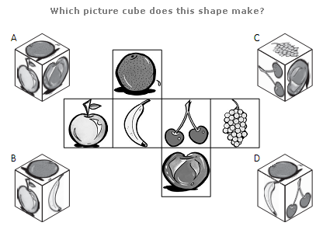 | It makes a cube C.
Because the water lily doubles its size every day and the complete pool is covered after 20 days, half of the pool will be covered one day before that, after 19 days. | After 19 days, the water lily will cover half of the pool.

